Developing the prototype Task2

Table of Contents

Overview 2

Changes to development 3

Development methodology/plan 4

Sprint 1 6

Goals/Requirements 6

Triage/Tasks 6

Log table 7

Review 14

Sprint 2 14

Goals/Requirements 14

Triage/Tasks 14

Log table 20

Review 22

Sprint 3 23

Goals/Requirements 23

Triage/Tasks 23

Log table 31

Review 32

Sprint 4 32

Goals/Requirements 32

Triage/Tasks 33

Log table 40

Review 42

Sprint 5 42

Goals/Requirements 43

Triage/Tasks 43

Log table 47

Review 48

Sprint 6 49

Goals/Requirements 49

Triage/Tasks 49

Log table 51

Review 52

Overview of Development 52

Client Requirements 52

How Requirements been met 53

Development progress review 55

Future development 56

Thoughts about the project 57

Citations 57

Link 57

Number 57

https://docs.microsoft.com/en-us/aspnet/core/mvc/overview?view=aspnetcore-6.0 57

(1) 57

https://www.w3schools.com/css/ 57

(2) 57

https://docs.python.org/3/library/hashlib.html 57

(3) 57

# Overview

Toka Fitness needs a new digital solution which would help their company out to communicate with their existing and coming customers as well as helping their employees on completing the tasks. Now Toka Fitness currently provides customers with **personal training sessions, advice about fitness training and advice about healthy living**. But they are now in need of features such as:

* **provide information and advice about fitness training and healthy living**
* **provide access to digital content to support customers with their training and healthy lifestyle**
* **encourage existing customers to use more of the services provided by Toka Fitness**

Toka Fitness has also carried out market research with existing customers to identify potential features which could be included in the digital solution. Potential features included items such as:

* **free and paid-for content**
* **accessibility features for users with sight loss**
* **‘social’ features**
* **customisable workout and eating plans**

As a result of this, the features they required can be completed and will be done by the time they expect this solution to be completed.

For this project I have decided to create a Web based application for Toka Fitness with functionality they in need of included in it. This application will have a SQL data base system which will store customer information and the necessary data needed.

# Changes to development

Payment

Due to the risks of storing users’ payment information I have decided to no longer include any fields requiring a user to enter their private card number information to buy a premium account due to reasons such as security and Toka Fitness assumably not having a valid or usable e-commerce license to sell products online.

Storing information

User information will now be stored in a SQL database instead of Excel file. I have decided to make this change as SQL is fast and can handle large loads of data whereas Excel cannot. SQL is a highly secure database as it uses sophisticated encryption algorithms making it virtually impossible to break the security layers. SQL server is a commercial relational database with additional features to reduce the risks of attacks. SQL also has features allowing users to restore and recover lost or damaged data with its advanced tools.

As a result of this I no will be using Excel as a database and instead a MySQL on a virtual machine to get all users data.

Features

Workout Plan changes

**Push Up page**

Instead of having a workout plan page with drop downs and saving information I have decided to make it more interactive for the users and make them click a button every time they have done a push up. This will then be shown up on a counter telling them how many push ups they have done. Once user is finished, they will need to press save button to save the amount of push ups they have done to the database.

**Squats Page**

This page will act the same as Push ups page with the interactives of clicking a button and showcasing the amount of squats user has done which will then allow user to save it to the database.

**Records Page**

Data such as Push ups and Squats will be stored in a table which user will be able to see on how many they managed to achieve within the log. This will then allow users to share their information online to social media such as Facebook, Instagram and twitter. As a result of this socials page has been removed as this page will act as a social feature which Toka Fitness customers are wanting.

**Socials Page**

Socials page has been removed and replaced by Records page social media share buttons.

# Development methodology/plan

To build this solution which Toka Fitness needs I have decided to use the agile approach to develop this product. As a result of this instead of developing everything in one go, I will deliver work in small increments such as sprints. The purpose of sprint planning is to set goals which can be delivered within a short, time boxed period. Using sprints for this project is perfect as it will allow me to give out functionality by the end of each sprint. This means the milestones set for the sprint are made and ready for the review of the client to see if its what they expect each function to work as it is. This is another advantage to using agile methodology due to always being able to have the clients themselves involved in the project and if they have any new features they want to add or remove it can be easily achieved.

When developing this product, I will be splitting this big problem into sprints with each sprint being a day to itself. This allows me to have my full attention and work to be completed for that specific sprint. This table below will be the layout which my sprints will be held in. Each sprint will have set tasks to be completed within it which will act as milestones. This will allow me to keep track of tasks which need being completed as well as giving time frames. If I don’t manage to complete a certain task in (Sprint 1) it will be moved into (Sprint 2) to make sure it gets done one way or another. Each task in different Sprints will be given a number which would represent the difficulty which would make it to be completed a bit longer than the other vice versa for tasks which have lower number set.

|  |  |  |  |  |  |
| --- | --- | --- | --- | --- | --- |
| Sprint 1 | Sprint 2 | Sprint 3 | Sprint 4 | Sprint 5 | Sprint 6 |
|  |  |  |  |  |  |
|  |  |  |  |  |  |
|  |  |  |  |  |  |
|  |  |  |  |  |  |
|  |  |  |  |  |  |
|  |  |  |  |  |  |
|  |  |  |  |  |  |

At the end of each sprint, I will review on what I have produced and achieved while I was developing the set tasks. The review will contain information such as the tasks in the sprint I was able to achieve, the tasks didn’t complete or had trouble on creating them, the tasks which need to get moved to the next sprint to be completed in and review on what I think about the sprint in general. This all then will be repeated for each end of the sprint as it will give me a clear overview of where I’m at and any more things which need testing or fixing.

Throughout this development I will be using a wide range of testing including White box testing and Black box testing. As I’m the one building this software Black box testing will be a priority and frequently done to test out the interface and functionality. Testing such as:

* unit testing
* integration testing
* system testing
* acceptance testing
* boundary testing

All these tests will be done in the log table to make sure that no broken/non functionality is being give to the client as well as lets me know if any future development will be required on completing the product.

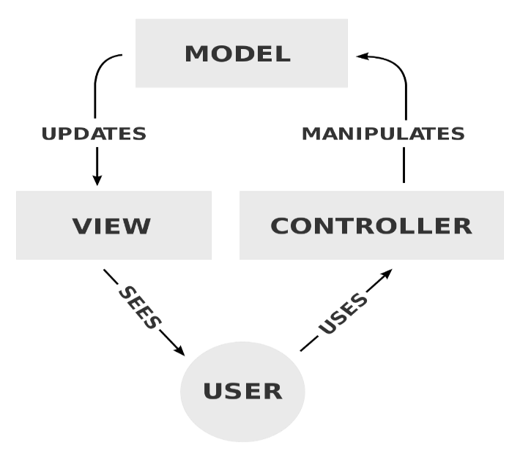MVC (1)

MVC(Model-View-Controller) is pattern which I’m using for this project as it separates an application into three groups of components: Model, View and controller.

User requires are routed to a controller which is responsible for working with the model to perform user and retrieve results of queries. The controller chooses the view to display to the users and provides it with any Model data it requires.

Both view and controller depend on model, however, benefit of this is that model depends on neither the view nor the controller. The benefit of this separation is that model can be built and tested independently.

Responsibilities

|  |  |
| --- | --- |
| Model | Represents state of the application and any logical operations that should be performed by it |
| View | Responsible for presenting content through the user interface. There should not be any logic within view. |
| Controller | Handles user interaction and works with the model and selects a view to render |

Version Control

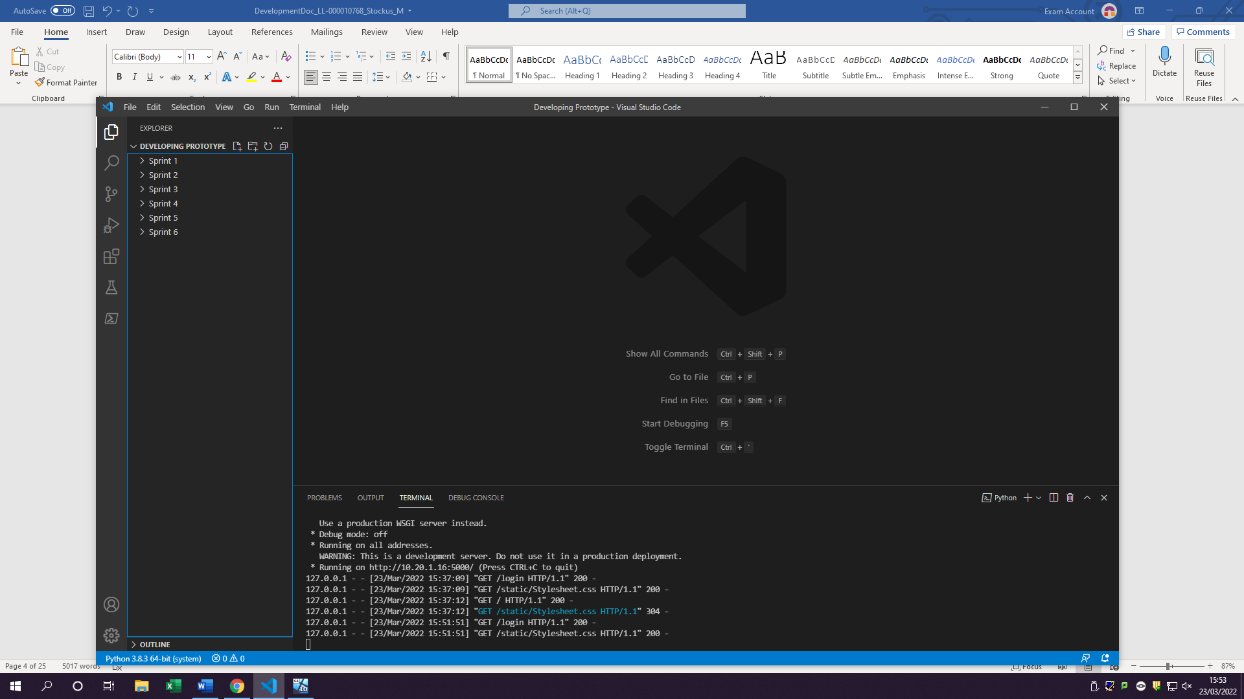As this project development will take multiple sprints I have to make sure all the files are backed up by the end of each day and the next day I copy all the files from the previous sprint on to the new one therefore if I ever need to look back on what I did in sprint 1 I will be able to.

Cookies

Will be used as part of my tracking the customer once they login using their email it will act as a cookie which could then be used to get their name so it can be displayed on the dashboard as an interactive thing.

## Sprint 1

Sprint 1 will consist mostly of creating main modules like the server where it will be getting requests and sending user to specific page. Model will define what each request and what it should do then returns it to server

### Goals/Requirements

|  |  |  |
| --- | --- | --- |
| Goal Set | FR# | Requirements |
| As a user I would like to be able to access a website | 1 | Create a webpage which user can access online |
| As a user I want to see forms to fill in on the webpage | 2 | Create forms for user which can be filled in |
| As a user I want to be able to submit forms | 3 | Create submit form button to submit form for user |

### Triage/Tasks

|  |  |  |  |
| --- | --- | --- | --- |
| FR# | Task # | Functional requirement | Expected outcomes |
| 1 | 1.1 | Create Controller module |  |
|  | 1.2 | Create Model module |  |
|  | 1.3 | Create Database module |  |
|  | 1.4 | Connection Controller with model |  |
|  | 1.5 | Create a basic homepage | User is able to get on a webpage and see ‘Toka Fitness Title’ |
|  |  |  |  |
|  |  |  |  |
| 2 | 2.1 | Create a user in database | User is made in the database |
|  | 2.2 | Create a form for free account | User is able to see free account form |
|  | 2.3 | Create a form for Premium account | User is able to see Premium Account Form. |
|  | 2.4 | Add detail to be filled out in the forms | User can fill out any one of the forms |
|  | 2.5 | Create CSS file for all CSS (designing) |  |
| 3 | 3.1 | Create a submit form button | User is able to click on a submit forms button |
|  | 3.2 | Button should lead it to another page | Once user clicks on submit button it should lead it to blank page |

### Log table

* 1. 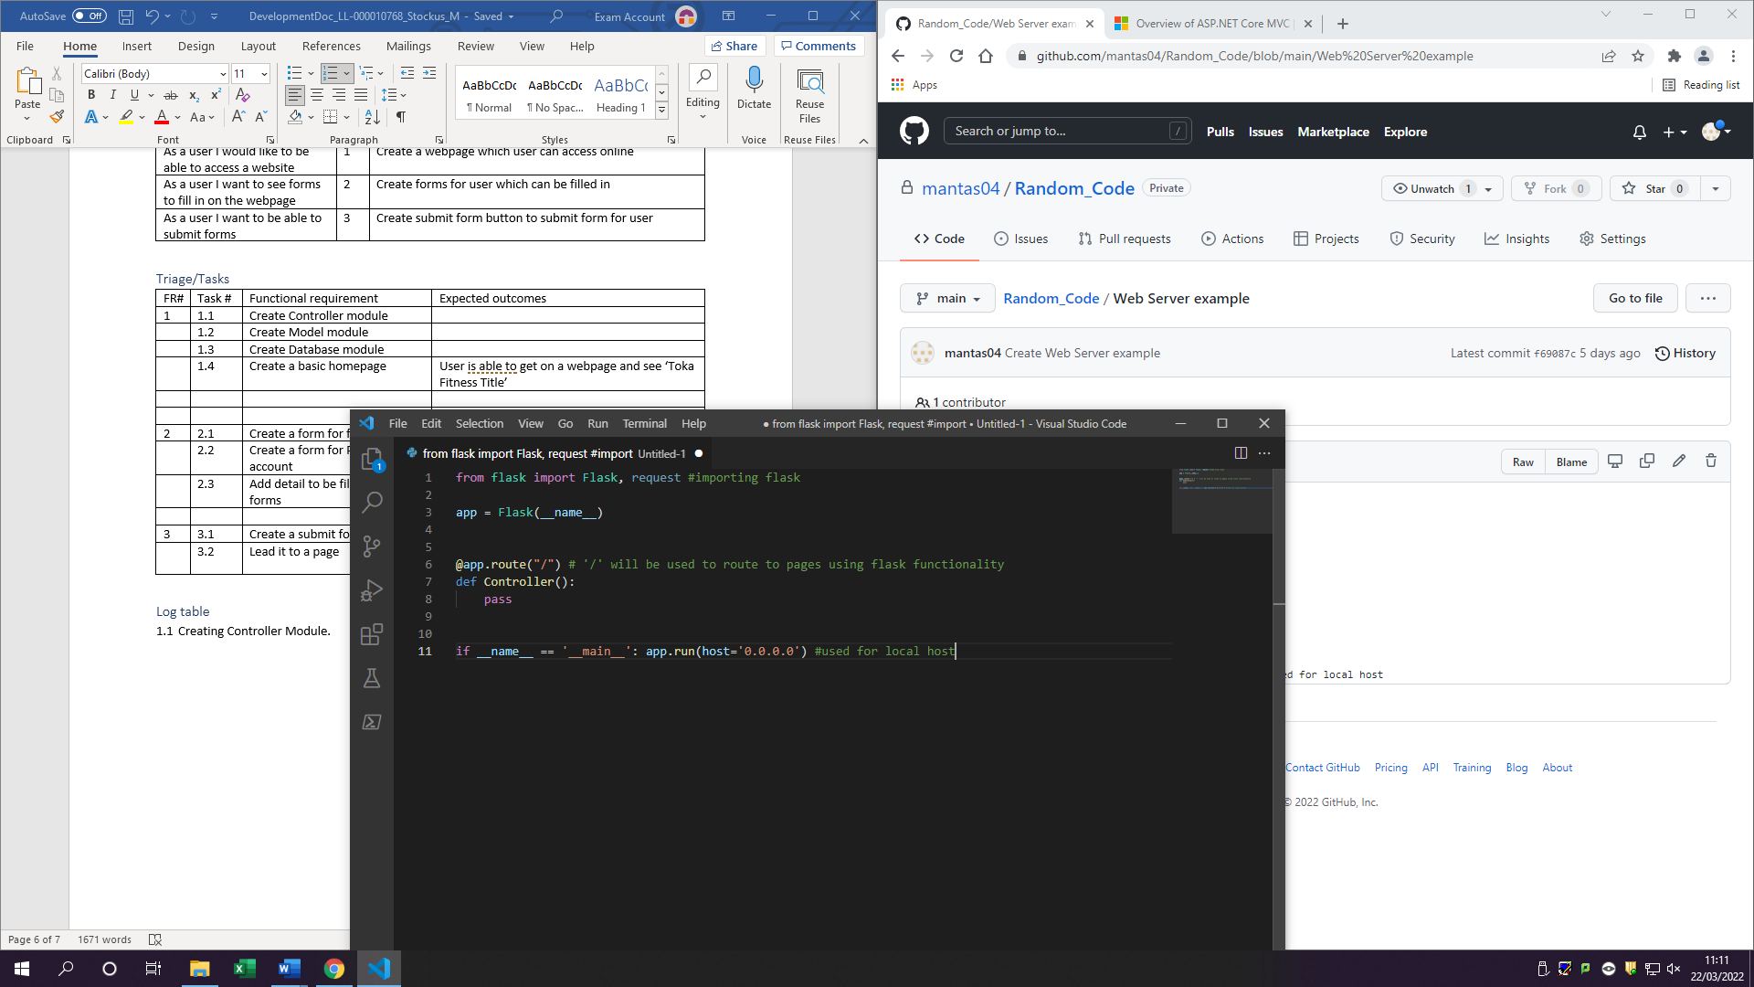Creating Controller Module.

Flask is a web framework for creating web applications in python easier.

* 1. Creating Model module

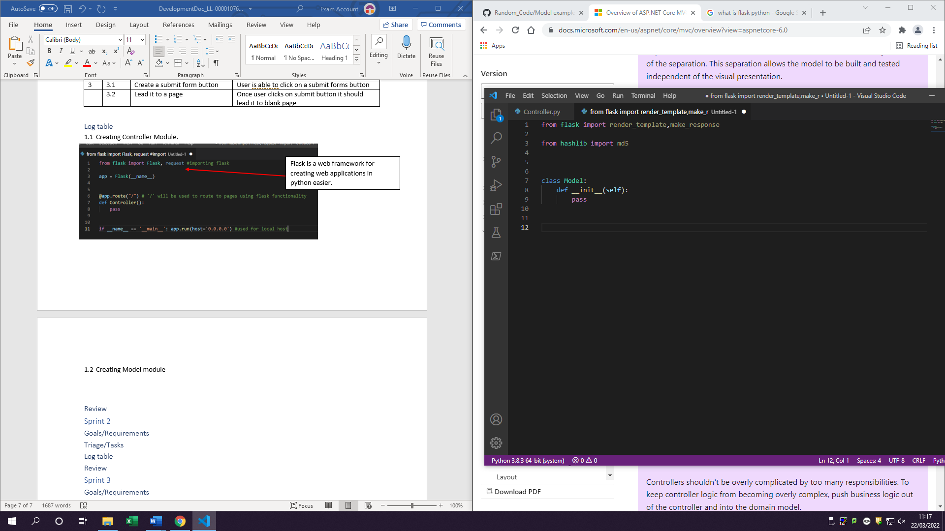

Hashlib module is a module for hashing messages easily (will be used for encrypting) (3)

* 1. Create Database Module

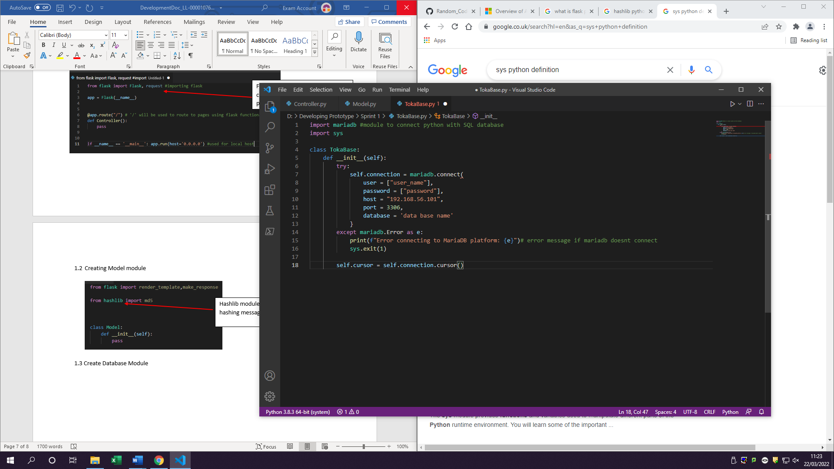

Details to have access to the database to be admin

Mariadb is open-source relational database

If connection fails instead of getting no message, I will receive this message:

* 1. Connecting Controller with model

Declaring Model as model in controller variable

Importing model into controller

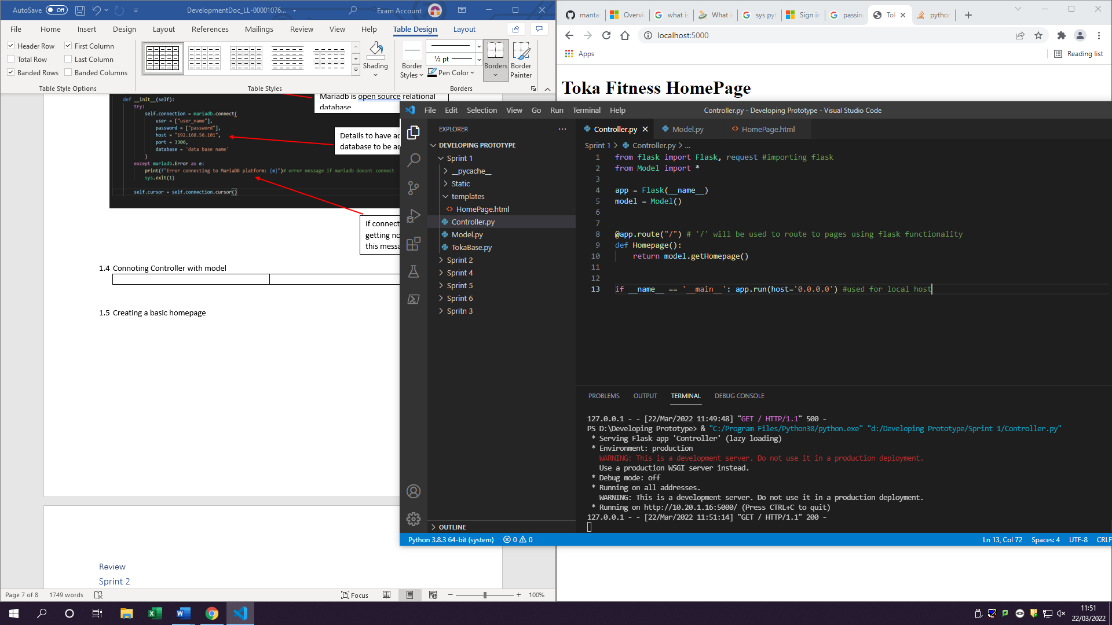

* 1. 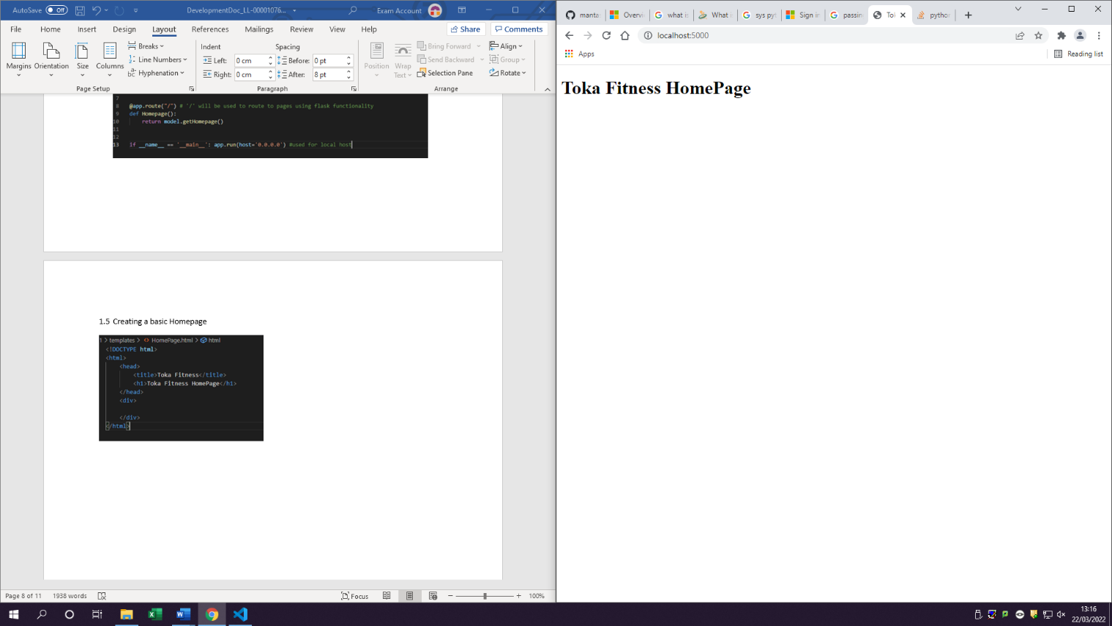Creating a basic Homepage

Message user will see

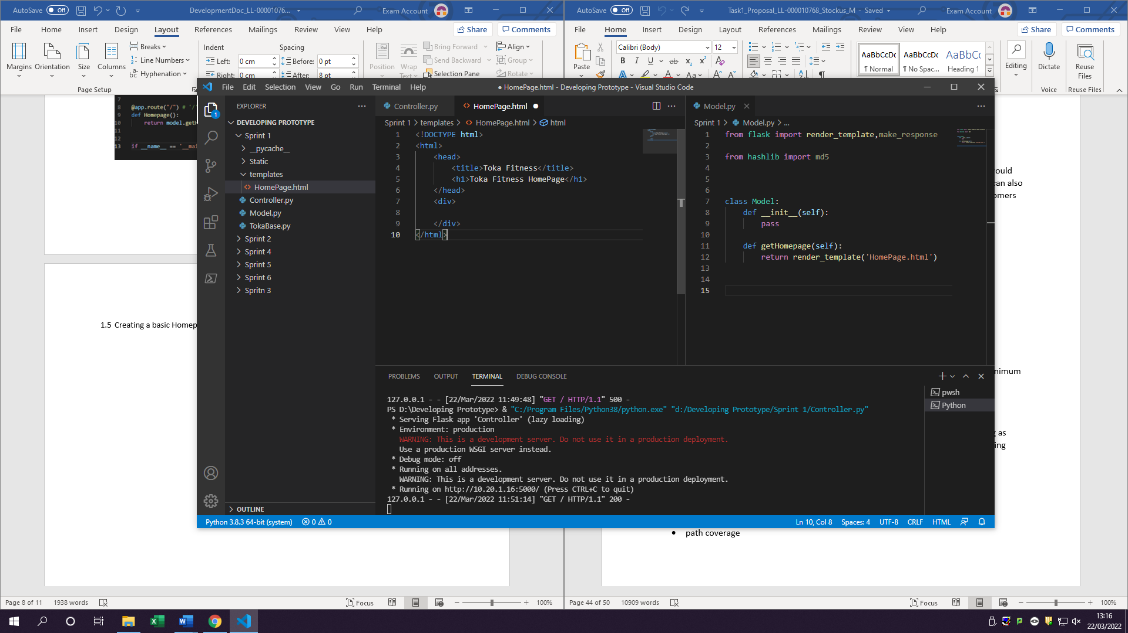

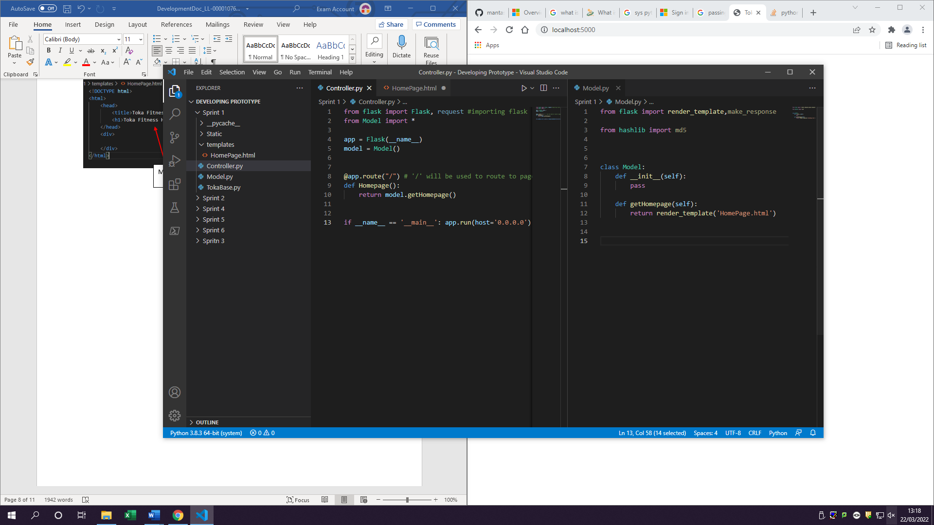

If the function in model exists it will return a template to render in this case ‘HomePage.hmtl’

Return model.getHomepage is sending this variable to model.py

2.1 To create a user in my database I done the commands:

create [USER](http://localhost/phpmyadmin/url.php?url=https://dev.mysql.com/doc/refman/8.0/en/information-functions.html#function_user) 'Remote'@'localhost' IDENTIFIED BY 'qwerty';

GRANT ALL ON tokadb.* TO 'Remote'@'localhost';

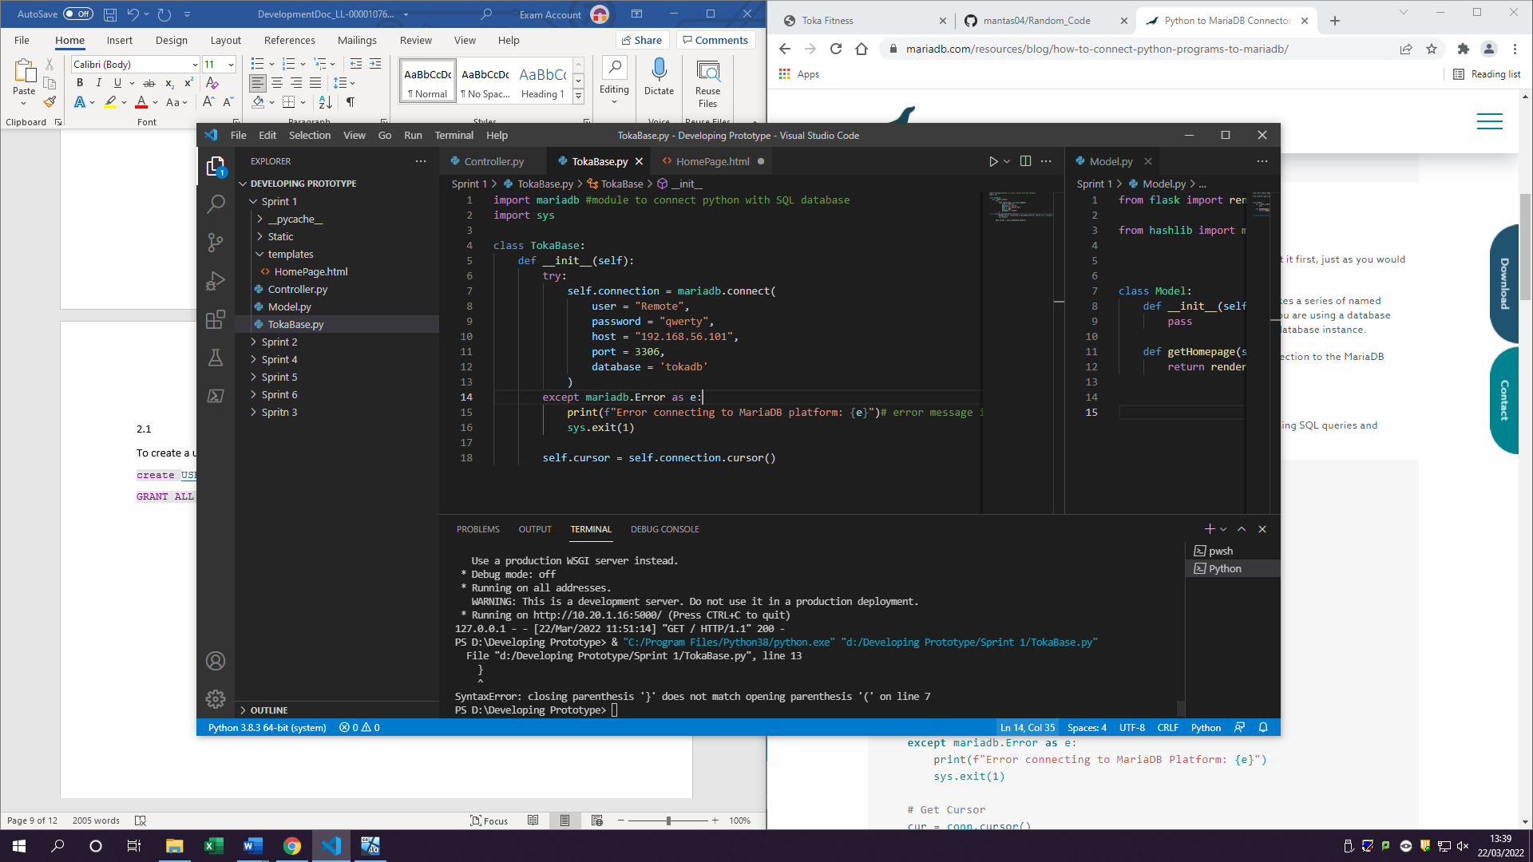

User information is now update giving access to all the commands too

2.2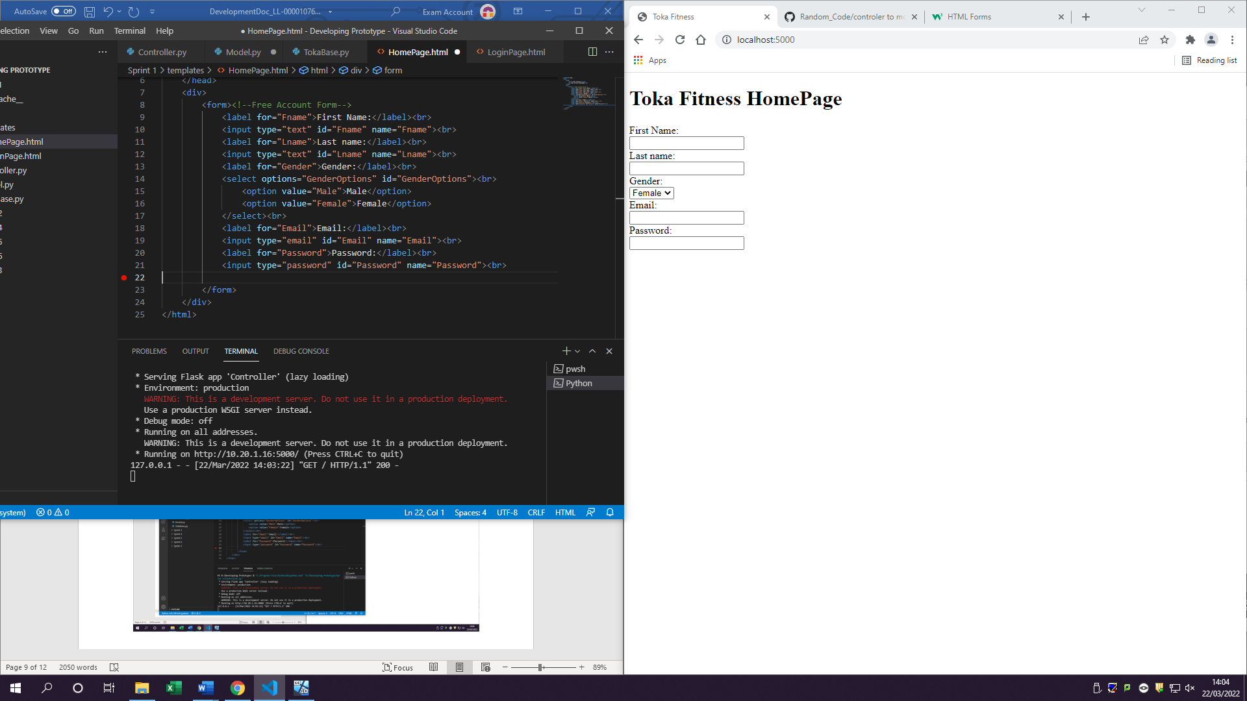

Form which user will need to fill in

All the behind the scenes of form creation such as name, password email etc

2.3 Create a form for Premium account

Same form Created for premium version

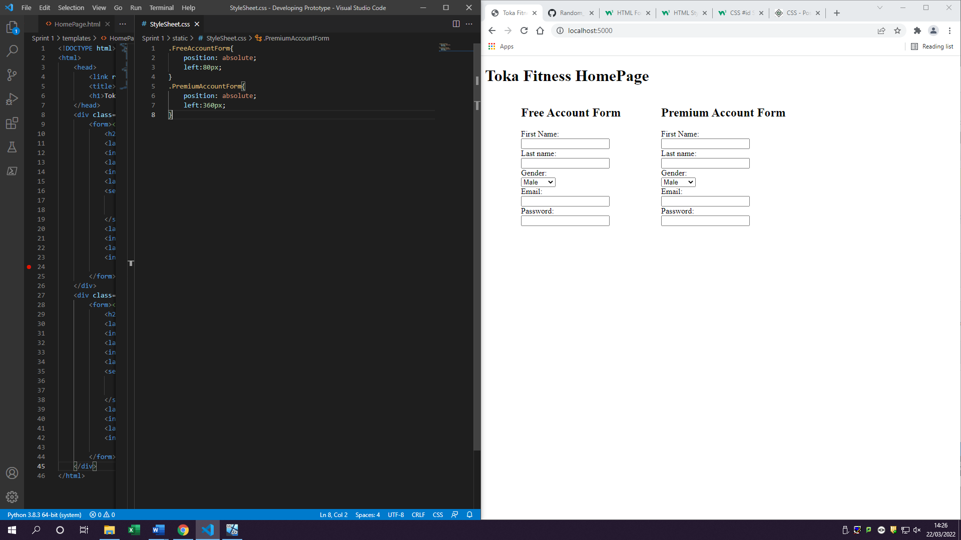2.4 Add detail to be filled out in the forms

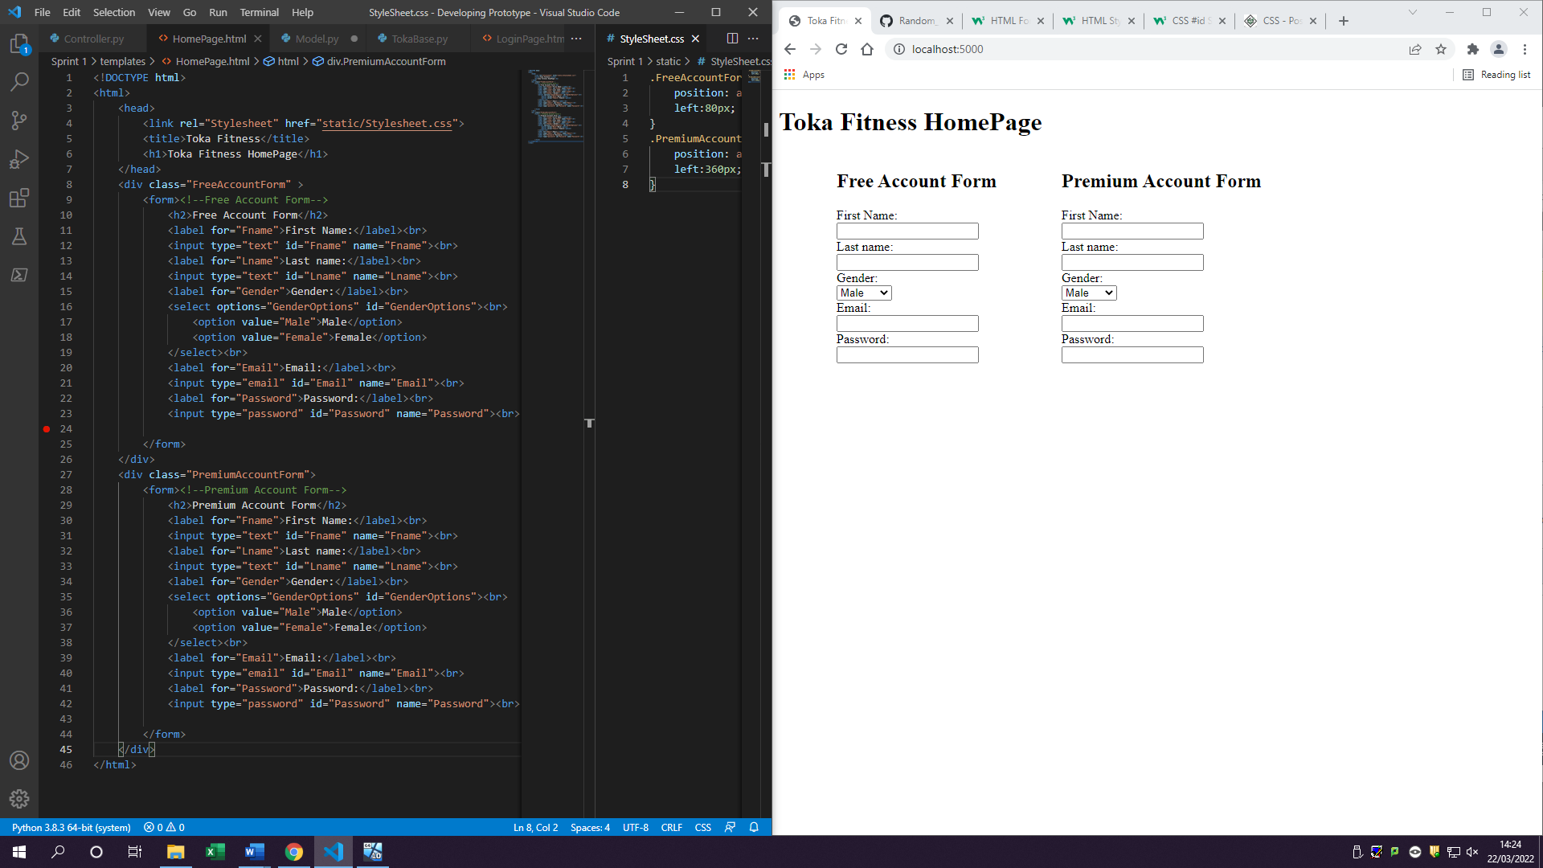

Creating a style sheet with CSS to get forms side by side and inserting link in Homepage (2)

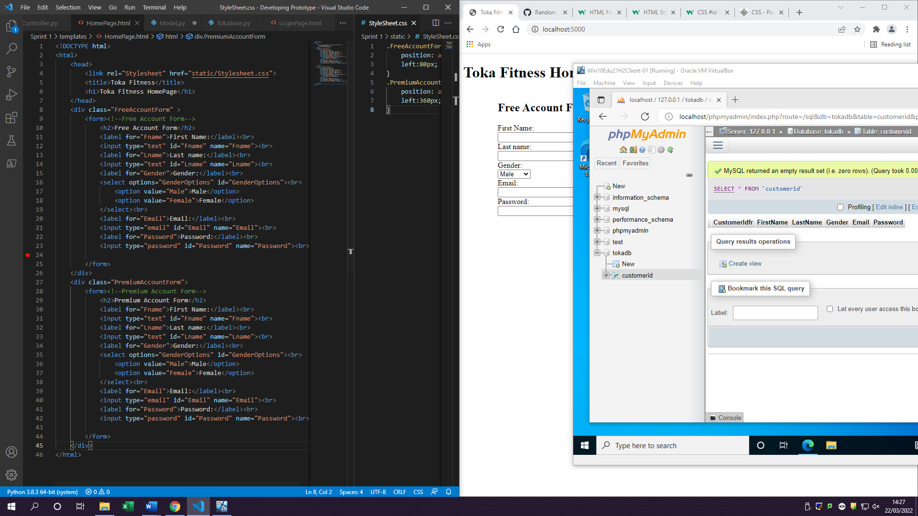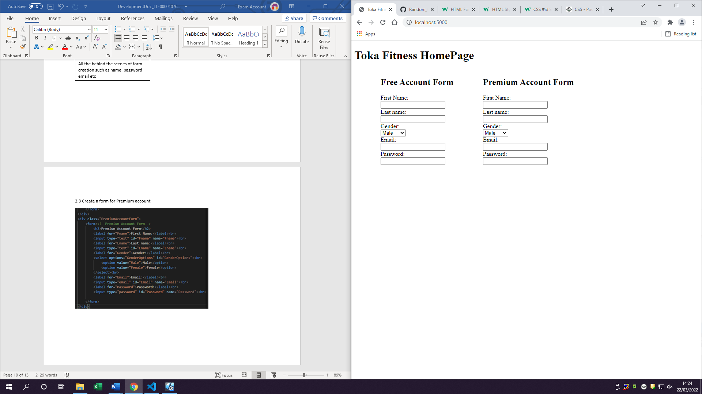

2.5 Creating CSS file



3.1 Create a submit form button

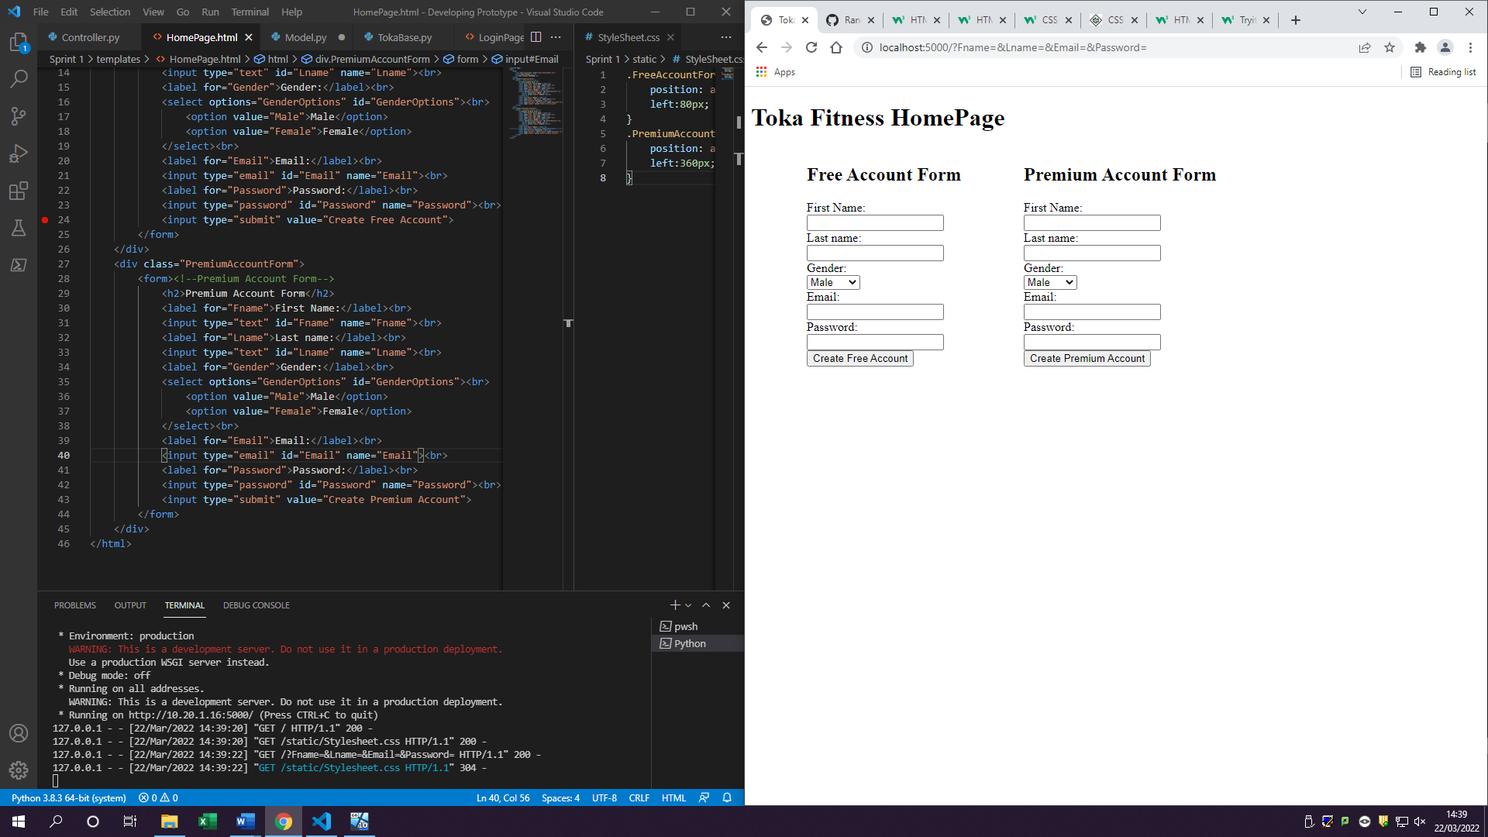

Submit button is created and can be viewed and clicked by user

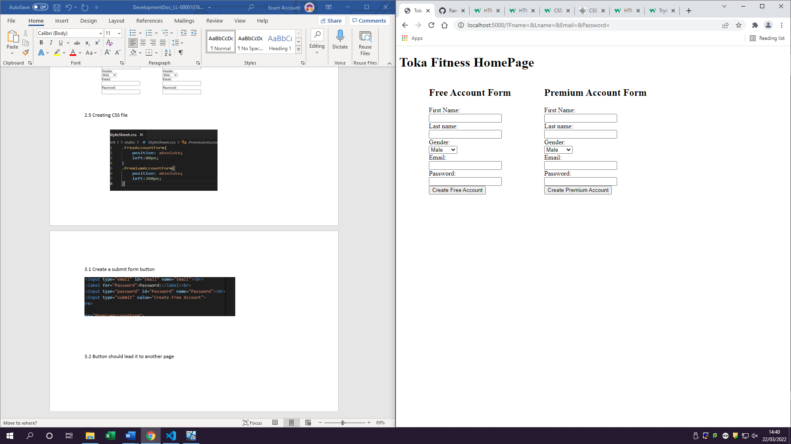

Once controller gets the root of /login sent it will send a request to model to return a template with that function which is login page

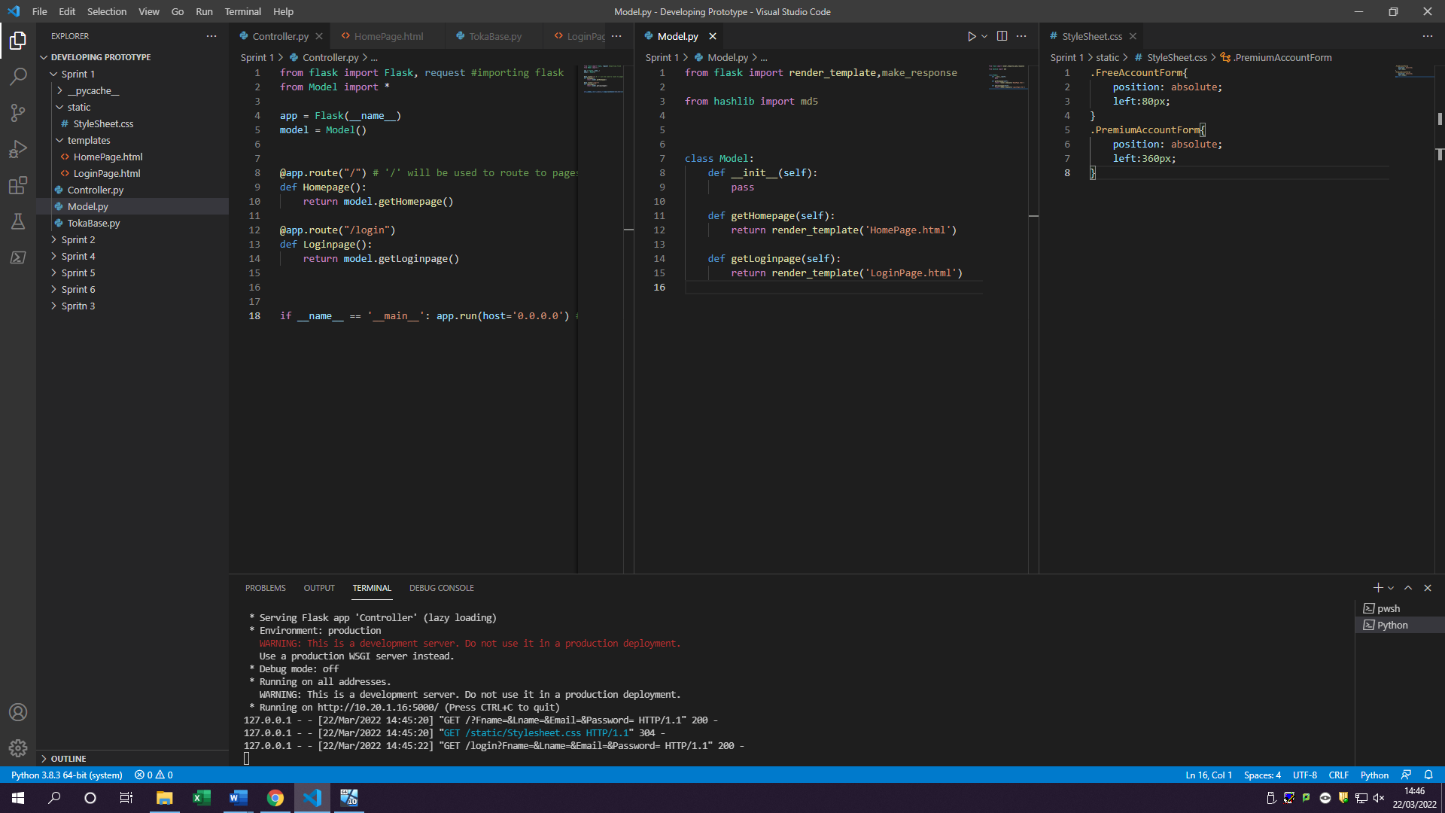3.2 Button should lead it to another page

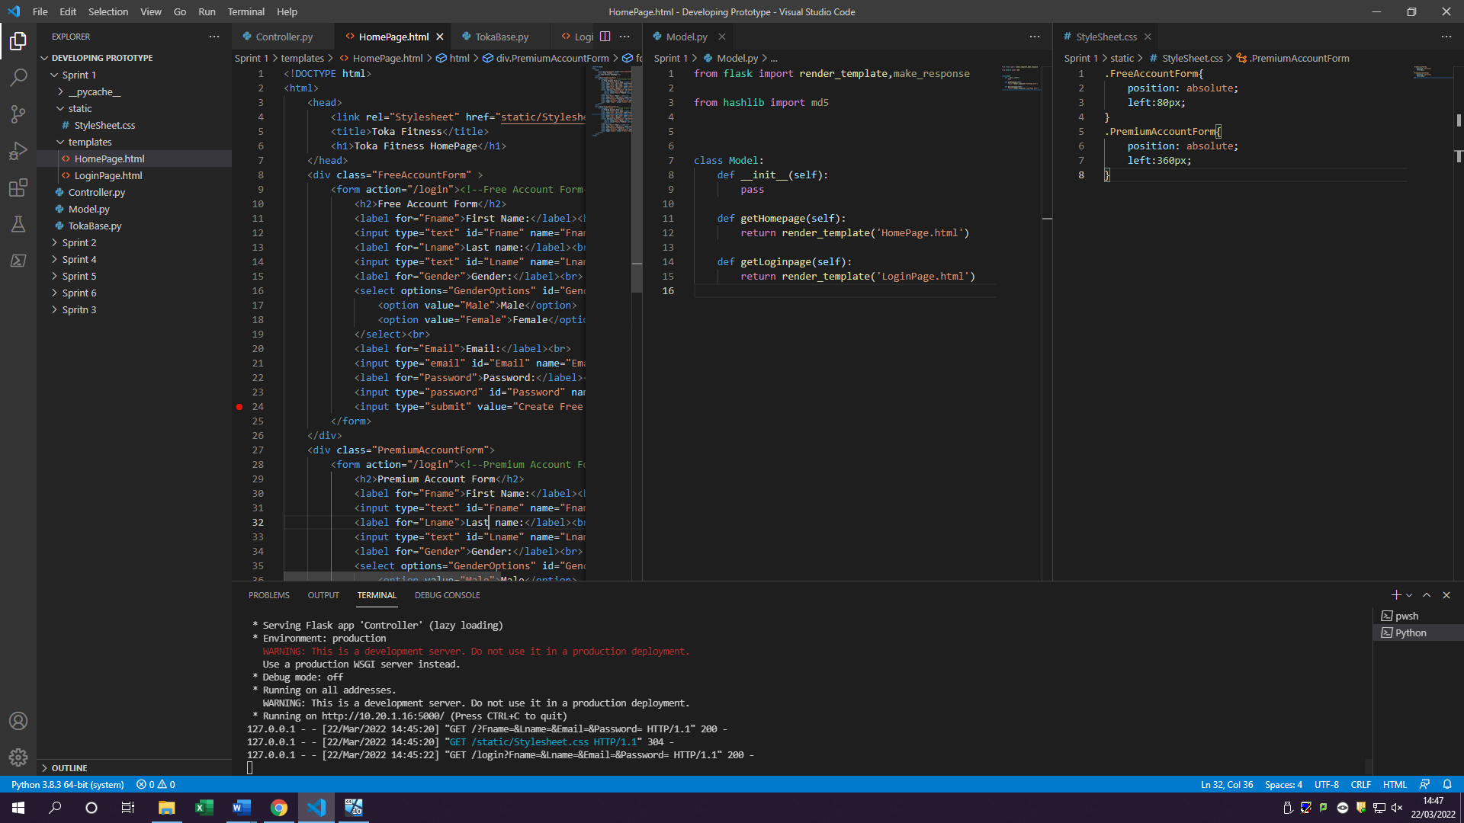

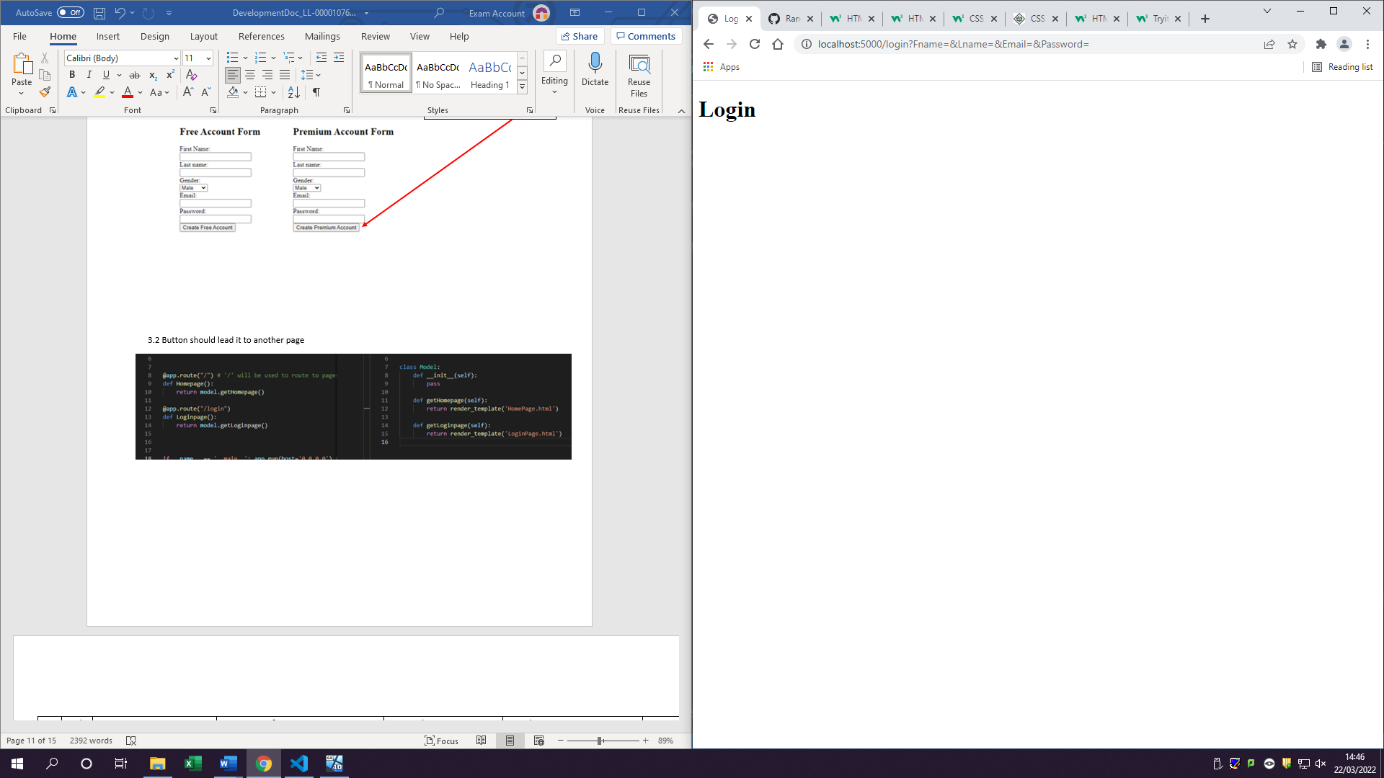

Form has an action of /login

This will work when form button is pressed

|  |  |  |  |  |  |  |
| --- | --- | --- | --- | --- | --- | --- |
| Fr# | Task# | Testing type | Description of test | Expected outcome | Actual outcome | Notes |
| 1 | 1.1 | Unit testing  Functional test | Testing to see if flask import is working correctly | Server should be able to run on local host | Localhost:5000 is running | Localhost:5000  Is website |
| 1.2 | Unit testing  Functional test | Just to see if model runs | Model can run by itself once clicked run | Model runs with no errors | x |
| 1.3 | Unit testing  Functional test | Checking if TokaBase (database) is running | Should work as it suppose to | Not running due to not having a user created yet | Need to create a user for database |
| 1.4 | Integration test  Functional test | Checking to see if controller and model communicate with each other | Model should receive controllers’ requests | Controller and model can communicate with each other by returning template | x |
| 1.5 | unit testing  integration testing | Webpage is made and displays Toka name  Controller sends request to model to show database | On localhost user should be able to see Toka Fitness Title to be displayed | Toka Fitness Homepage is getting Displayed for the user once entered in search bar for localhost:5000/ |  |
| 2 | 2.1 | Unit testing  Functional test | Creating a user in MySQL database and granting it access to everything | User should be created with all the permissions | User has been created and named as ‘Remote’ | User has now been created for database |
| 2.2 | Unit testing  Acceptance testing | Creating a form for user to be able to fill in with all the necessary details | All field names are in the form which is required and are drop downs work as well as text | Drop down works and text can be entered in the fields | x |
| 2.3 | Unit testing | Create a form for Premium account | All field names are in the form which is required and are drop downs work as well as text | Drop down works and text can be entered in the fields |  |
| 2.4 | Unit testing | Add detail to be filled out in the forms | All information requested in the forms getting displayed | All requested information is displayed | x |
| 2.5 | Unit testing | Making sure CSS file is linked to home page | If linked forms should be side by side instead of on top of each other | CSS has linked with the home page and now is side by side with each other | x |
| 3 | 3.1 | Unit testing  Functional testing | Once can see and click on submit button | User can click on submit button but should do nothing | A user can now click on a button | x |
| 3.2 | Unit testing  Functional testing | Once user clicks on submit, they should be sent to a blank page (login page) | Once submit button is clicked, they get sent to another page | Once user clicks on login button it will lead them to page with login title | x |

### Review

Sprint 1 was very successful as I manged to finish all the goals which I have set out and can even see some of the functionality work. The benefit of completing all these tasks is that it means that in sprint 2 there are no backlogged tasks which need completing therefore my time management is correct and should be on schedule for completing the product by the deadline.

There was a problem at the start when I tried to run controller and model together, but it didn’t work because in the controller file I haven’t imported model function which meant that there was no link with each other and therefore I kept on getting error: ‘model = Model() isn’t defined’ But this was an easy fix as I was missing a ‘from Model import*’. This line means that controller has called model function.

For Sprint 2 I will need to start adding in some designs onto the pages as sprint 1 was mostly setting everything up and not considering any design instead just functionality. Sprint 2 will also be a bit harder as it will require to me to start retrieving customers details and storing them in the database to be used for the login page. To make this easier I will split this functional requirement into smaller tasks and once again complete them one by one and test them to the fullest.

As result of completing sprint 1 early I’m able to start adding colour and designs to the homepage to not make it as plain white as it is.

## Sprint 2

Sprint 2 is based of sprint 1 by developing more on the storing data in the database (TokaBase) from the forms which the user has filled in. This means there will be more database work required and more communication between the webpage and the server.

### Goals/Requirements

|  |  |  |
| --- | --- | --- |
| Goal Set | FR# | Requirements |
| As a user I want my information to be stored in a database | 1 | Inserting all user information from forms into database |
| As a user I want to be able to log in to the dashboard I register for | 2 | Create login button and once user enters their information, they will be sent to the dashboard they requested |

### Triage/Tasks

|  |  |  |  |
| --- | --- | --- | --- |
| FR# | Task # | Functional requirement | Expected outcomes |
| 1 | 1.1 | Have Customer increment by 1 | Every time user submits a form data gets sent to database and CustomerID should start incrementing |
|  | 1.2 | Customer details should be placed in correct spots in database | All data should be in their correct spots such as name in name column email in email column etc |
|  | 1.3 | In html forms add invisible label which will determine the account type | The hidden field will be used once user submits the form it will send it to the account type which will determine if user registered on a free account or a premium |
| 2 | 2.1 | Create a login Page | Login page should have a form which requests for email and password |
| 2.2 | Create login button | User should be able to click on login button |
| 2.3 | Login button sends them to login page | Login page asks user for information |
| 2.4 | Verifying users information to see if it exists in database | When user fills in the requested information and it exists in database it should give user a blank page with either free of premium dashboard |
| 2.5 | Create free dashboard | If user has a free account type, they get sent to free dashboard |
| 2.6 | Create Premium Dashboard | If user has premium account type, they get sent to premium dashboard |

1.1

[ALTER](http://localhost/phpmyadmin/url.php?url=https://dev.mysql.com/doc/refman/8.0/en/alter-table.html) [TABLE](http://localhost/phpmyadmin/url.php?url=https://dev.mysql.com/doc/refman/8.0/en/alter-table.html) tblcustomerid MODIFY COLUMN CustomerIdfr [INT](http://localhost/phpmyadmin/url.php?url=https://dev.mysql.com/doc/refman/8.0/en/numeric-types.html) AUTO_INCREMENT;

This line is telling SQL to automatically increment it once it updates meaning CustomerIdfr will be increased by 1 every time

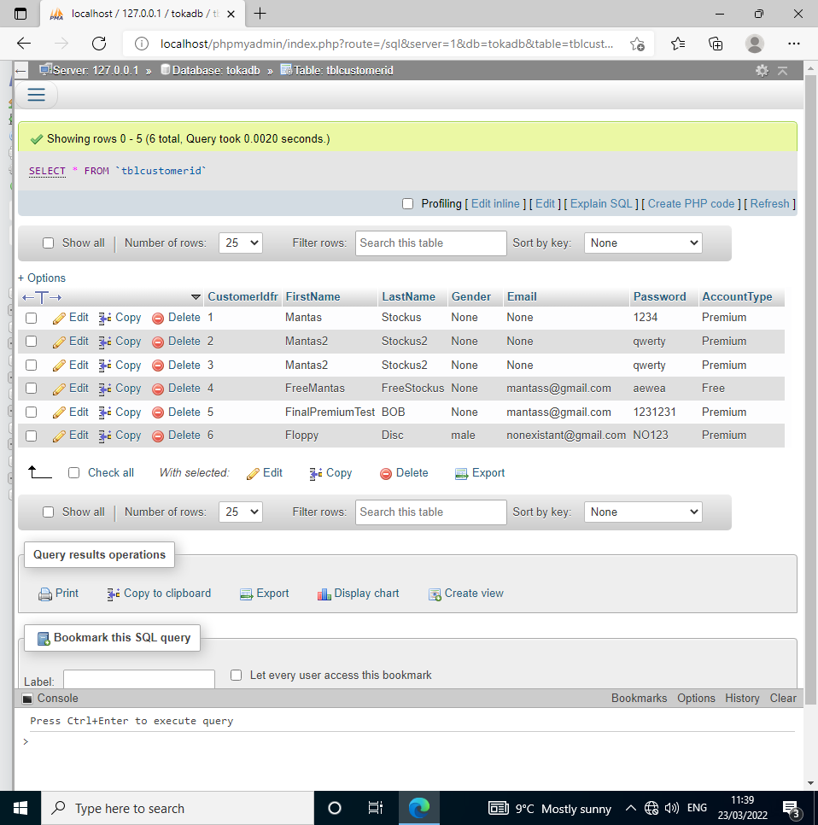

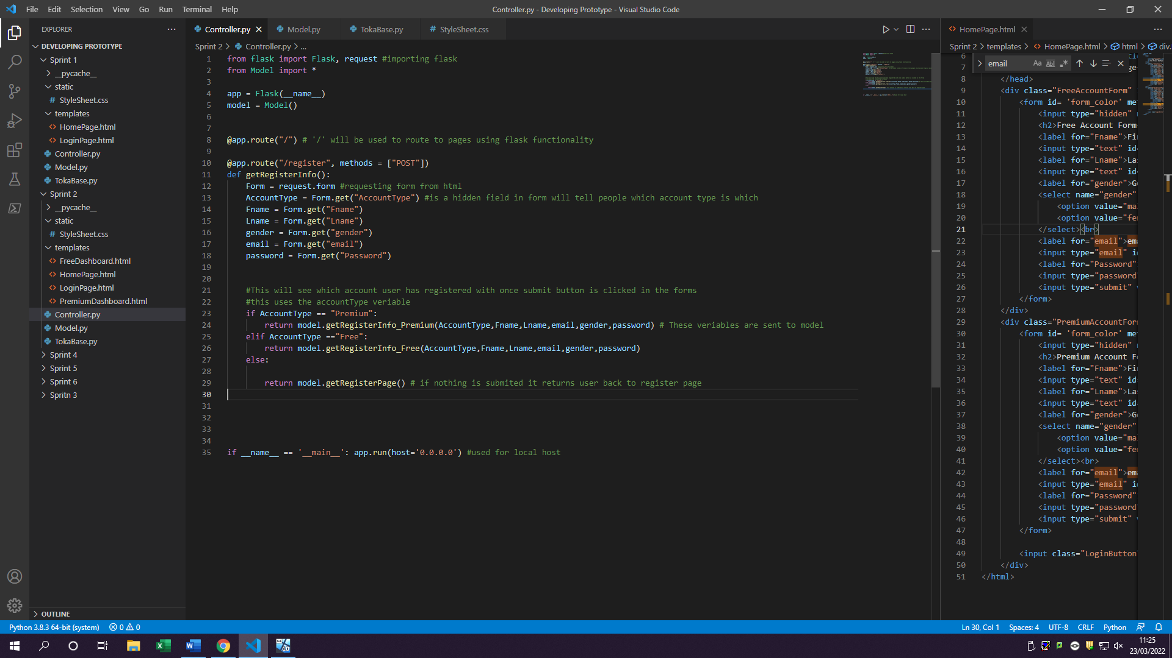1.2

Returning variable to model

Data gathered from forms

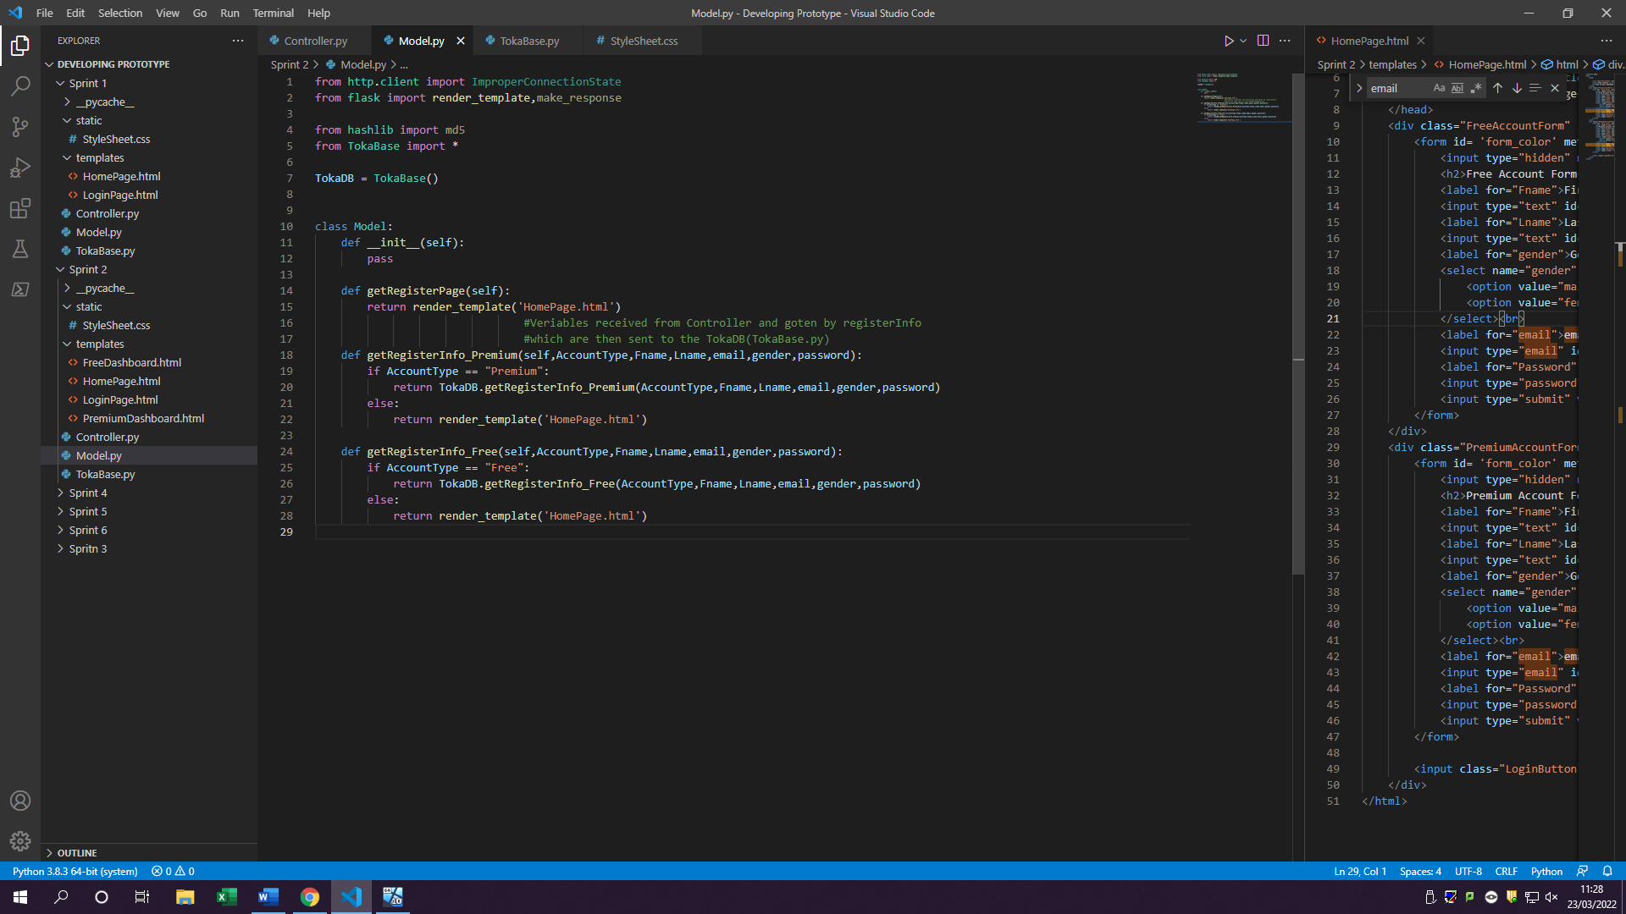

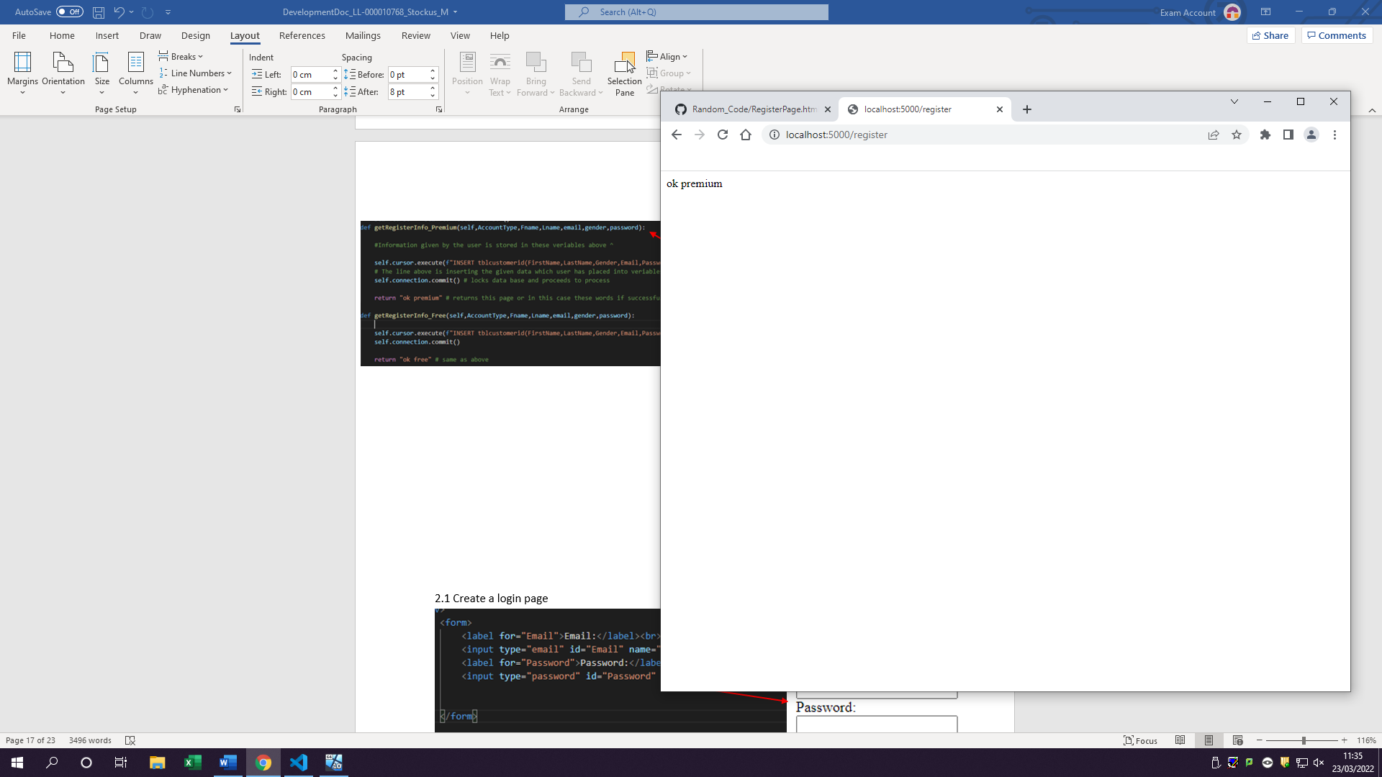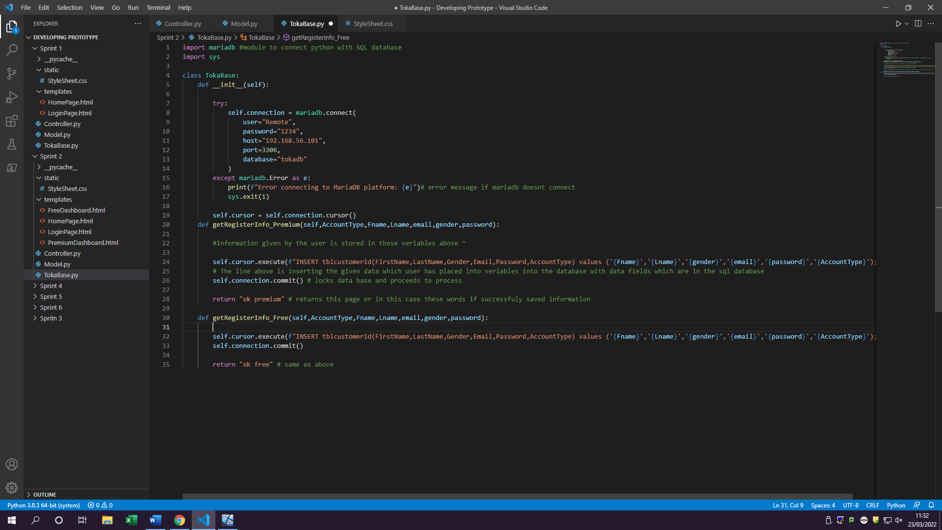

Database receives model variables

This means that user has entered details in the premium form, and they clicked submit therefore leading them to this page. The words ok premium act as information to development to suggest which form, they done

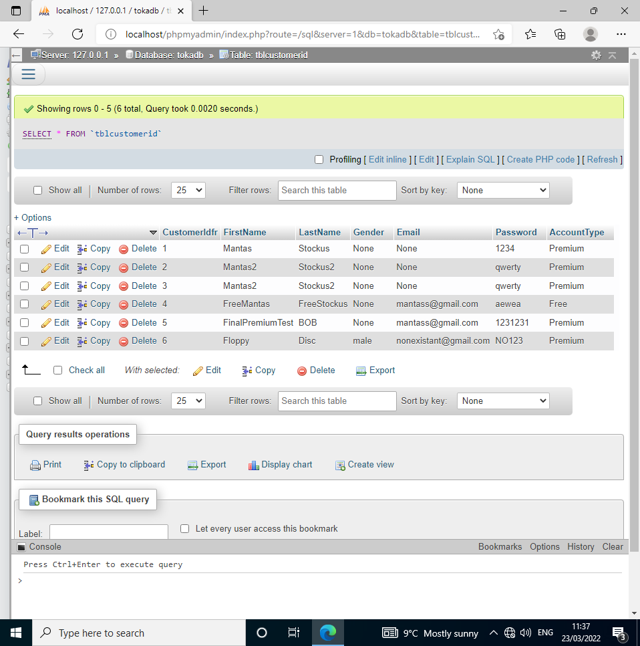

The data from the form has now been stored in database

However is missing 2 fields ( variable names in html are wrongly typed). This has been fixed in test log

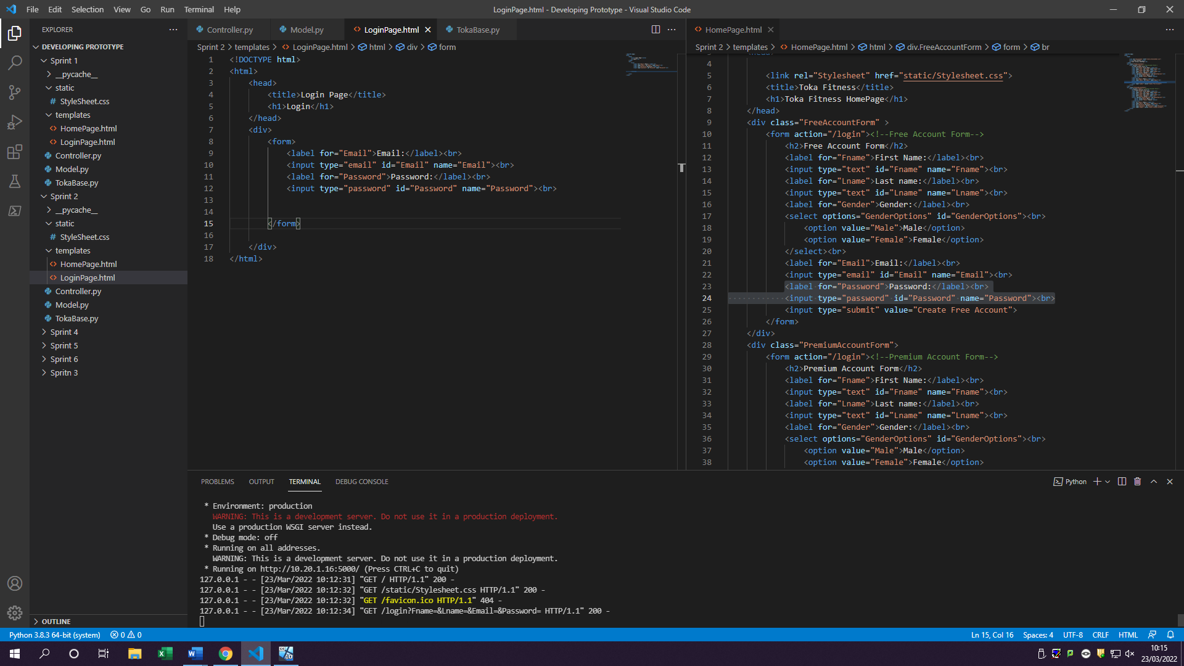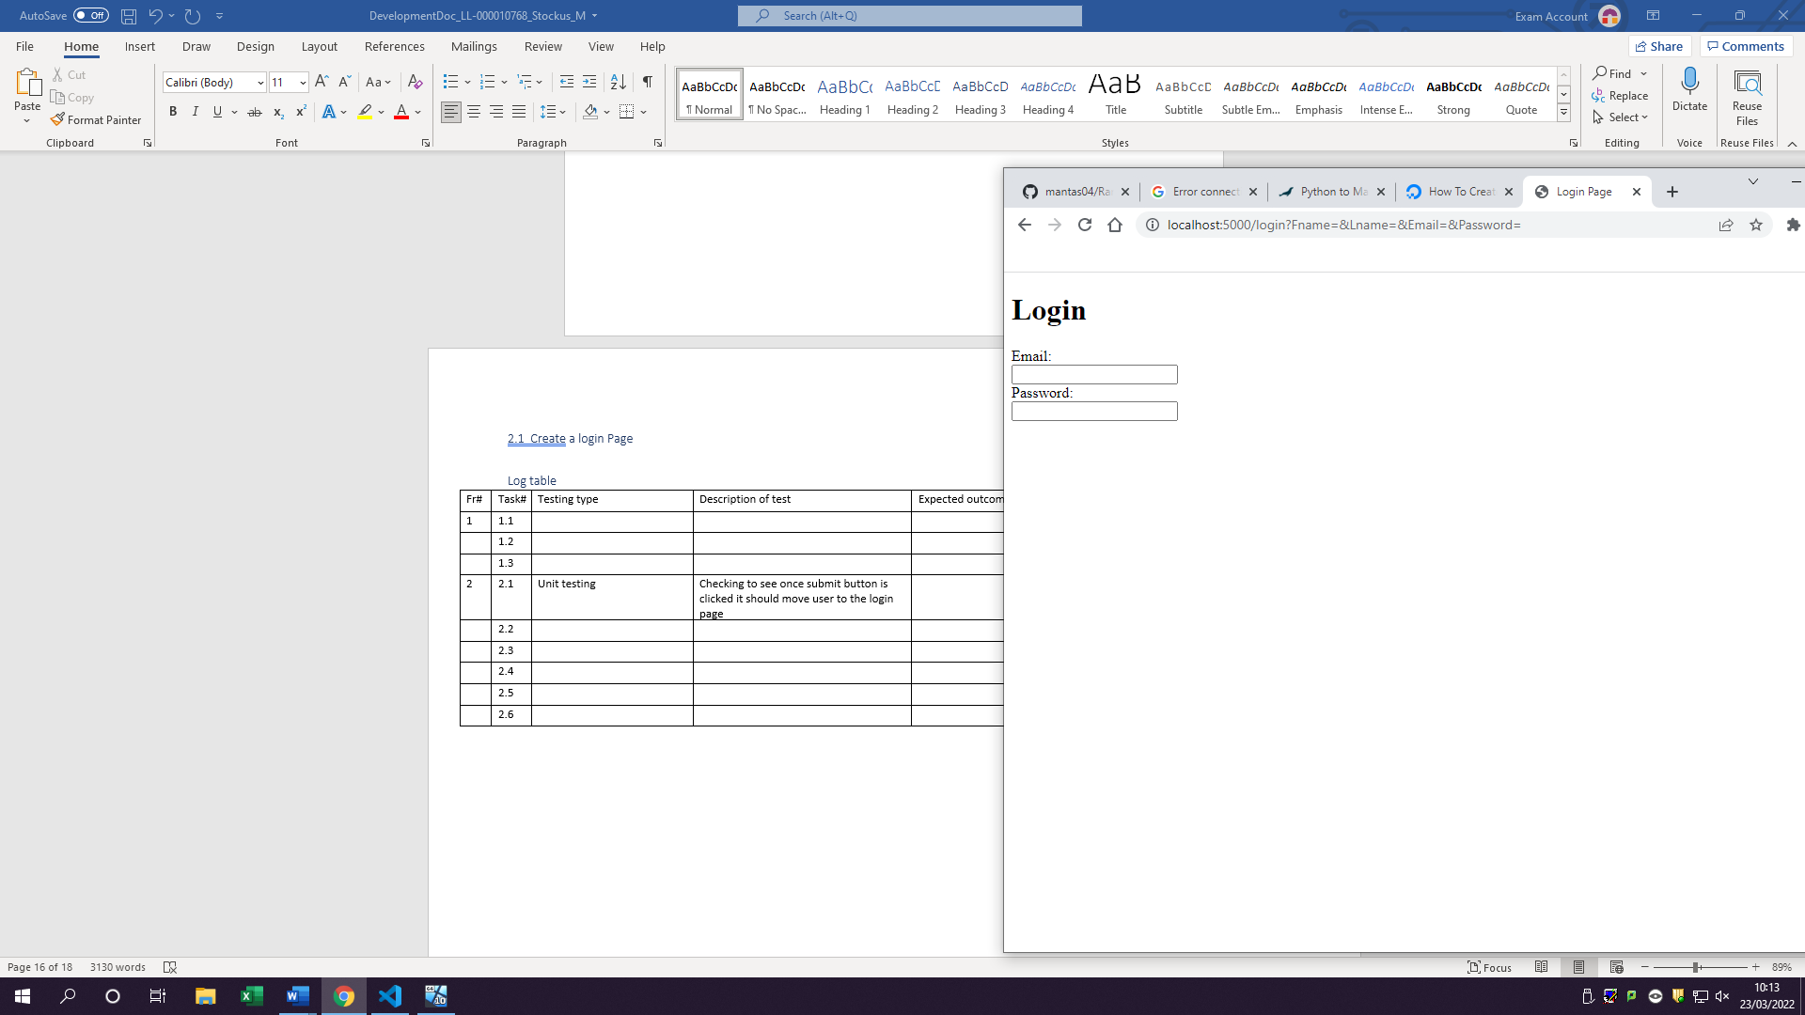2.1 Create a login page

This html is the form behind the login page asking user for email and password as verification to validate them

1.3 In html forms add invisible label which will determine the account type

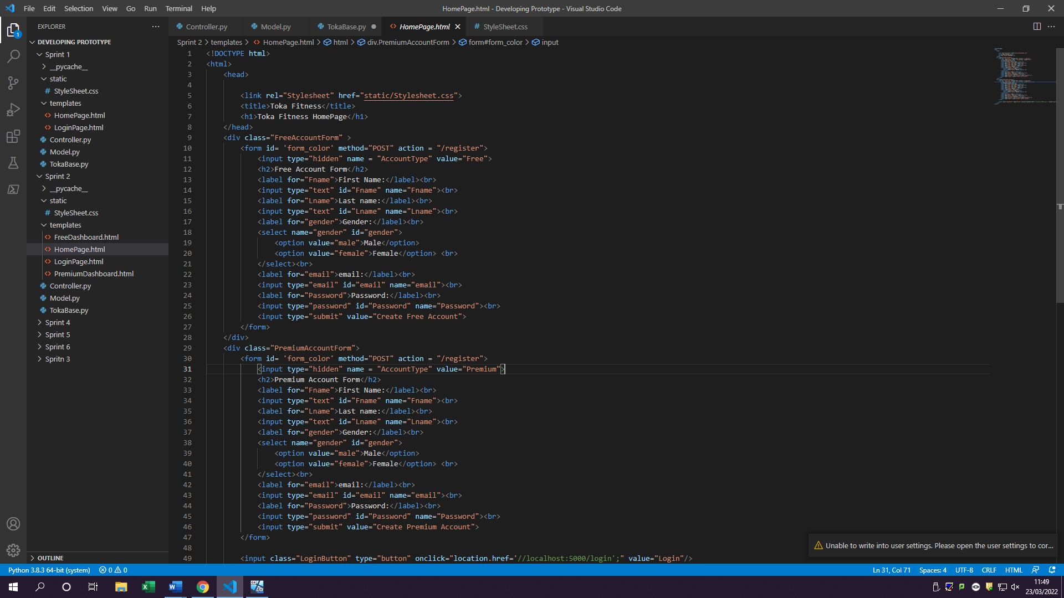

This is a hidden input which the form will be able to receive and store users account preference telling user has made premium account or free account

2.2 Create login button

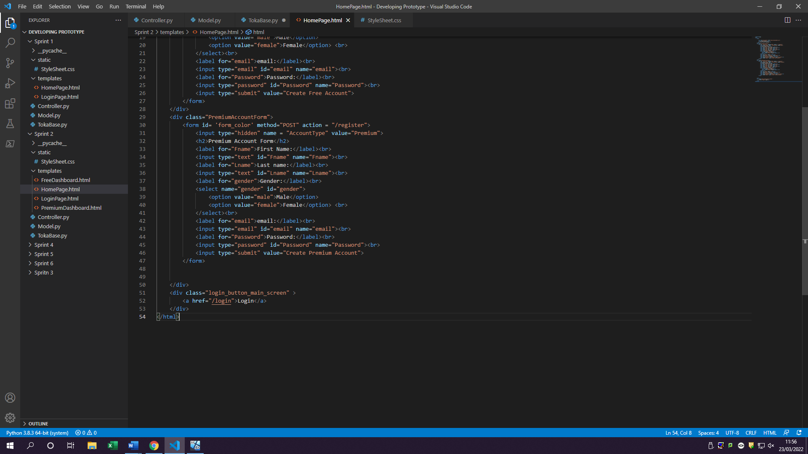

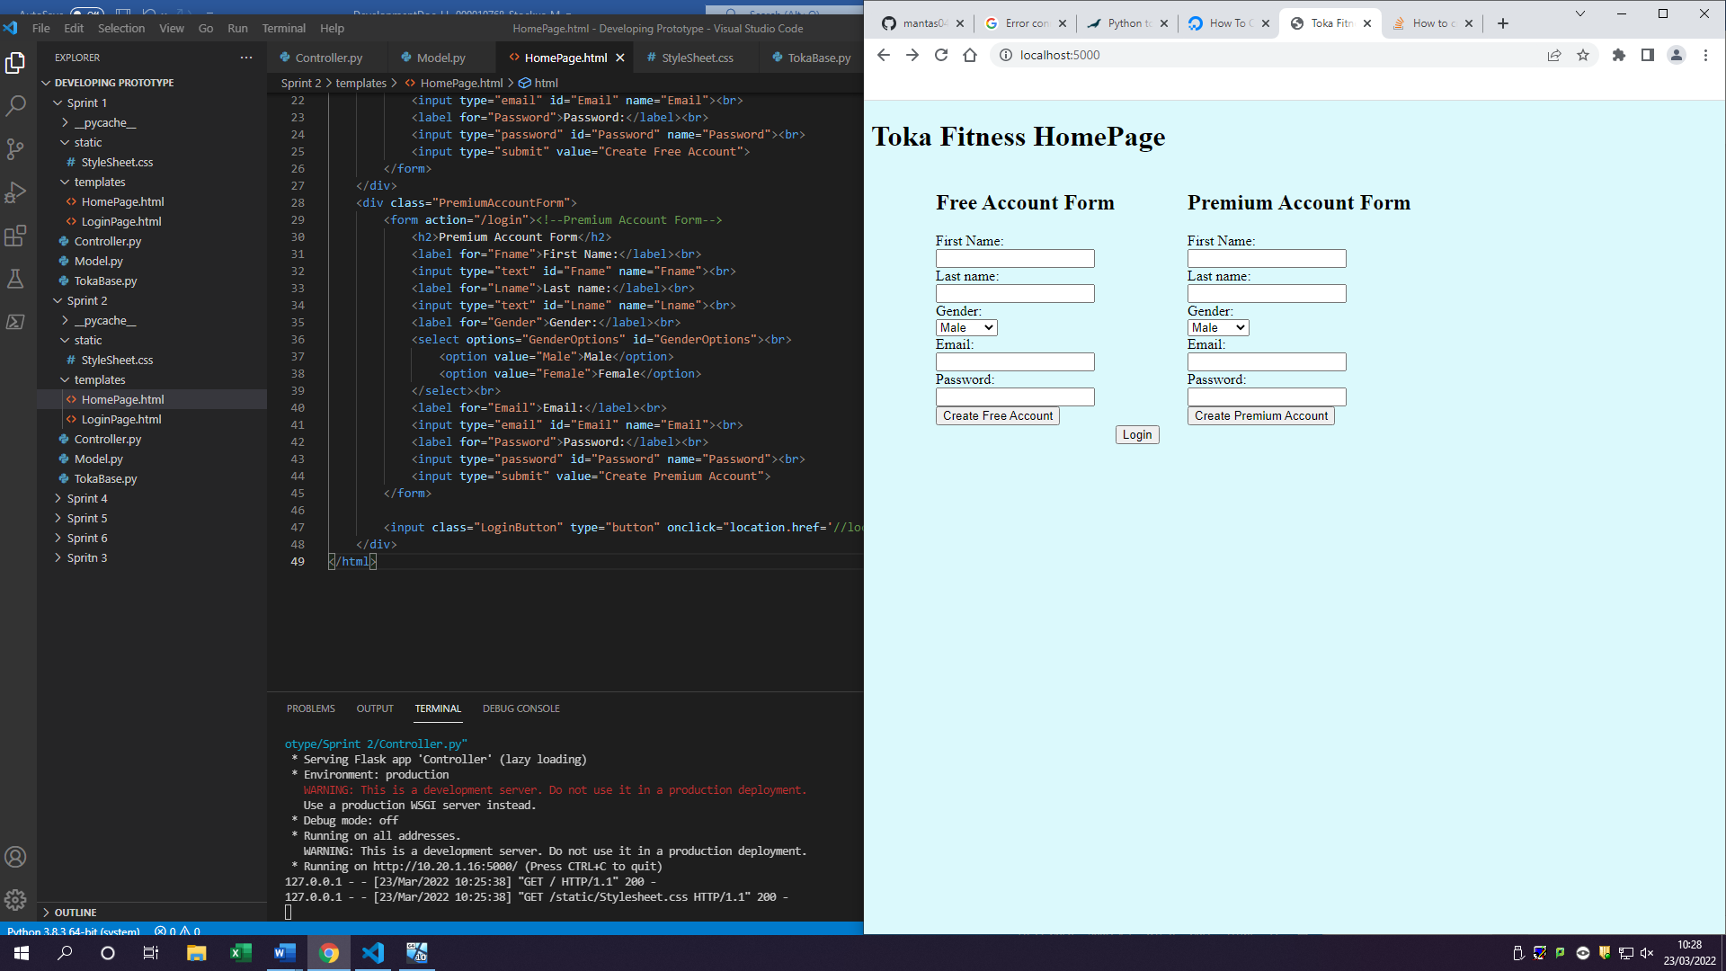

Html code for creating code which goes to login page once clicked on

2.3 Login button sends them to login page

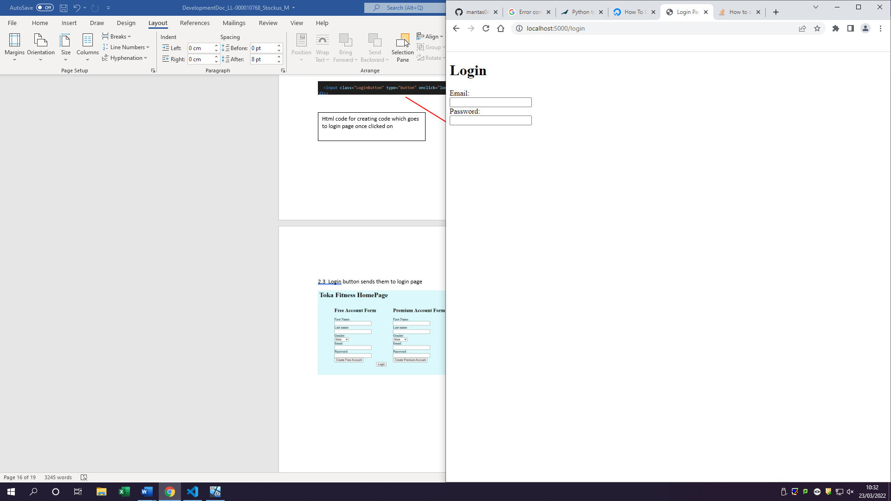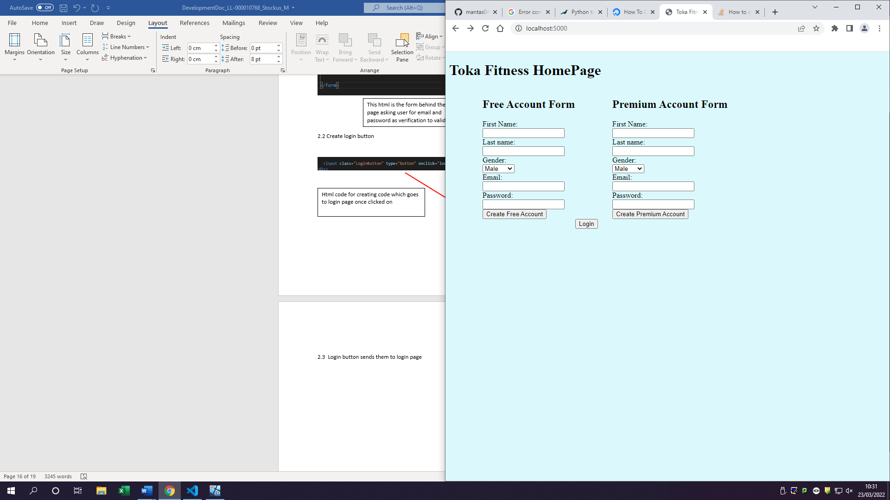

Once click on login user is sent to this page with a form of login

2.5 Create free dashboard

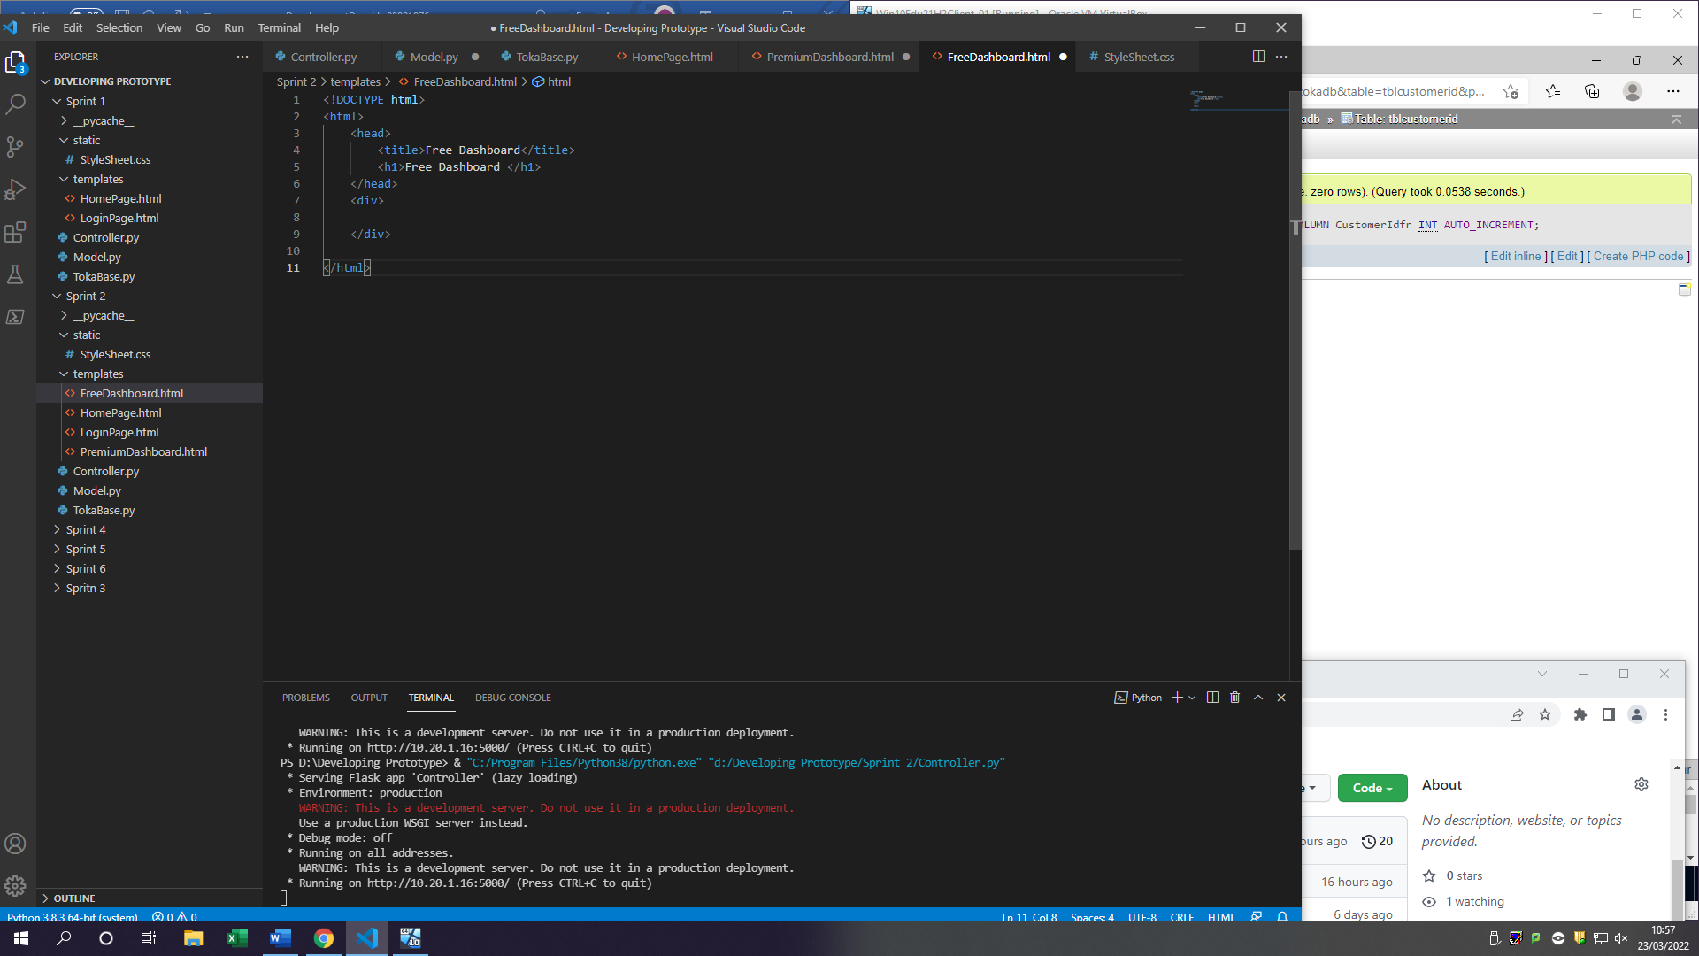

2.6 Create Premium Dashboard

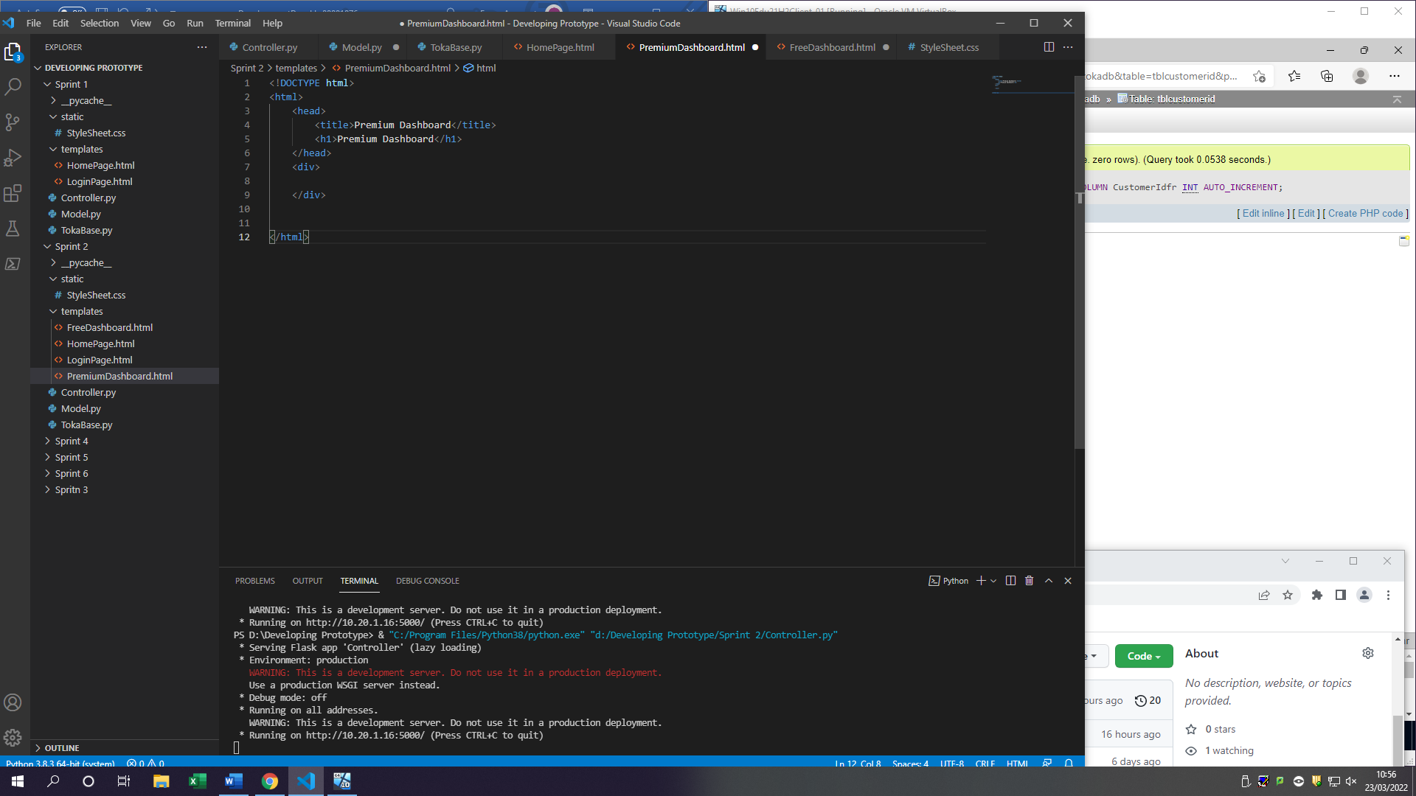

### Log table

|  |  |  |  |  |  |  |
| --- | --- | --- | --- | --- | --- | --- |
| Fr# | Task# | Testing type | Description of test | Expected outcome | Actual outcome | Notes |
| 1 | 1.1 | Unit testing | When there is new data added to customer table it should increase by 1. This will be used to identify which customer is which as it’s a unique one number | Under customeridfr there should be numbers appear starting from 1 once there is a record added | (to be tested) | This will need to be tested in the next task as right now we are not getting any new information from user |
|  | 1.2 | System testing  Integration testing | There should be communication from controller received user inputs from forms submit button pressed. Controller should get form information and store it in variables which then should be sent to model. Model will receive all the information sent from controller and send all data to the database file. The database should insert those variables which contain users’ data into the table in SQL and return a page with a message depending on which form has been completed | Controller receive form details from user  Controller sending details to model  Model receiving details  Model sending data to TokaBase  TokaBase using the variables in inserting the data into the database | Users’ data is now stored in the database. This means all information from forms is getting correctly received and sent across different modules (controller, model, tokabase). This also means that Tokabase is storing user data. | CustomerIDfr is now getting increased by 1 (1.1)  Data can now be stored in the database |
|  | 1.3 | Integration testing | When retrieving forms depending on the form submitted it should store the correct account type (FREE/PREMIUM) this will be used to distinguish if user is a premium user or free user | Controller should get AccountType variable with data inside.  TokaBase should send data to SQL to store it | Controller now receives AccountType  TokaBase saves it in the table | AccountType is hidden field user will not see it |
| 2 | 2.1 | Unit testing  Functional testing | Checking to see once submit button is clicked it should move user to the login page | Once submit form button Is clicked user should be sent to a login page | User is now sent to login page once clicked on submit button |  |
|  | 2.2 | Unit testing | When user clicks on login button, they get sent to login page | User should be able to click on button and be sent across to different page | User is now able to click on login button and get sent to login page |  |
|  | 2.3 | Unit testing  Functional testing | There should be a transition from click on login button to get to login page | Once user clicks on login button, they should be shown a form to fill in | User can click on login button and greeted with a form to fill in |  |
|  | 2.4 | Integrated testing | To test the login system, it will require me to get the information user has entered in login form and check it against existing users. As a result of this I need a cookies table where each user will be uniquely stored to retrieve their information and see if they can access database, they registered for | This cannot be tested or done till sprint 3 | This cannot be tested till sprint 3 therefore needs to be done | SPRINT 3 to make this work |
|  | 2.5 | Unit testing  Accessibility testing | Just the making of the pages themselves | There should be a free dashboard page added to files | There is a Free Dashboard page | (will be tested in sprint 3) |
|  | 2.6 | Unit testing  Accessibility testing | Just the making of the pages themselves | There should be a premium dashboard page added to files | There is a Premium Dashboard page | (will be tested in sprint 3) |

### Review

Sprint 2 was all about getting the data from the user and storing it in the database (TokaBase) from the forms filled in. As a result of this all my work was based of getting the inputs from the user and saving them in a database which was successfully achieved meaning that my goal for sprint 2 is done.

During sprint 2 I have come across a brick wall which used a lot of my time to figure out what is wrong. When I was creating a user account for the database, I was entering host name of: “192.168.56.101” in the MySQL statement which when if you run on python would give out an error saying: “Error connecting to MariaDB platform: Host 'CC-DT005-03-WCA' is not allowed to connect to”. This stumbled me as I believed I have entered all the correct details needed for the user to be able to have access to the database from python. This made me think that the host in my python file was the wrong address therefore making me change between localhost and the original address. However, the error was not in the python file it was instead in the MySQL statement where I created the user in. To get by this problem I re-created the user but this time giving it a hostname of ‘%’ which means any host can access my database. As a result of changing the hostname I have manged to create a user which has now got access to the database making my first task complete and giving me ability to complete the others

When I was inserting data into the database, I once again came across another problem of 2 data fields not getting filled in my database. The error was in html code as I have miss spelled the variables which collect the user’s information in the html code which meant that the controller who was reading them was not getting any data back and instead was just sending it blank to model and eventually tokabase sending it to the database. This however was fixed by spelling the variables correctly which meant the data is getting picked up by the controller and sending it to the other modules with variables containing the data

There is now a black log of one task to be completed in sprint 3 which is 2.4 which requires me to create a cookietbl to distinguish which account is which for the login. Cookies is a text files with small pieces of data in this case it would be email and password that will be used to identify the user who is login to the dashboard. As of right now I don’t have any cookies created meaning that login process/authenticating users’ task was unable to be completed making it go to Sprint 3 at the very top

All together I believe sprint 2 was successful as I managed to create most of the functionality which were my goals set at the start. Sadly, one of the tasks will need to be backlogged and placed in sprint 3 meaning that there will be extra work to be done in that sprint with extra time.

## Sprint 3

Sprint 3 will be based of creating a cookies table and a function to login/authenticate users to determine which dashboard they are getting sent to. This also includes the task from previous Sprint 2 to be completed 2.4 for login the user in and displaying the correct dashboard for the account

### Goals/Requirements

|  |  |  |
| --- | --- | --- |
| Goal Set | FR# | Requirements |
| As a user I want to be able to log in to the dashboard I register for (SPRINT 2) | (2 backlogged  Sprint 3) | Create cookies table and allows users to use login form which would authenticate them and send them to the specific dashboard |
| As a user I want to be able to be sent to the correct dashboard | 1 | Using cookies log the user in depending on the account type they have |
| As a user I want to see all the options I have in the dashboard | 2 | Have features on dashboard which are able to be seen by the user |

### Triage/Tasks

|  |  |  |  |
| --- | --- | --- | --- |
| FR# | Task # | Functional requirement | Expected outcomes |
| (2 Backlogged) | 2.4 | Verifying users’ information to see if it exists in database | When user fills in the login form it should check their information against existing register people info and if its on there allow them to process if it isn’t kept them on login page |
| 1 | 1.1 | Login the user in | If user details match the one’s in database check to see the account type and depending on account type send them to the specific dashboard page |
| 1.2 | If user doesn’t exist | If user doesn’t exist in the database for registering, they should not be able to get into any dashboard and instead stay on the login page |
| 2 | 2.1 | Displaying users name in the dashboard | Once user logs in they should get their name displayed on the dashboard |
| 2.2 | Show password/hide password | User has ability to see there password and hide it if they choose to. |
| 2.3 | Creating blocks/buttons which users can press to go to the functional pages | Create buttons that once pressed go to the page by the functional requirement |

2.4(bl) Verifying users’ information to see if it exists in database

1.1 is included in this task (Login the user in)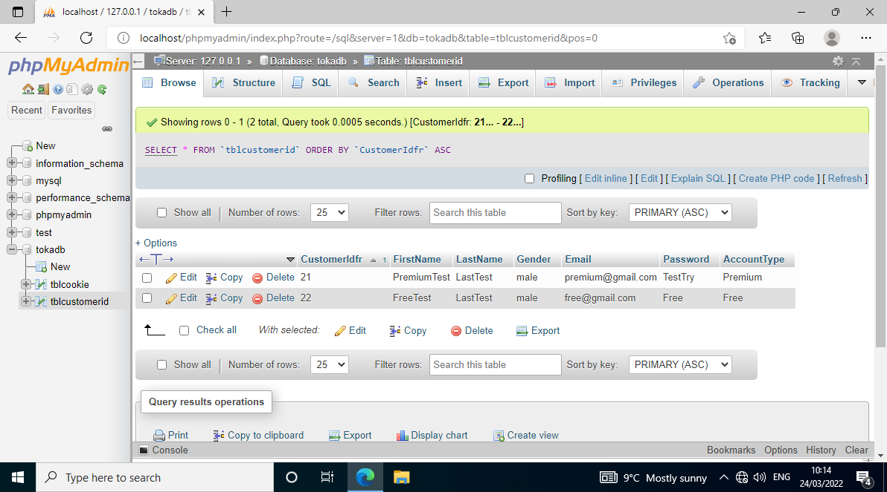

Users’ credentials are entered from the database into the login form

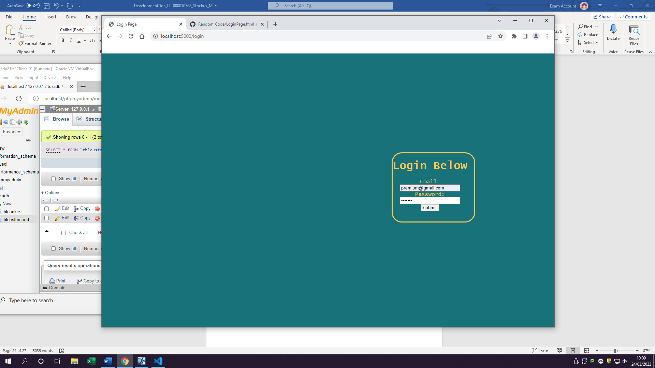

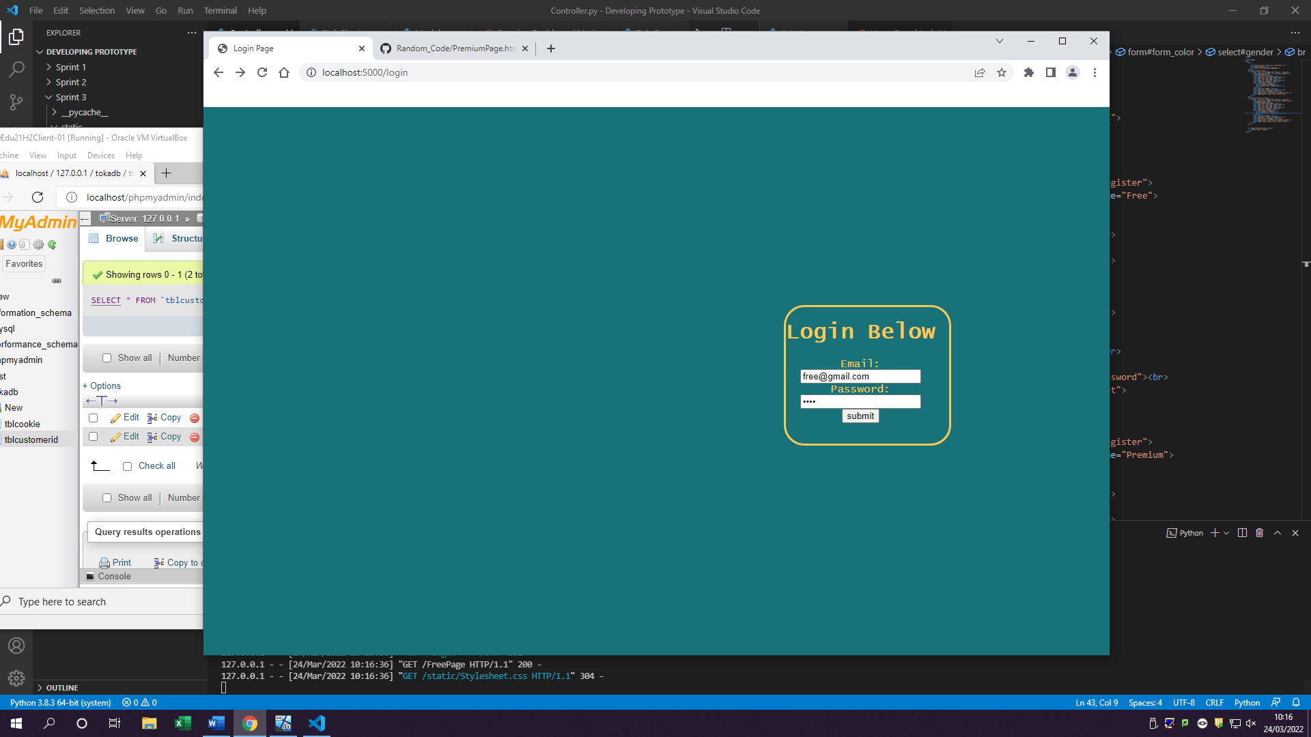

Once the user clicks submit their details get authenticated and sent to the dashboard they registered for

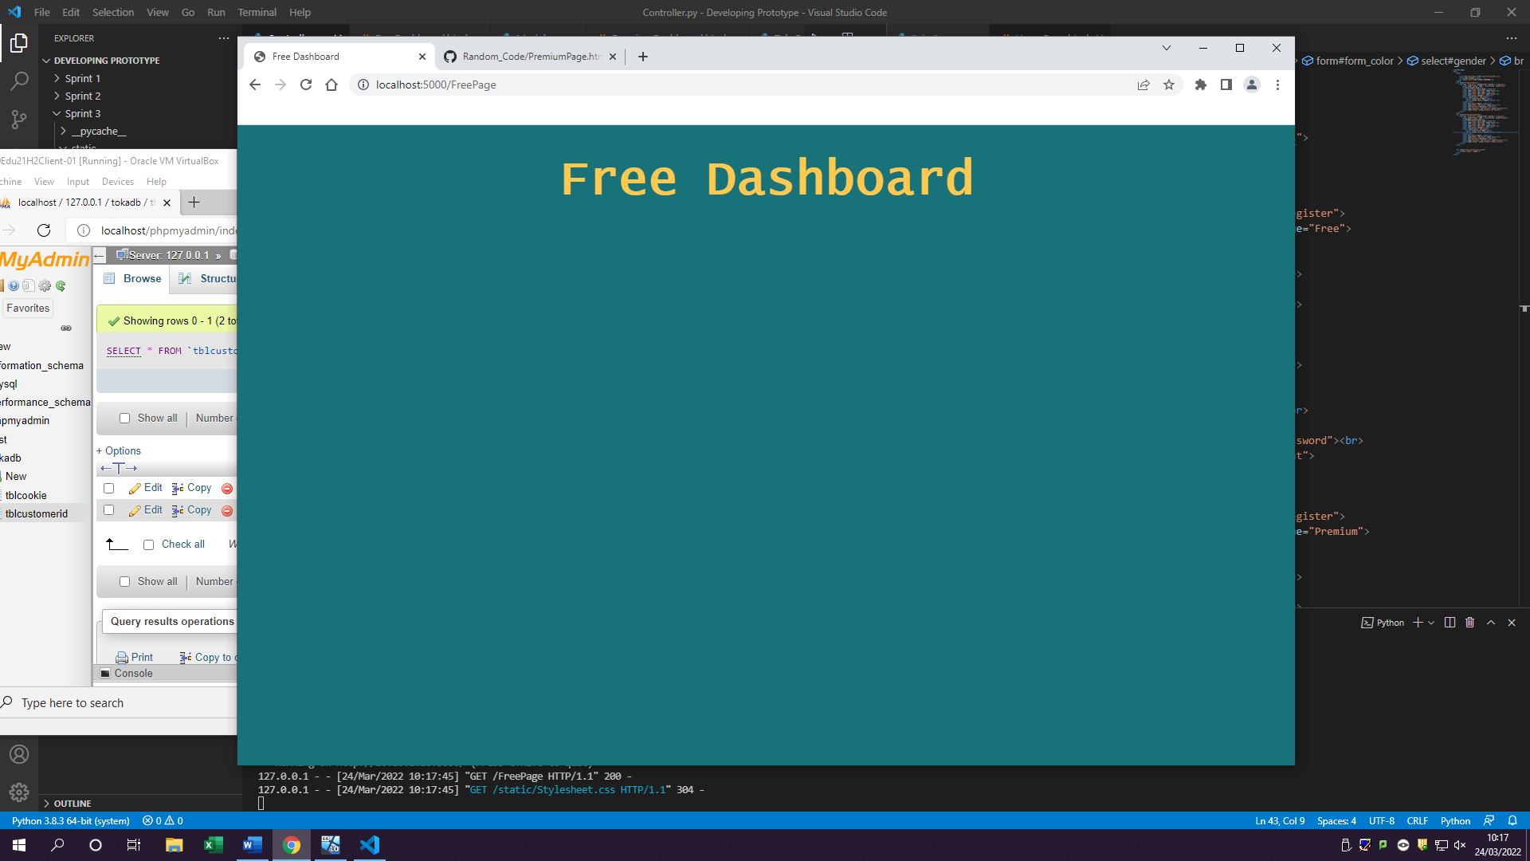

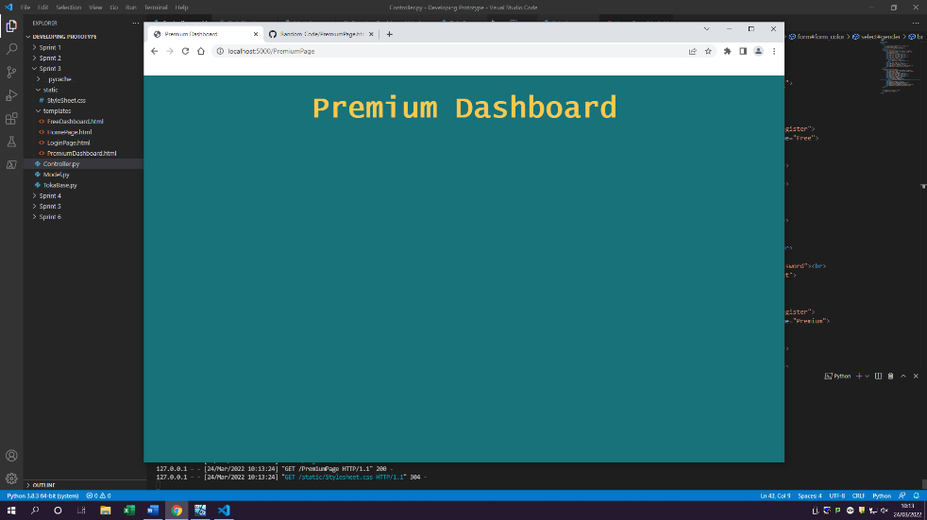

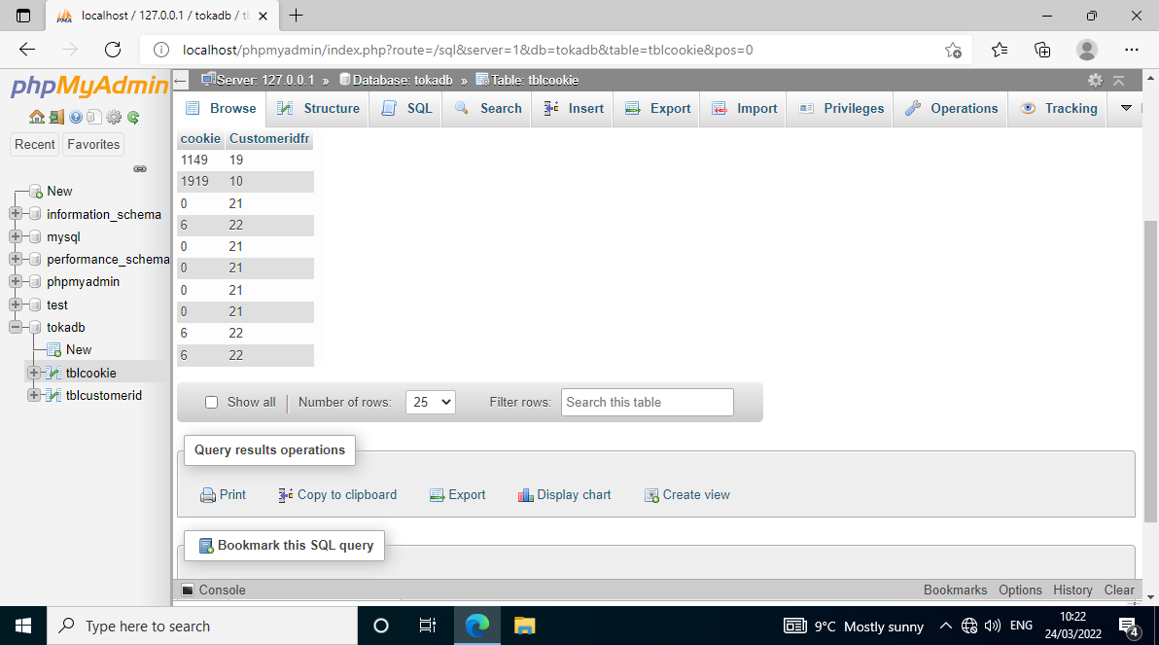

Table cookies has also been created this means once user has logged in with their account, they get a cookie set which will help me identify who is who



Code for inserting users’ information into the table and each column

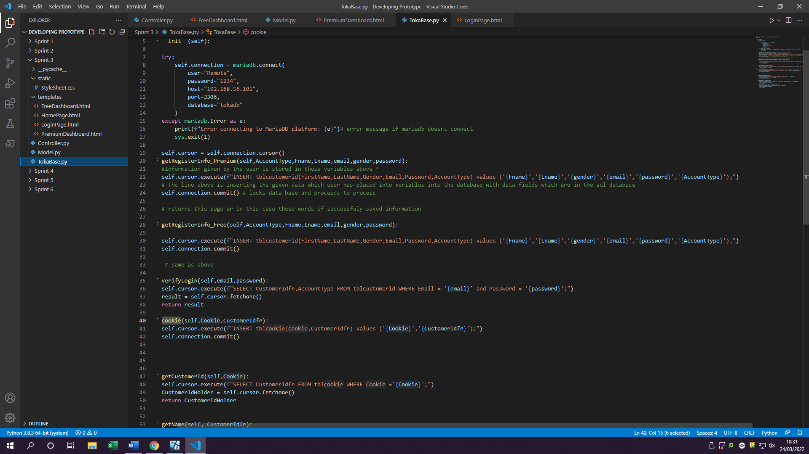



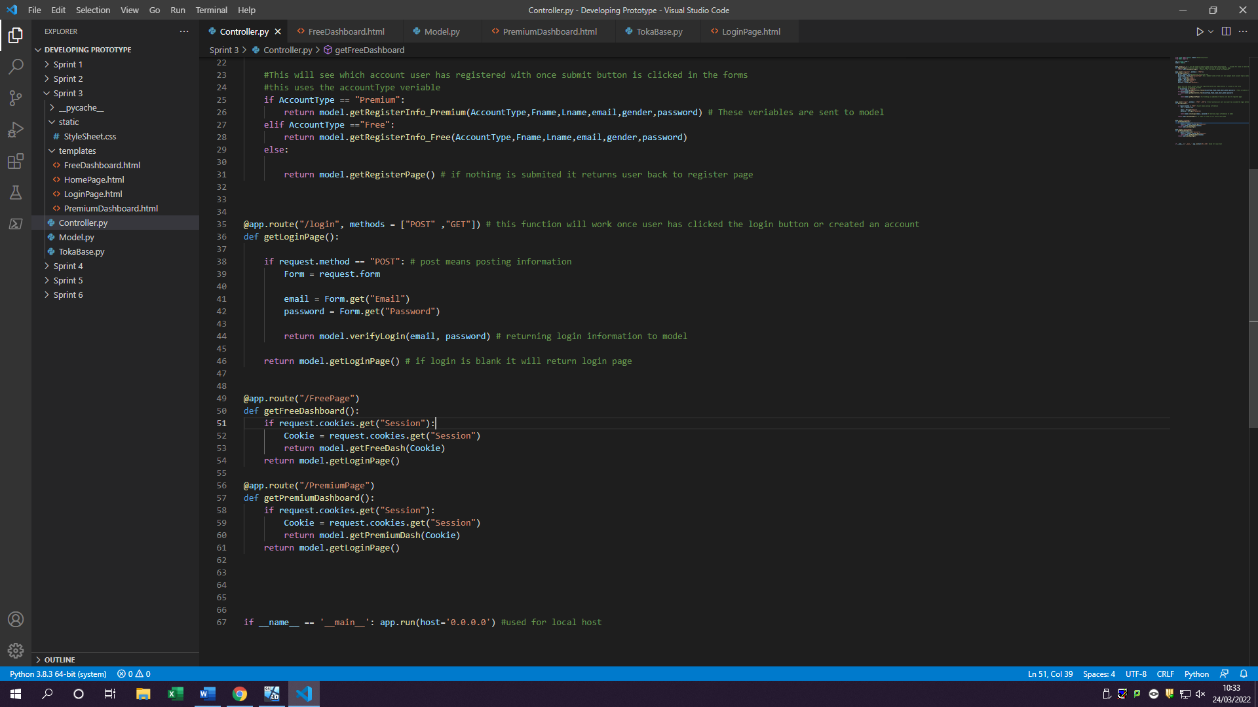

Code for retrieving the form with the fields which contain data.

Variable retrieved by model

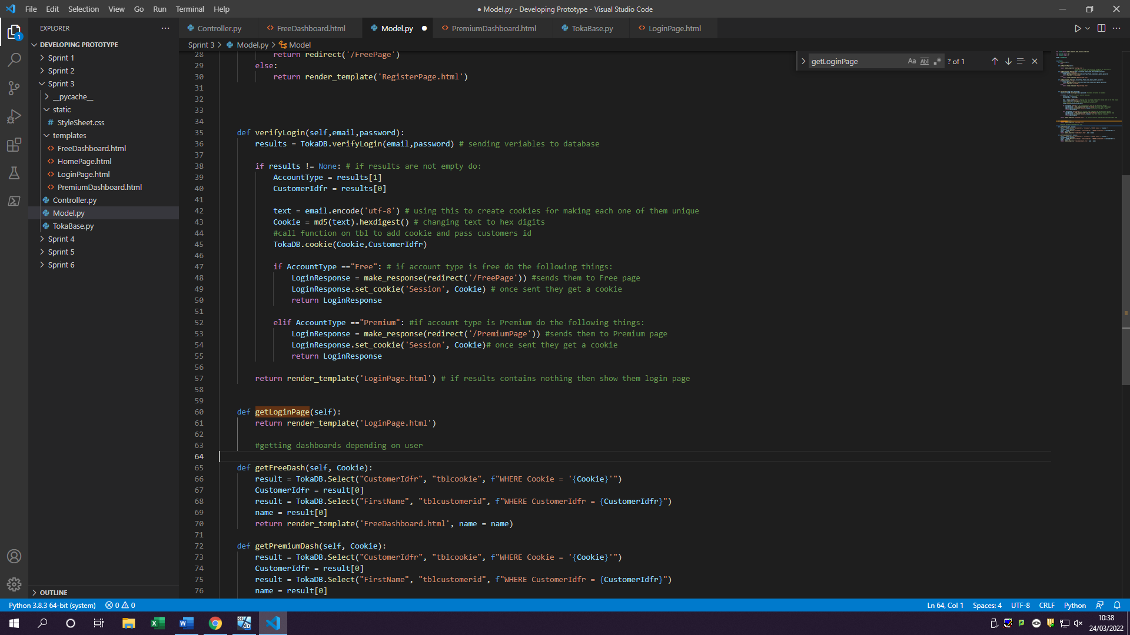

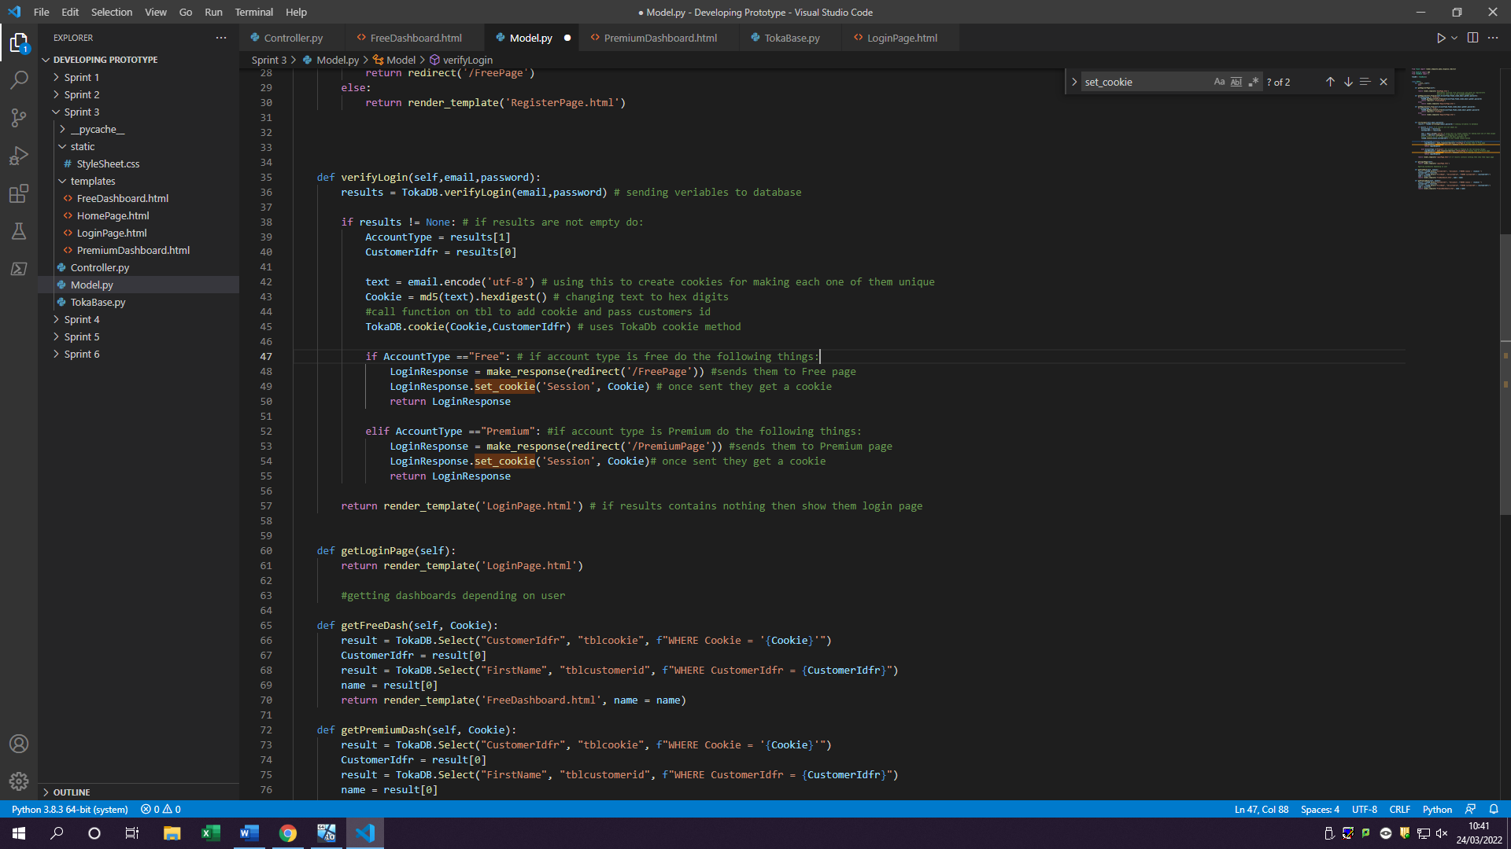

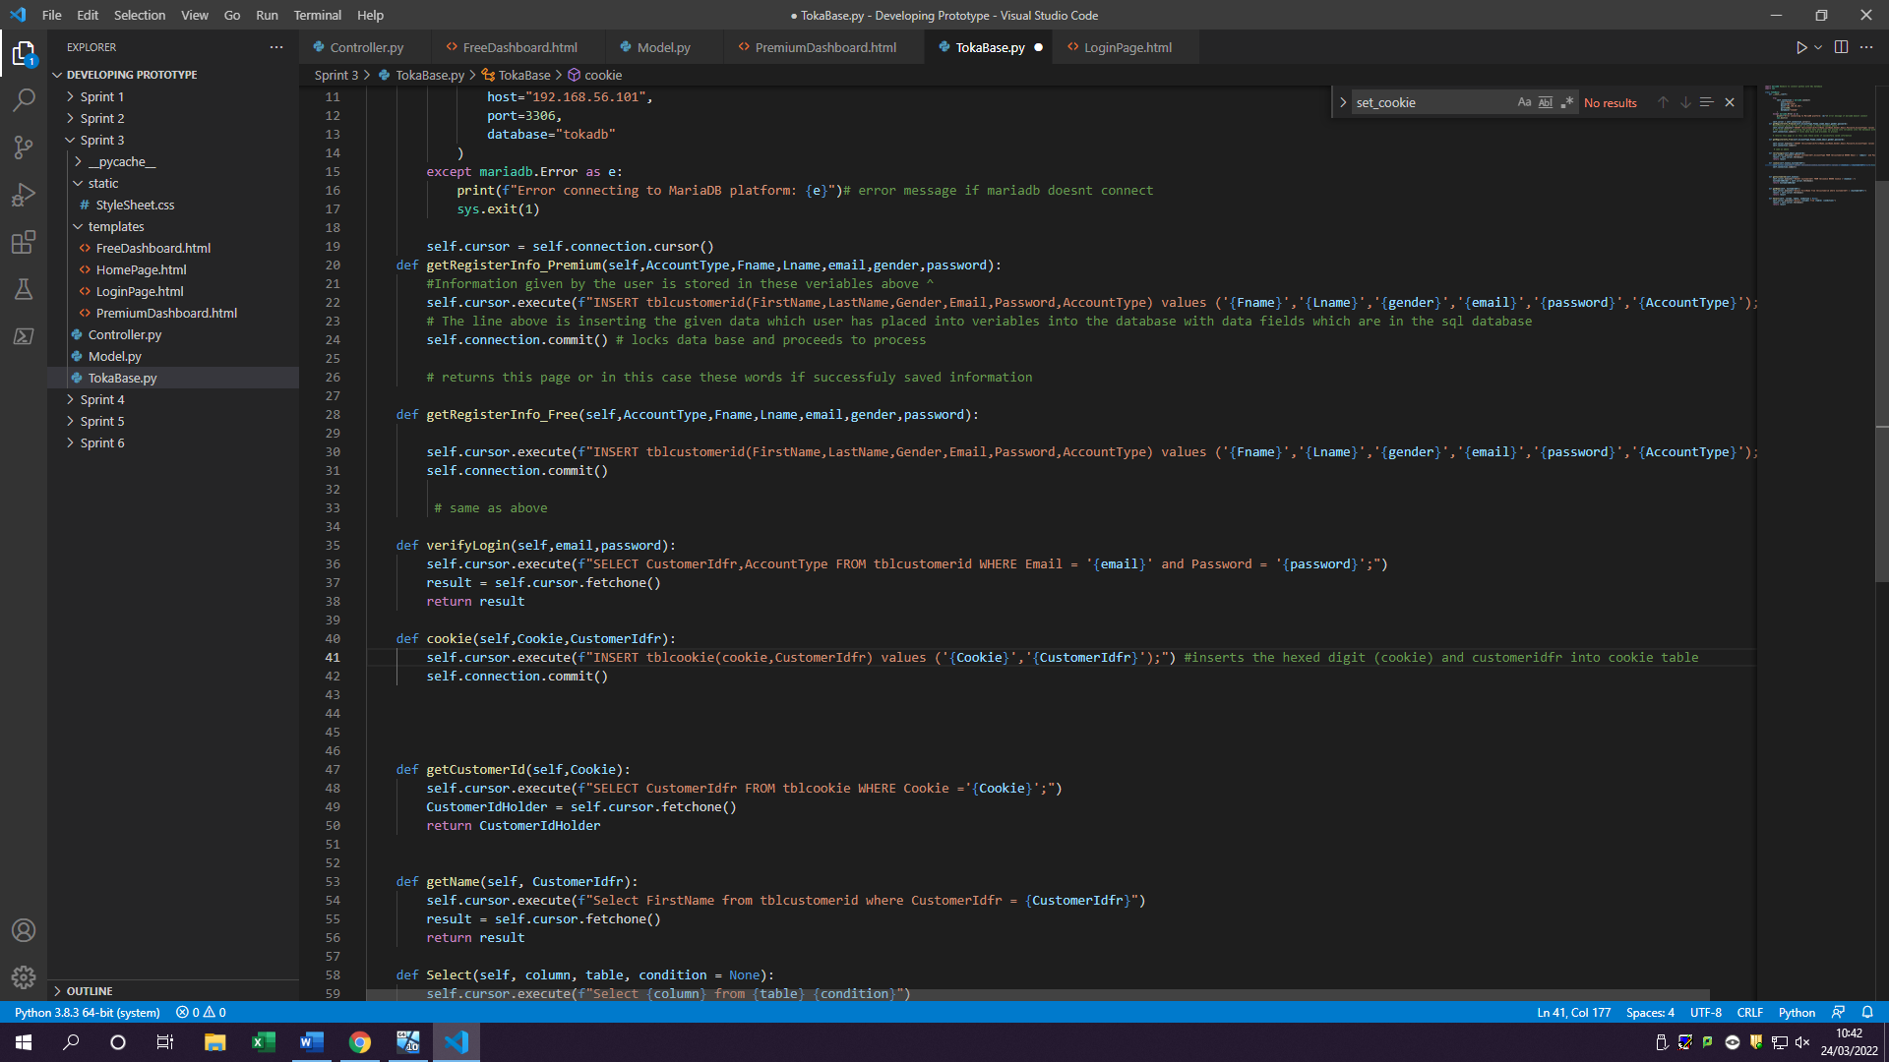

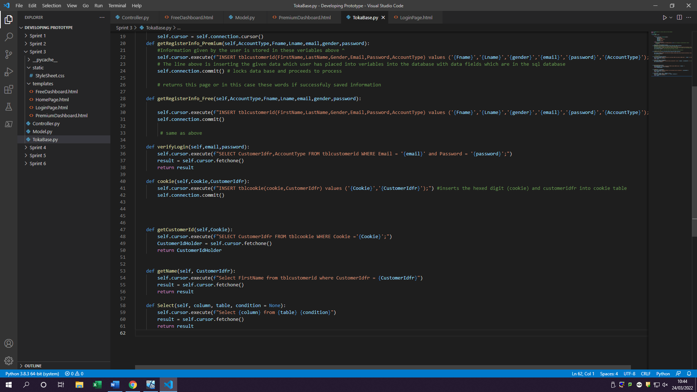

Selecting customer id from cookies table

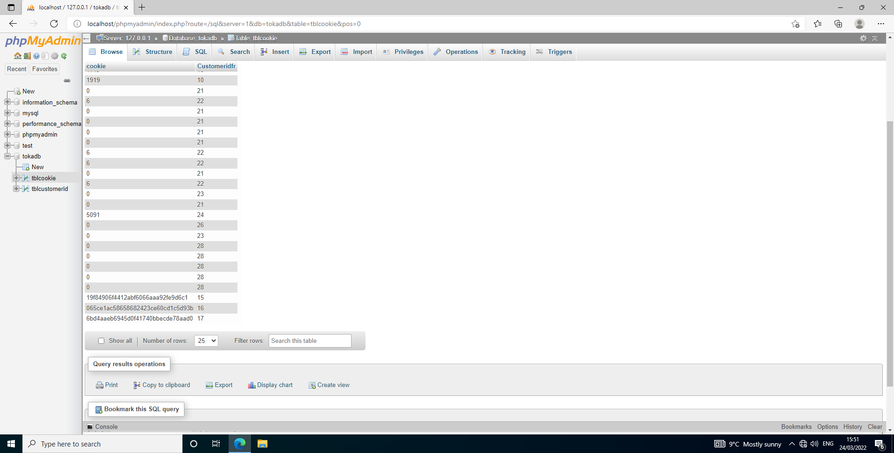

Checking cookies to see which account is signed up or which dashboard

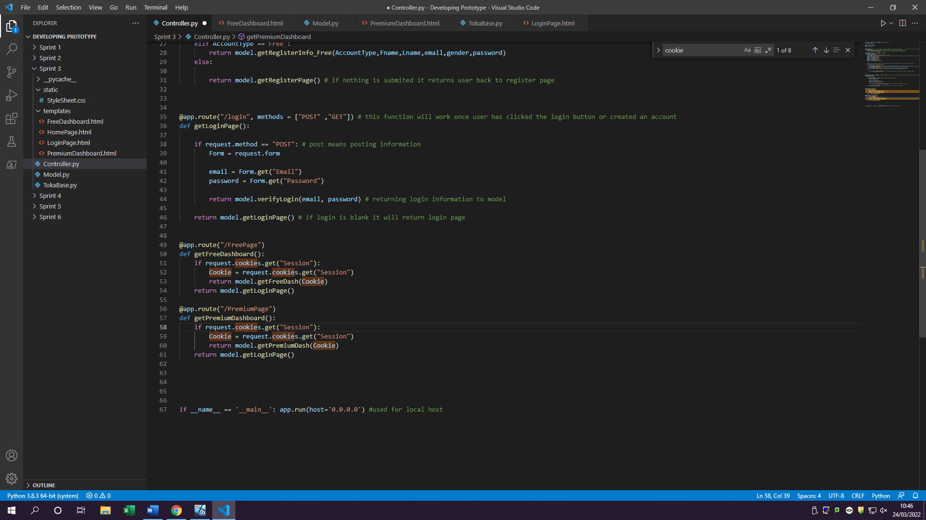

Returns variable to model if cookie matches any of the details to show user the page

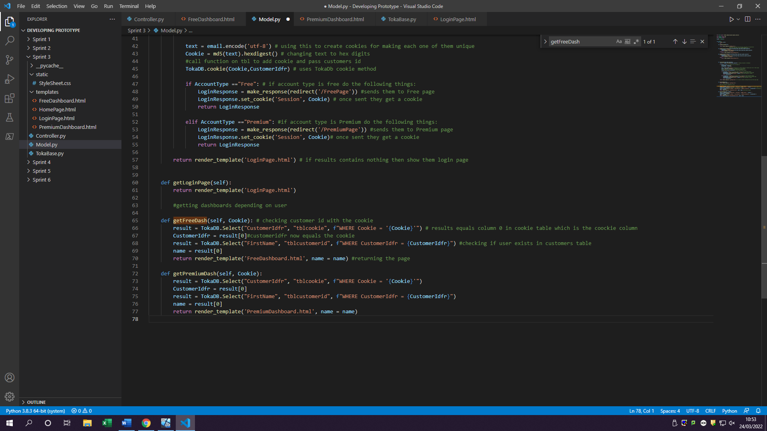

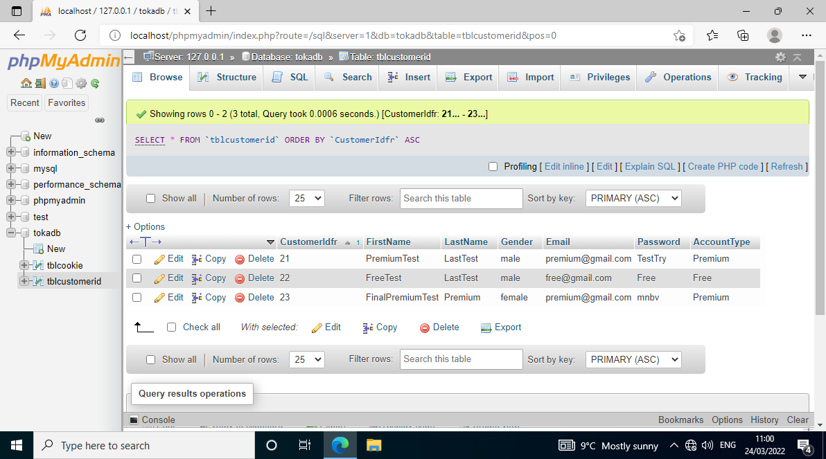1.2 If user doesn’t exist

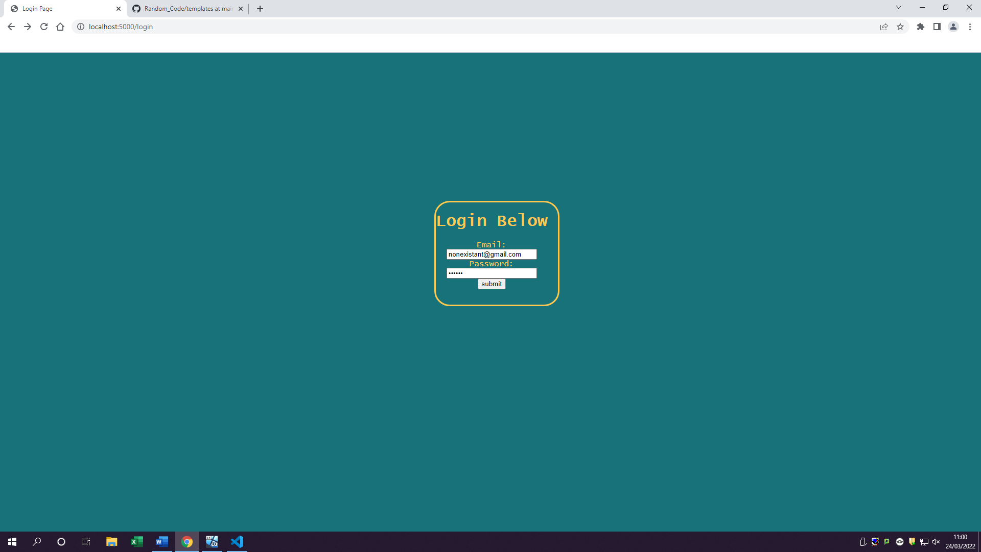

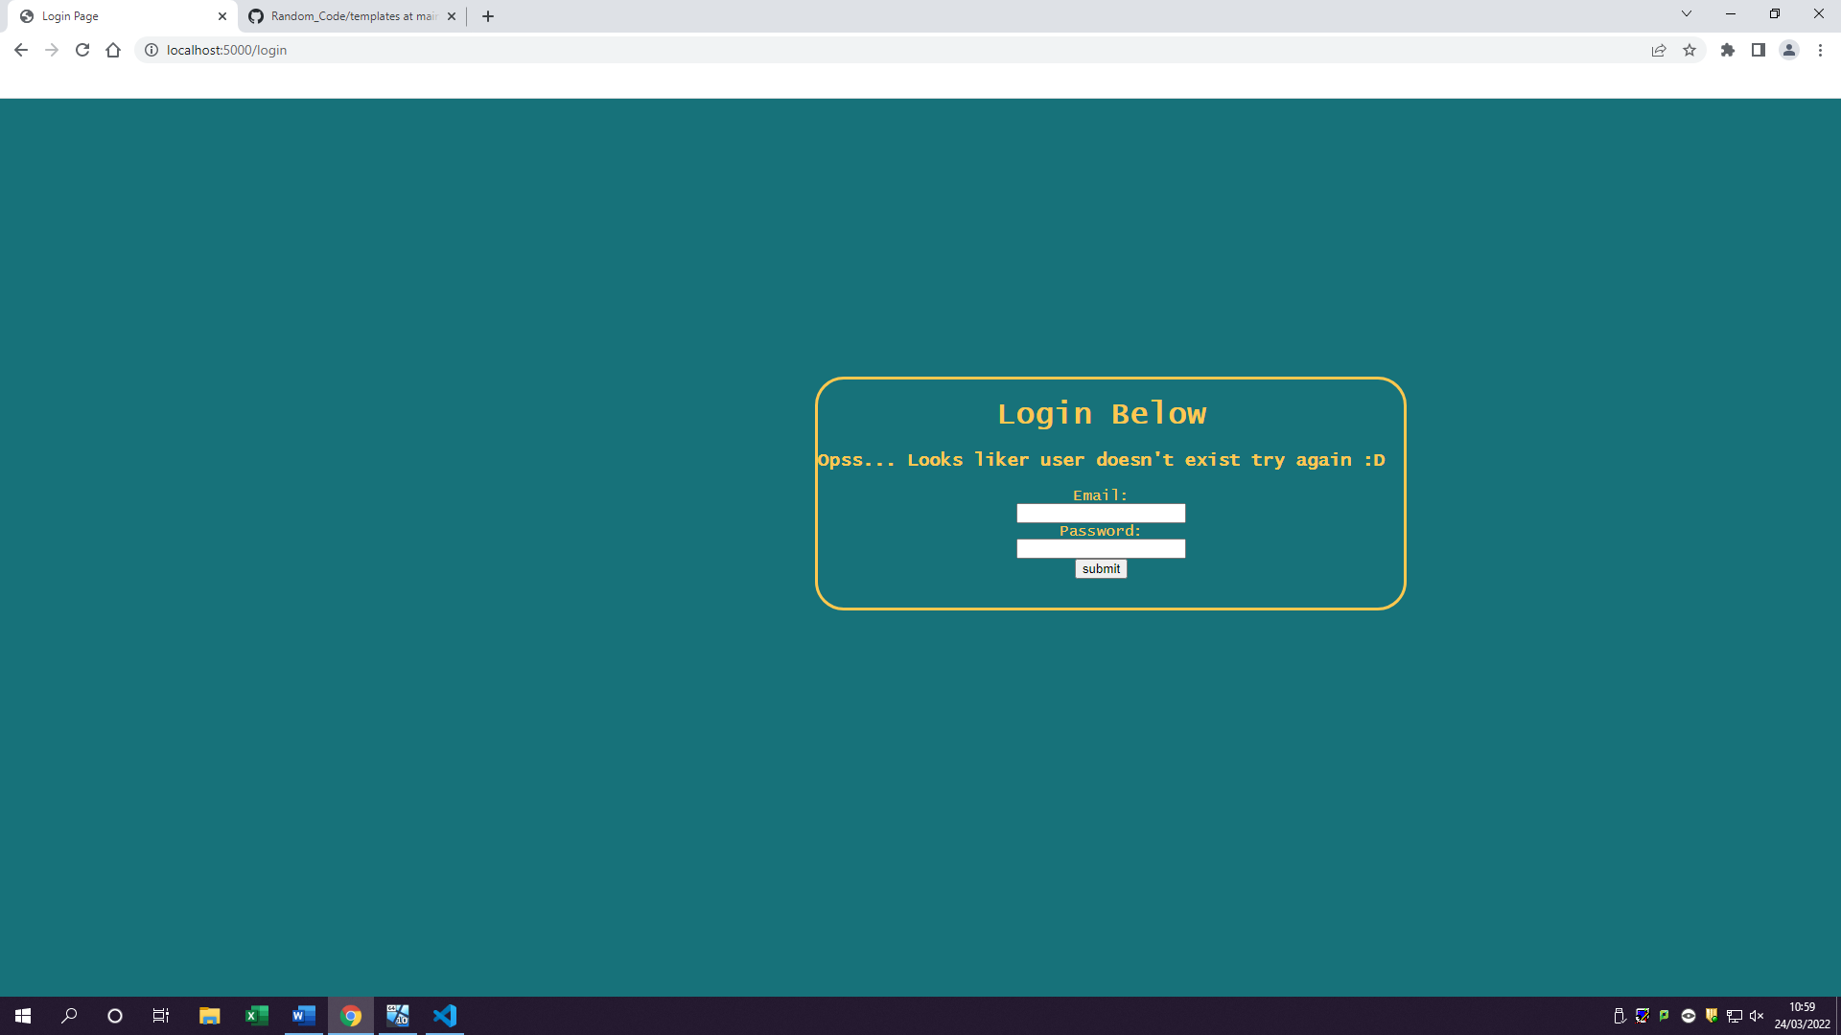

No email ‘nonexistant@gmail.com’ exists in the database therefore should not be found

User has not been found therefore giving them another page user does not exist

2.1 Displaying users name in the dashboard

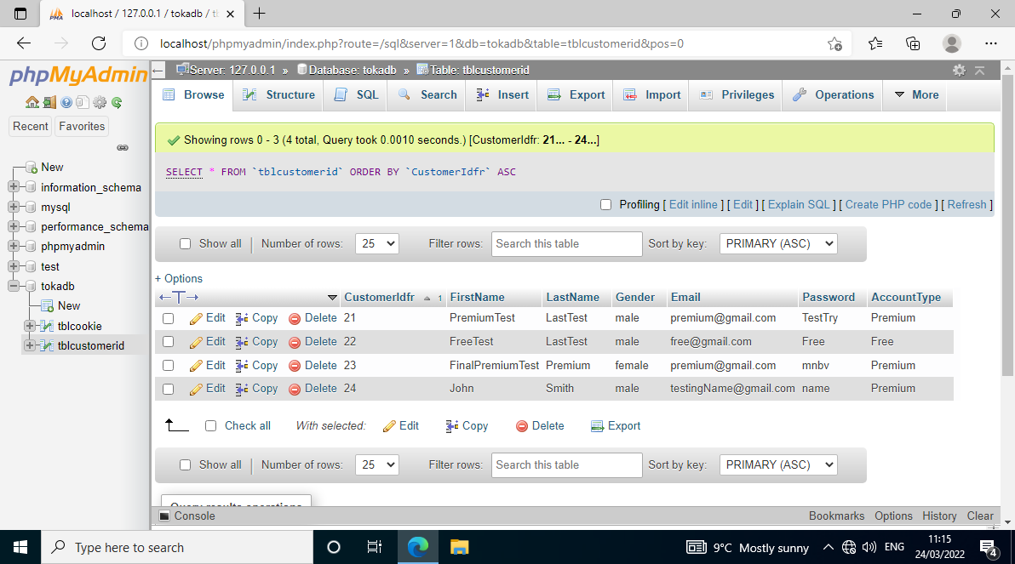

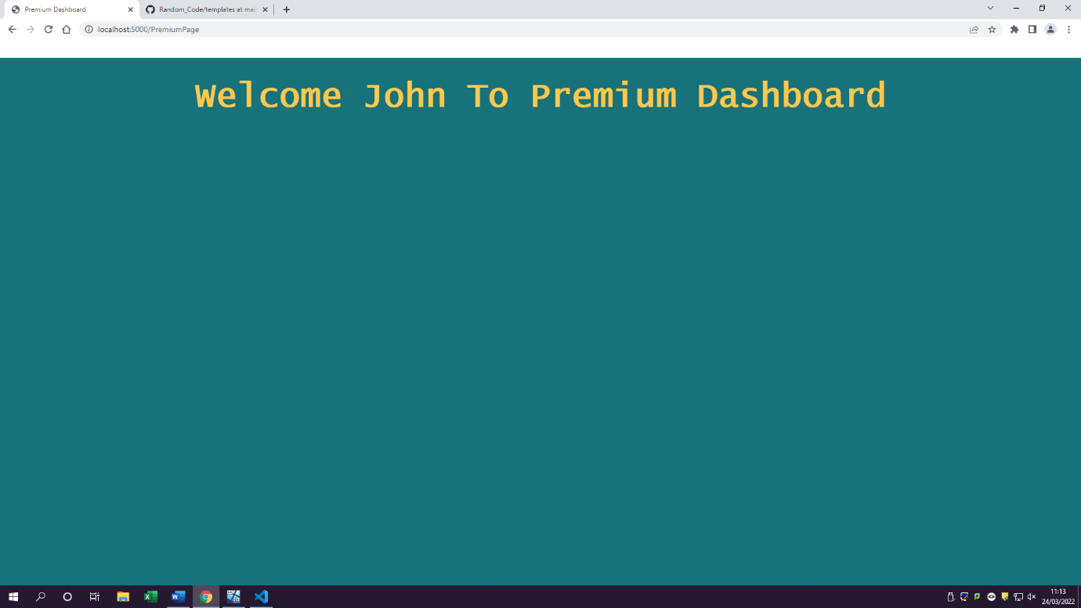

Users FirstName is now getting shown on their dashboard once they log in

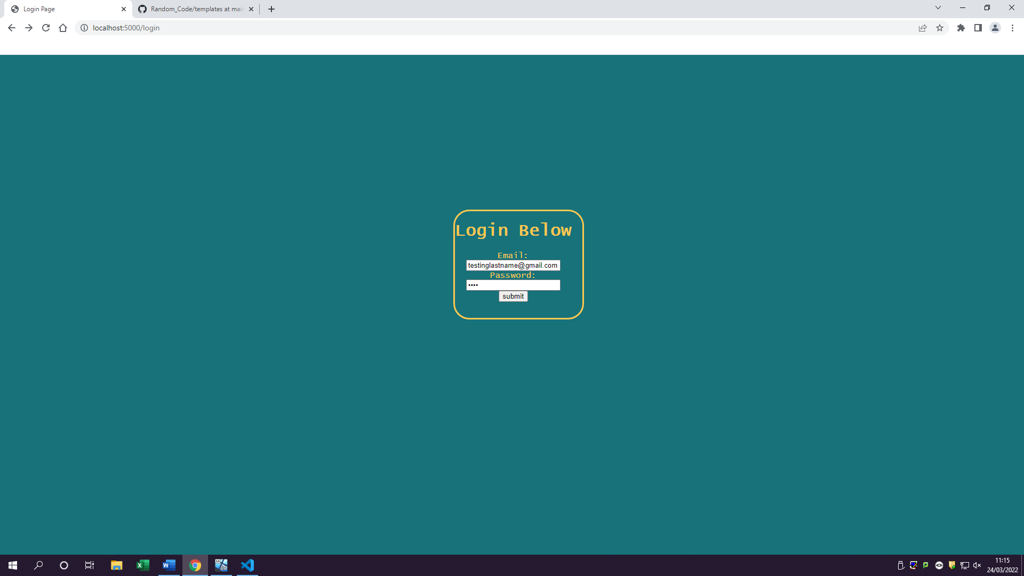

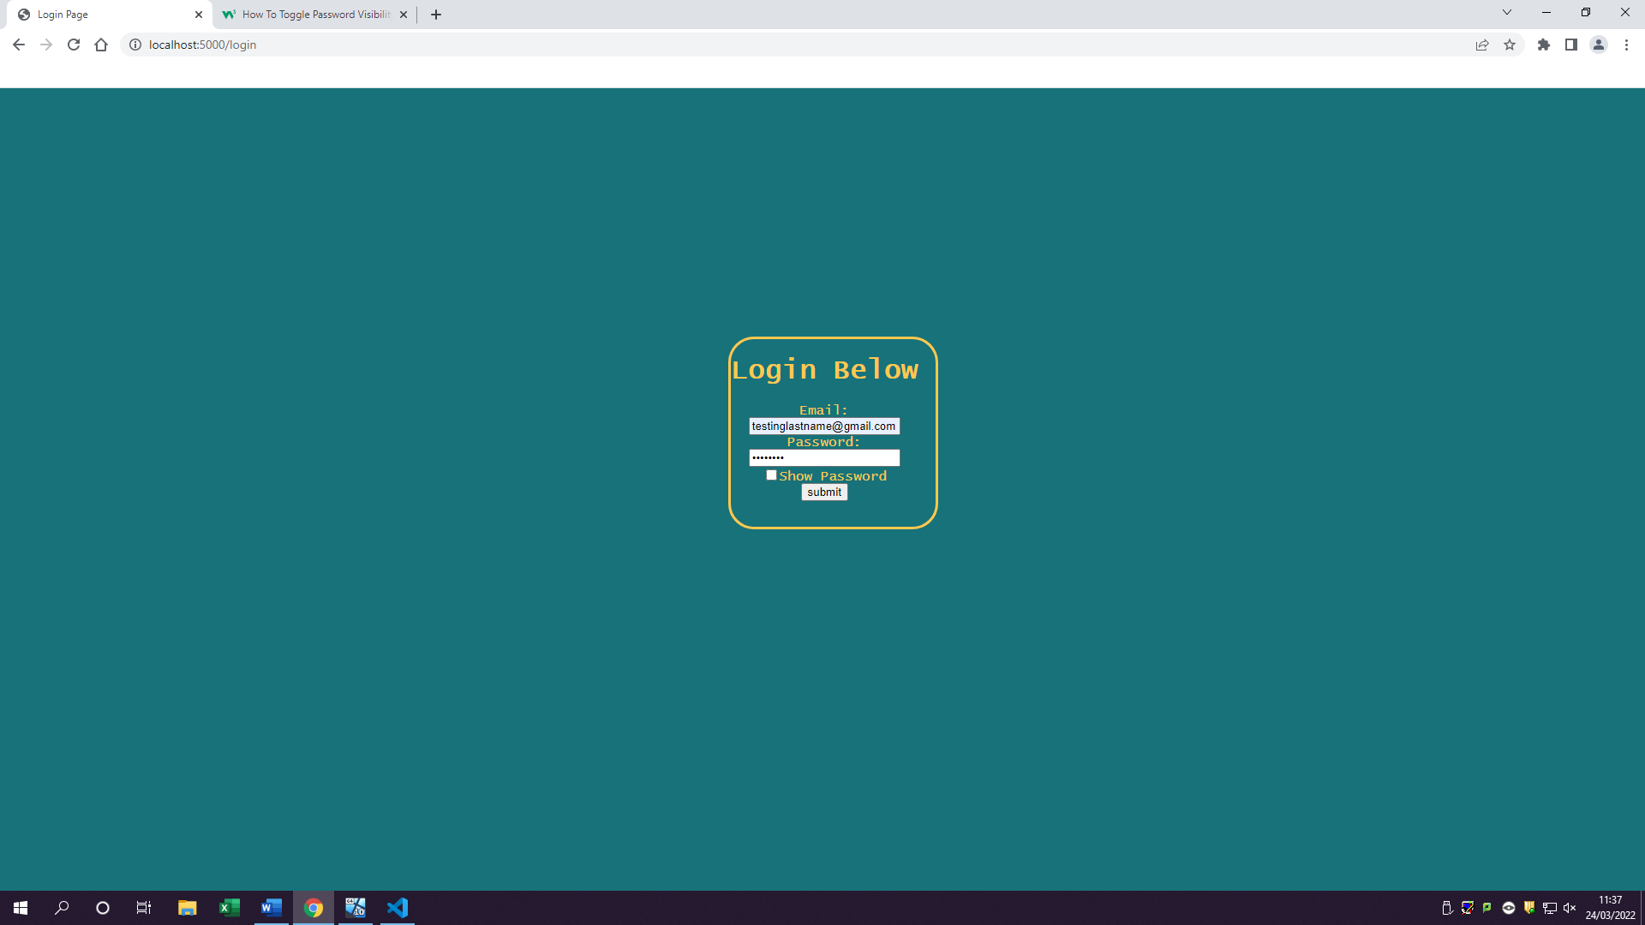2.2 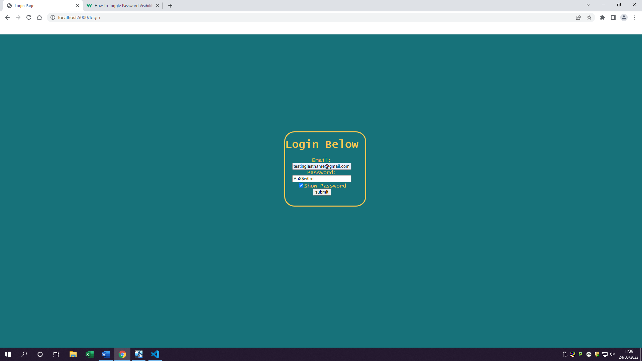

Show password box working once its been clicked by user

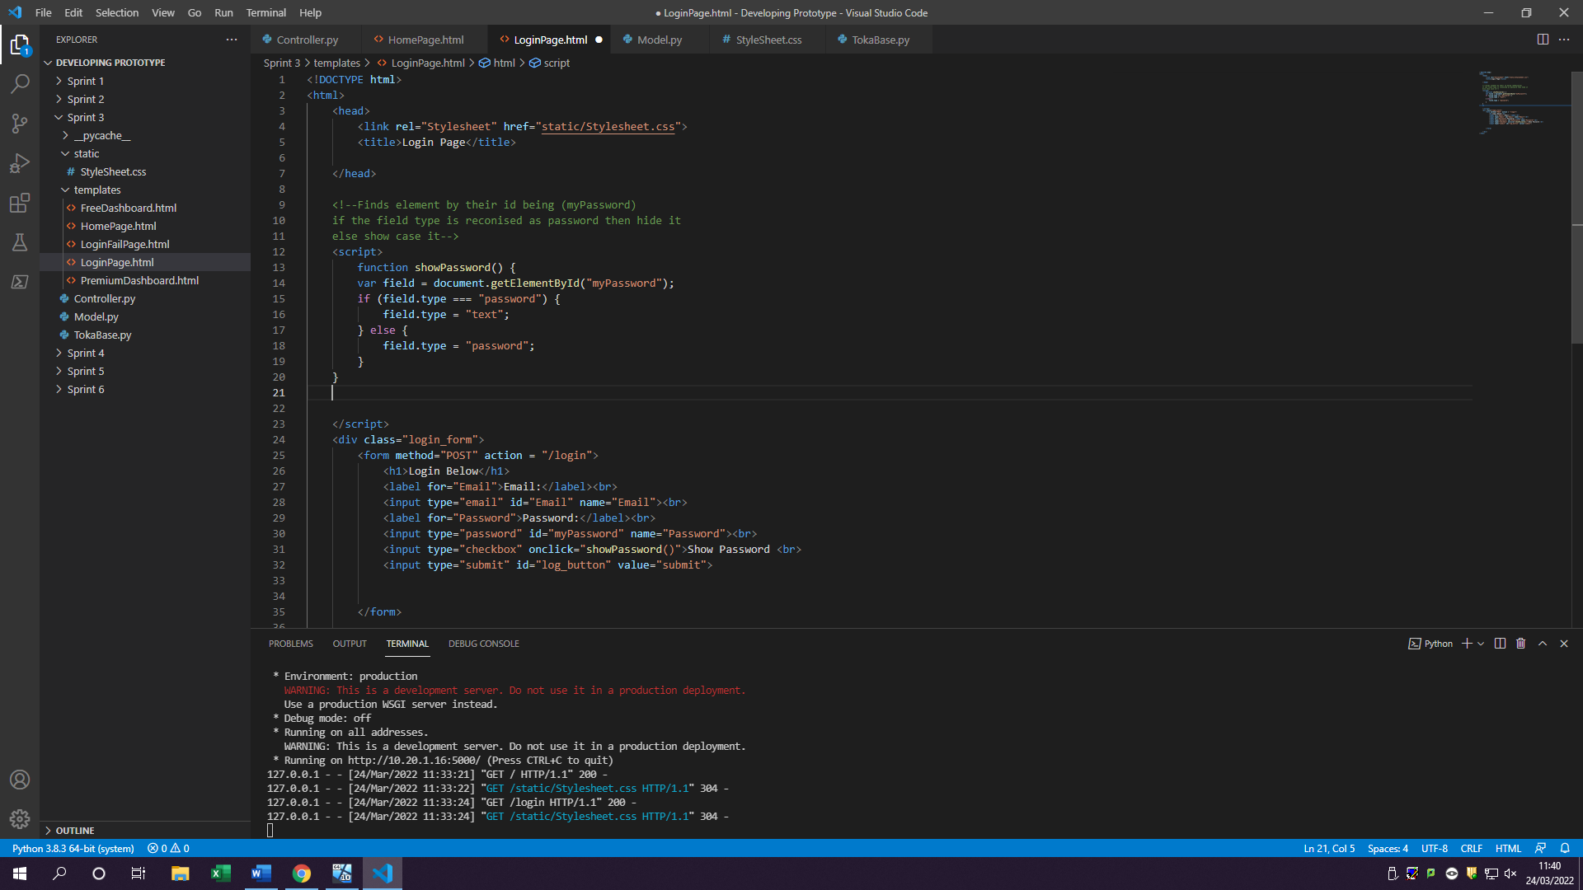

Once clicked on show Password box the function activates

JavaScript function used to hide password

2.3 Creating blocks/buttons which users can press to go to the functional pages

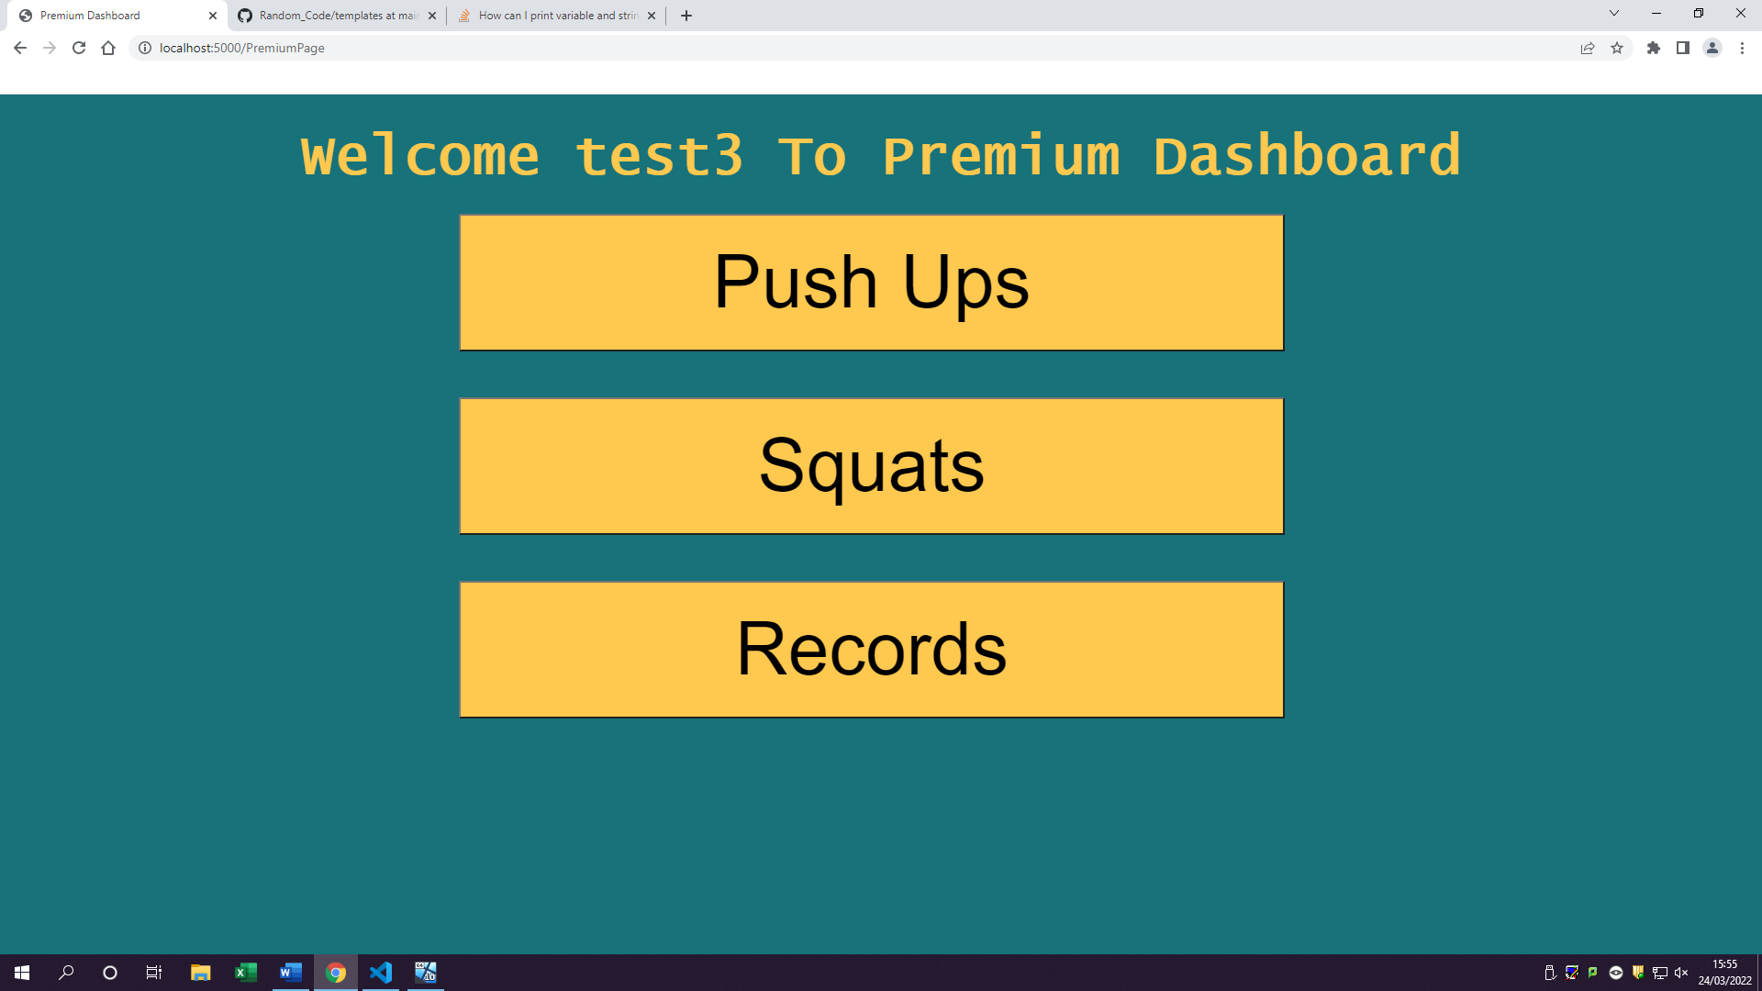

Links to buttons on html code

Pages still need to be made for them

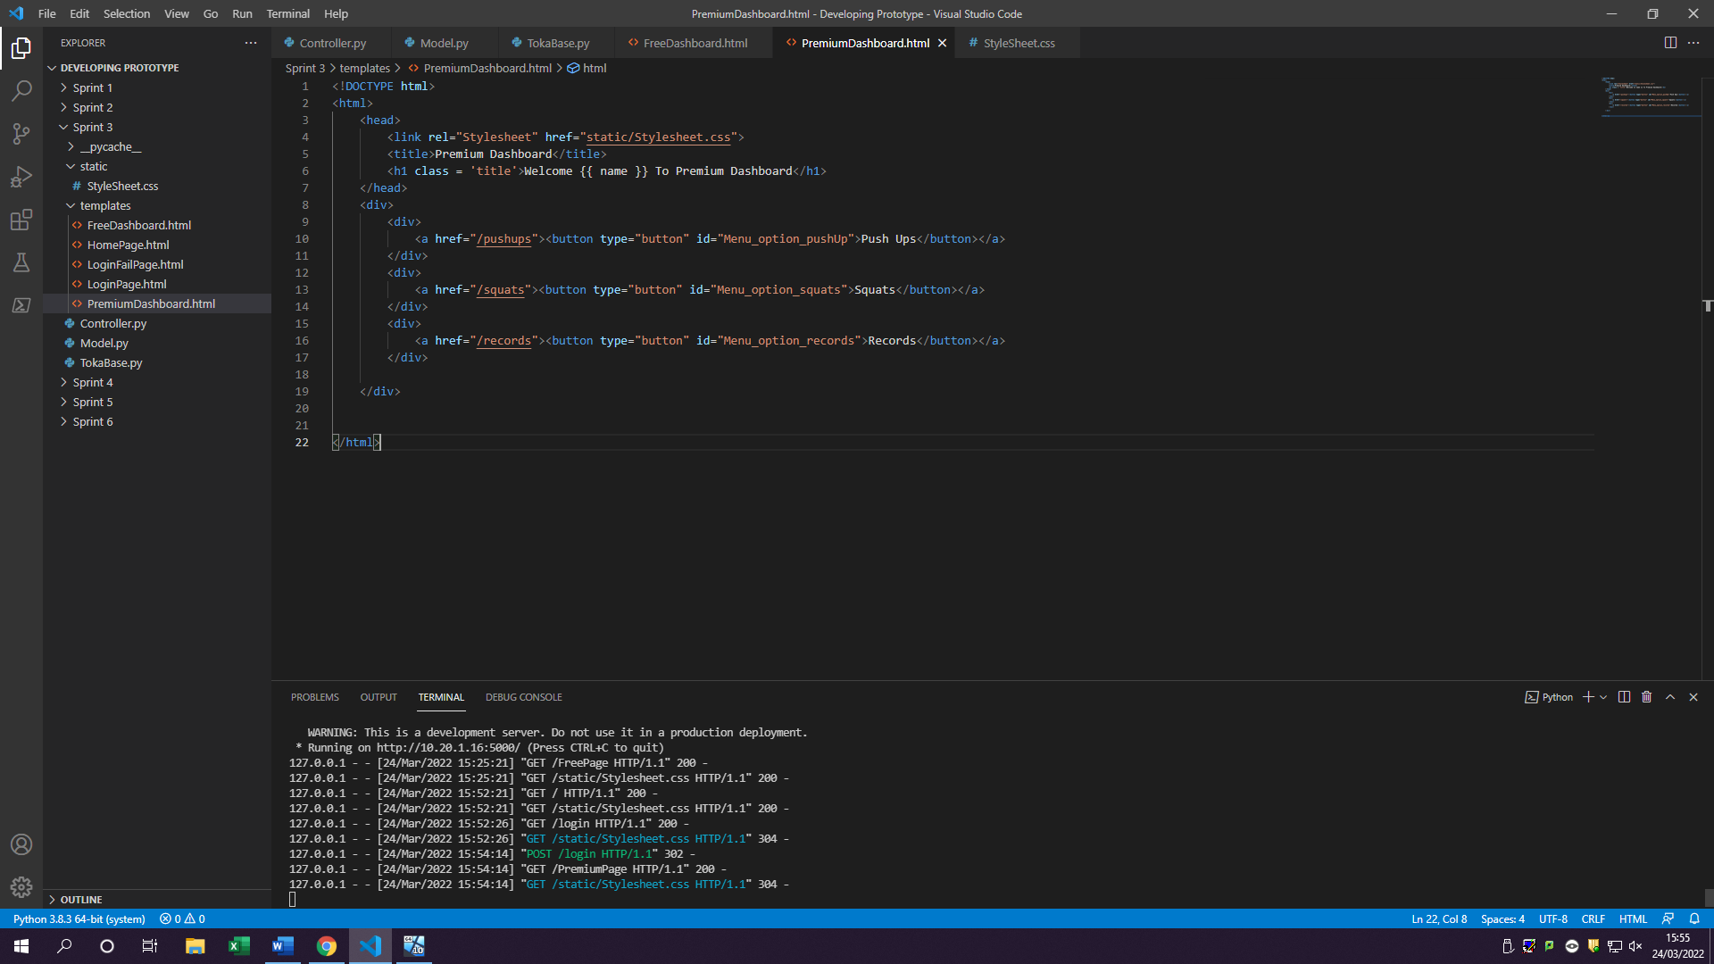

### Log table

|  |  |  |  |  |  |  |
| --- | --- | --- | --- | --- | --- | --- |
| Fr# | Task# | Testing type | Description of test | Expected outcome | Actual outcome | Notes |
| 2(BL) | 2.4(bl) | Integrated testing | Testing to see if database can select the items from the database and check against user login information and if it matches procced them to their dashboard | Users’ credentials should get authenticated and processed depending on if they match | The users can now enter their details in the login form and once they click submit it authenticates their details by checking the database and if exists sends them to the dashboard, they registered for | Variables were not lowercase instead of being uppercase, so form did not pick them up. |
| 1 | 1.1 | Unit testing  Load testing (lots of details sent across and checked against) | Testing to see if user is getting sent to the correct dashboard | Users should be sent to the correct dashboard by their credentials | User is getting sent to either Free or Premium Dashboard depending on account they registered for | Only works while login in |
|  | 1.2 | Unit testing  User acceptance testing | Testing to see if the user doesn’t exist are they still able to enter the dashboard through login | People who have not registered should not be able to log in | If a user tries to use email or password which doesn’t exist in the database, they will be shown an error screen asking them to fill the details in again to confirm | If user did not enter correct details or entered blank, they will be greeted with fail page |
| 2 | 2.1 | Integrated testing | Testing to see if getting users name from database and trying to display it on dashboard to see if it works all well | User’s name should be displayed on the dashboard title | Users FirstName is now getting displayed in their dashboard once they log in | Only works while login in |
|  | 2.2 | Unit testing | Additional feature which allows users to click on show password checkbox to see their own password | Users should be able to click on a checkbox and see their password | Users can click on check box and see their password | Uses JavaScript  For checkbox |
|  | 2.3 | Unit testing  Functional testing | Testing to see if buttons clicked go to their pages but still have no content on them/ testing to see if users can see buttons and are able to click on them | Once user logs in checking to see if they can click any of the dashboard buttons created and go to the pages | At the moment users can only see 3 buttons and once clicked on them they get internal server error (no pages made for them) | Pages will have to be made for each other content and functionality for sprint 4 |

### Review

Sprint 3 was very challenging in many ways as I was trying to catch up on backlog task which took a very long time, however on good news I managed to complete it to a high standard which I wanted to. Sprint 3 was hard as I was mostly trying to figure out and program on how to verify users’ information and giving them a cookie once they manage to log in. However, this wasn’t hard to make as all I had to do was create a cookies table as well as getting users email and their customerid and encoding their email which would then be hex digested into random letters and numbers which would then act as a cookie in the cookies table. One minor inconvenience was then I was trying to retrieve user’s login details I couldn’t as the variables set were different to the ones, I was trying to collect meaning that my controller was picking up no data. However, this was quickly fixed by just changing the capital letters of the first variable making it now collect users’ details

Displaying the name on dashboard was hard as I first had to make sure the correct user is in the correct dashboard by checking all their credential details and authenticating them with accounts made. However, to showcase the name part, wasn’t as difficult as expected as all I needed to do is retrieve their name from the database and display it using cookies to get the user logged in identity. There is a small problem however as of right now to get users name to show up they have to go through login button to see their name displayed, and if they decide to go through register then login it will not showcase their name instead it will be the previous person who logged in. This however can be fixed by making the user always login even once they registered therefore this problem can be easily avoided in future sprints.

Overall, I believe sprint 3 was successful and completed to a high standard meaning that the client has now received a registering function, login function and ability to see different dashboard depending on the account. As a result of this in Sprint 4 I will start to develop the key features in dashboard to make it more entertain for users to see and interact with.

The lesson learnt in this sprint was that when naming variables, I have to make so to remember if I give them a capital letter or not as it may stop me developing and instead make me look for a simple mistake which has been made.

## Sprint 4

Sprint 4 is mostly based around functionality of the dashboards such as getting push-ups,squats, blogs and records pages up and running with some of its functionality. As well as having to create another table for workouts to be stored in.

### Goals/Requirements

|  |  |  |
| --- | --- | --- |
| Goal Set | FR# | Requirements |
| As a user I want to be able to access the features on the dashboards | 1 | Creating different pages for the buttons on the dashboard |
| As a user I want to interact with the dashboard functionality | 2 | Allow user to click on buttons such as (squat button, push up button in those pages)  Creating a table for workouts |
| As a user I want a way to save my workout information | 3 | Have a save button for each different workout done and save the amount of reps done |
| As a user I want to see my workout information | 4 | Have a records page display users workout progress |

### Triage/Tasks

|  |  |  |  |
| --- | --- | --- | --- |
| FR# | Task # | Functional requirement | Expected outcomes |
| 1 | 1.1 | Create pages for each button | Once clicked on a button user should be sent to the page |
|  | 1.2 | User can view the page | User should be able to see some colour or items on the page |
| 2 | 2.1 | Create buttons for squats page | User can click on squats button |
|  | 2.2 | Counter go up when squat button clicked | When user clicks on squat button counter goes up by 1 |
|  | 2.3 | Create button for push-ups | User can click on push-up button |
|  | 2.4 | Counter go up when push-up button clicked | When user clicks on push-up button counter goes up by 1 |
|  | 2.5 | Create a tblworkouts | Creating tblworkouts with column such as squats and pushups |
| 3 | 3.1 | Create a save button | User can click on a save button |
|  | 3.2 | Save button saves data in a variable (JS) | Once clicked on save button all the counter information gets saved |
|  | 3.3 | Tblworkout stores saved information from workout | The tblworkout should store data such as push ups and squats once clicked on save |
| 4 | 4.1 | Create records page with a table | Records page contains a table showing pushups and squats |
|  | 4.2 | The table has users’ information such as squats and pushups, | Table is now storing data from tblworkout such as number of squats and pushups |

1.1 Create pages for each button

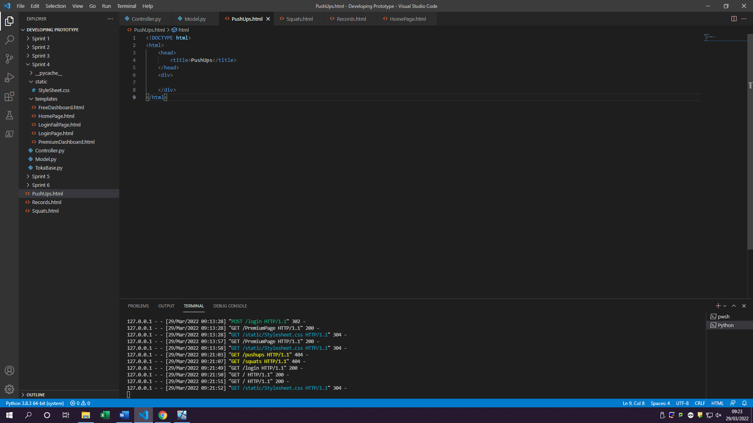

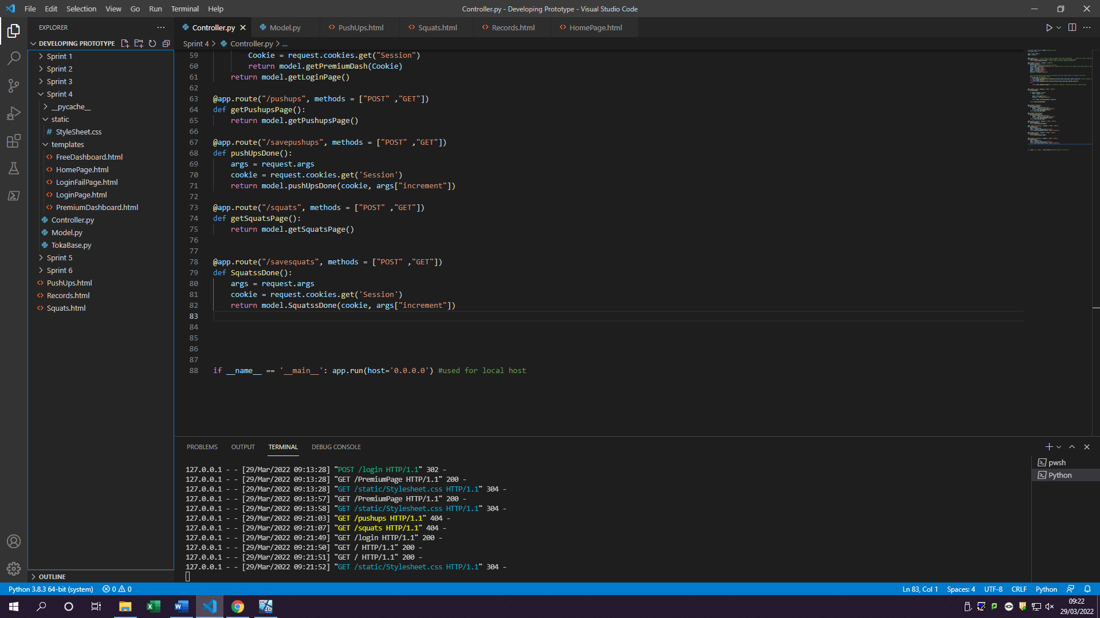

Created pages for each category in dashboard, with at the moment just containing tiles of what page is.

1.2 User can view the page

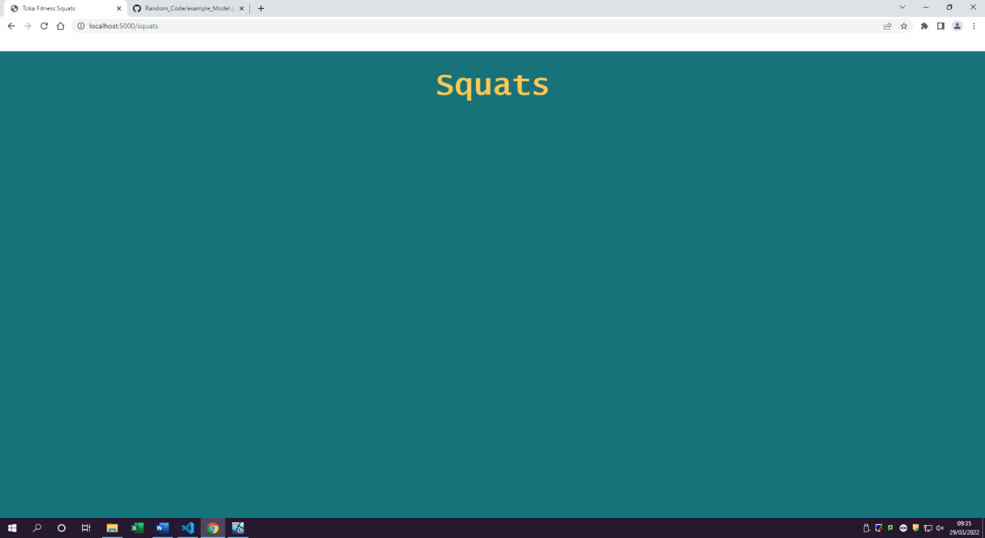

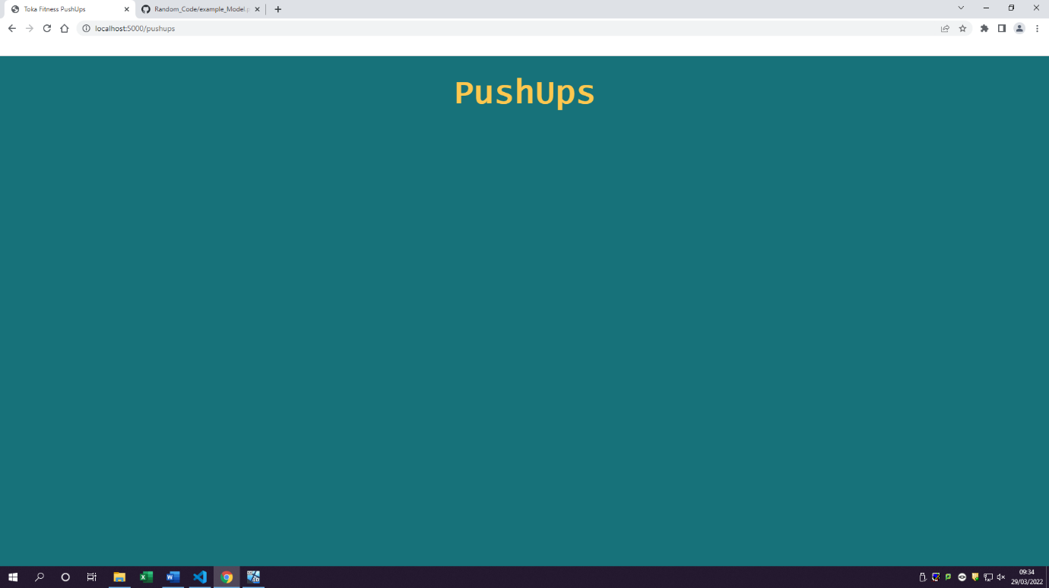

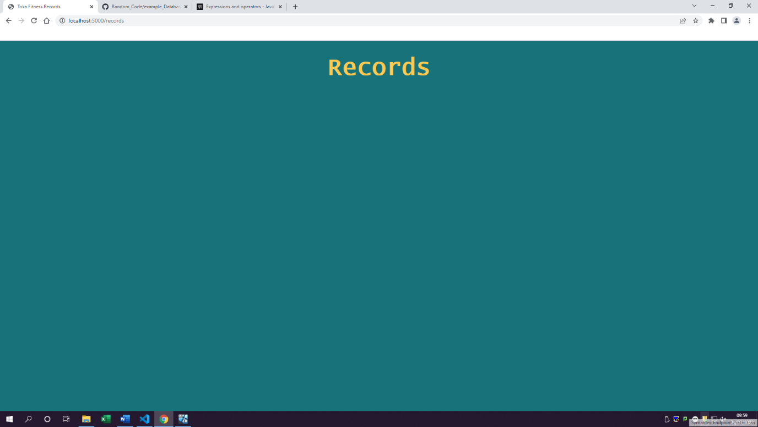

All 3 button pages can be access by user and user can see them

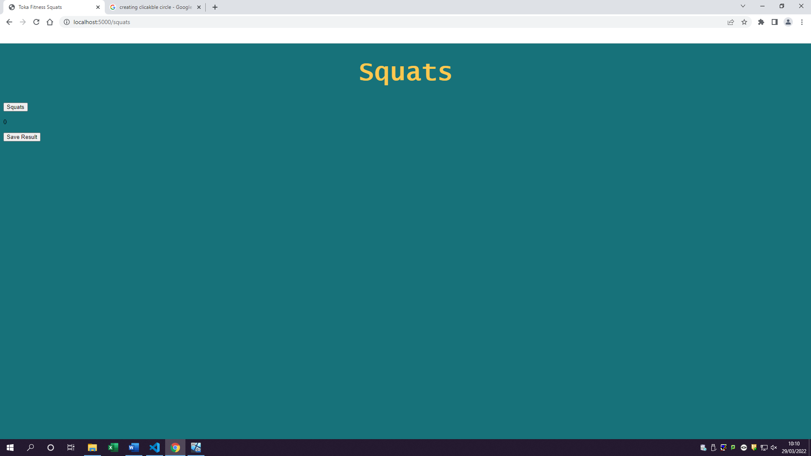2.1 Create buttons for squats page

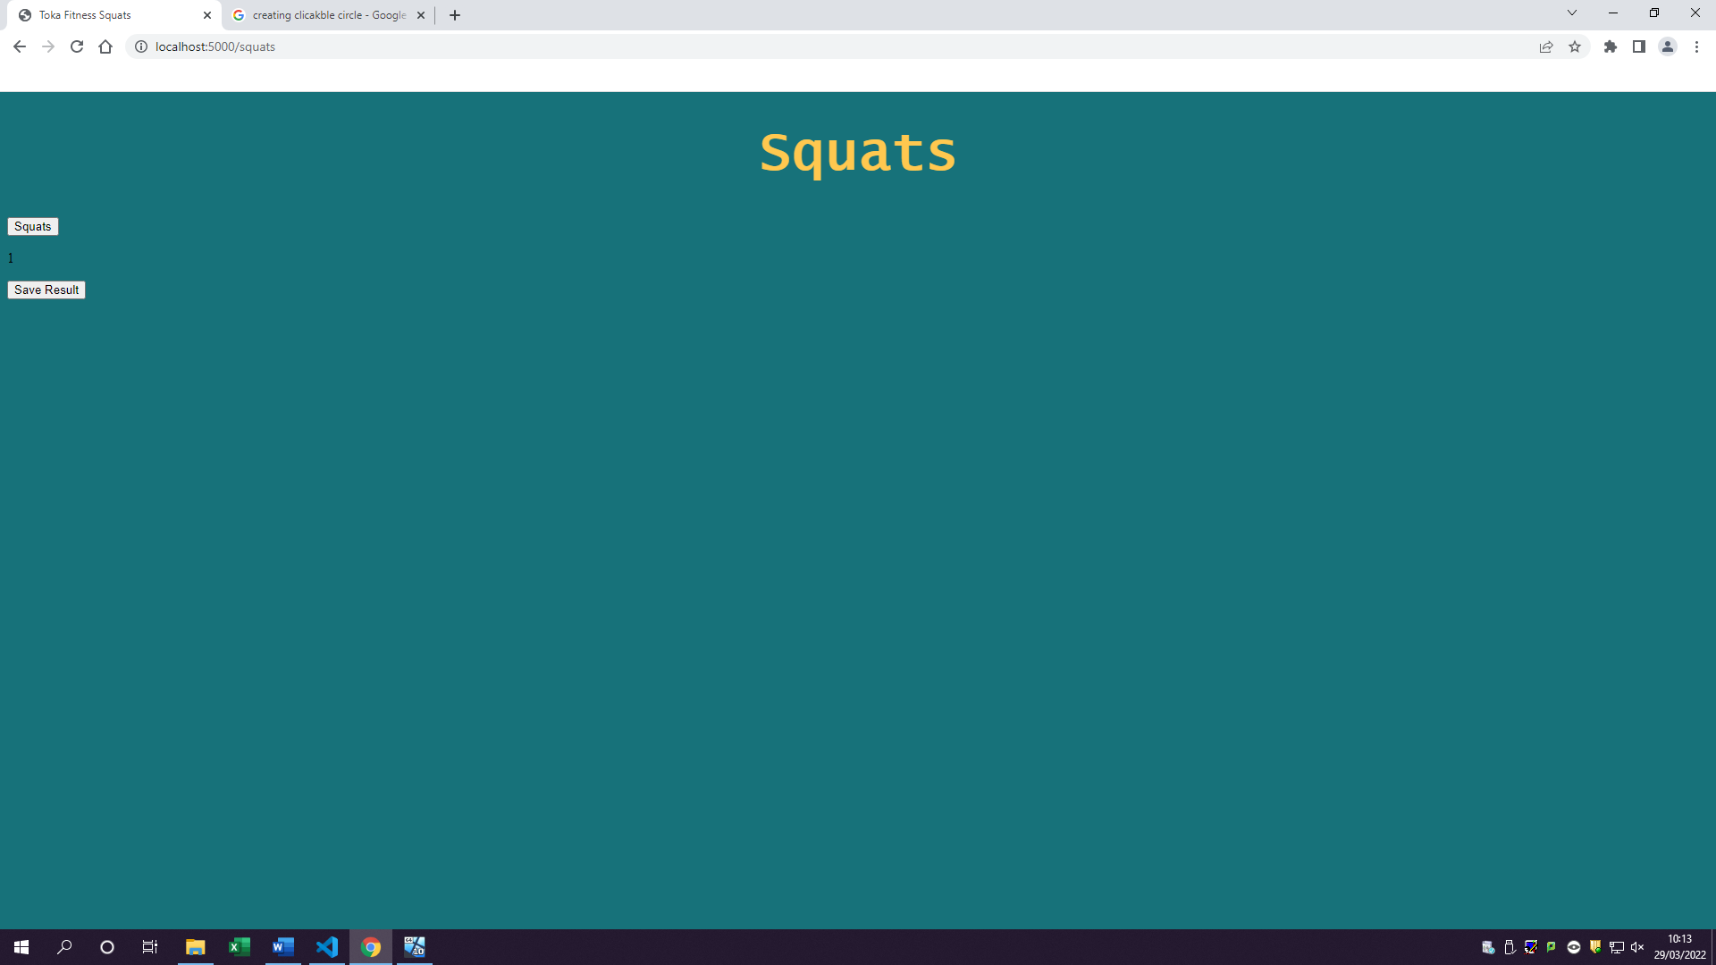2.2 Counter go up when squat button clicked

Once clicked on squat button it will increment by 1

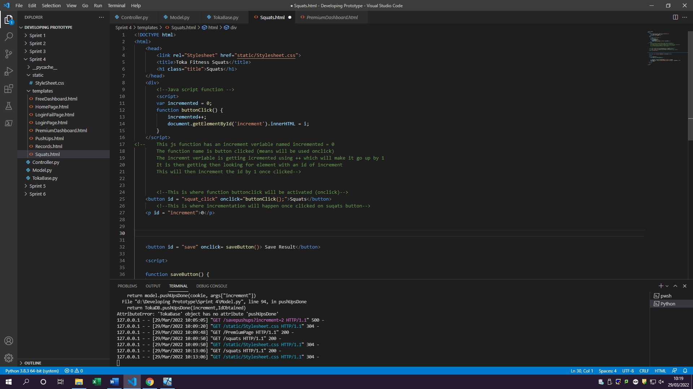code for 2.1 & 2.2

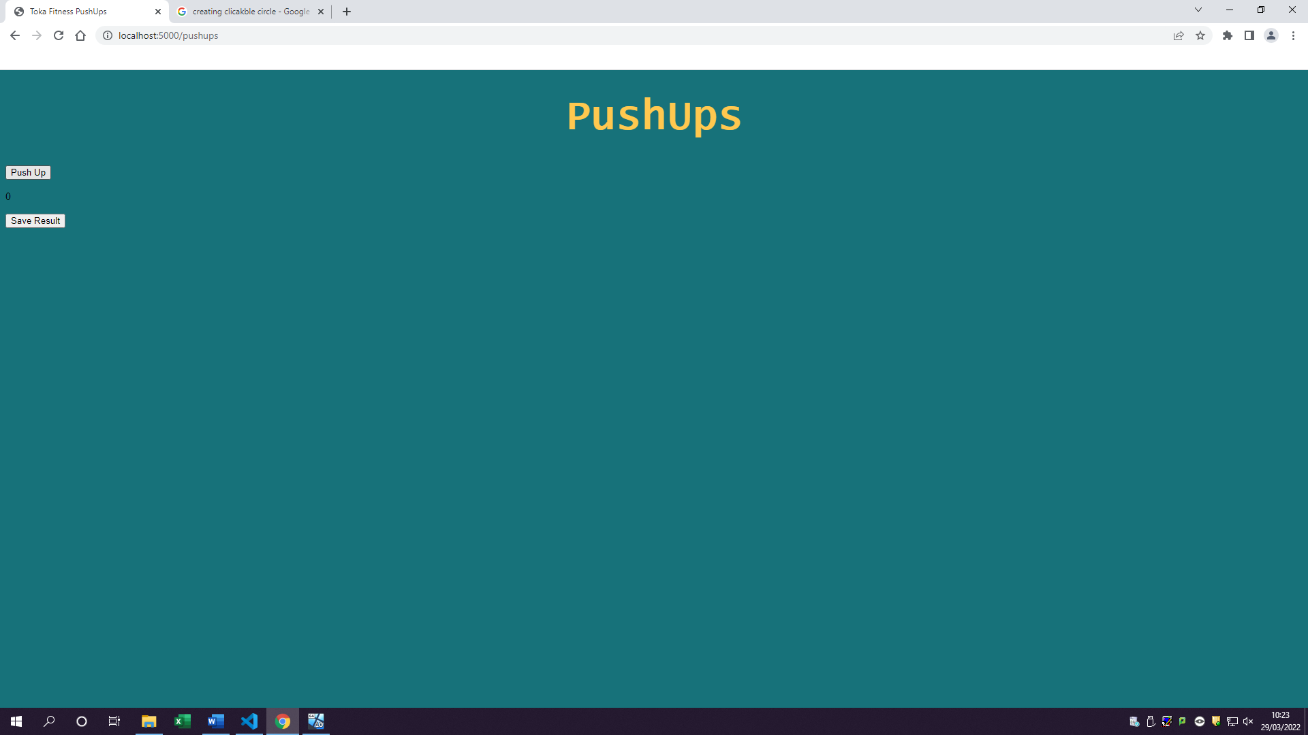2.3 Create button for push-ups

2.4 Counter go up when push-up button clicked

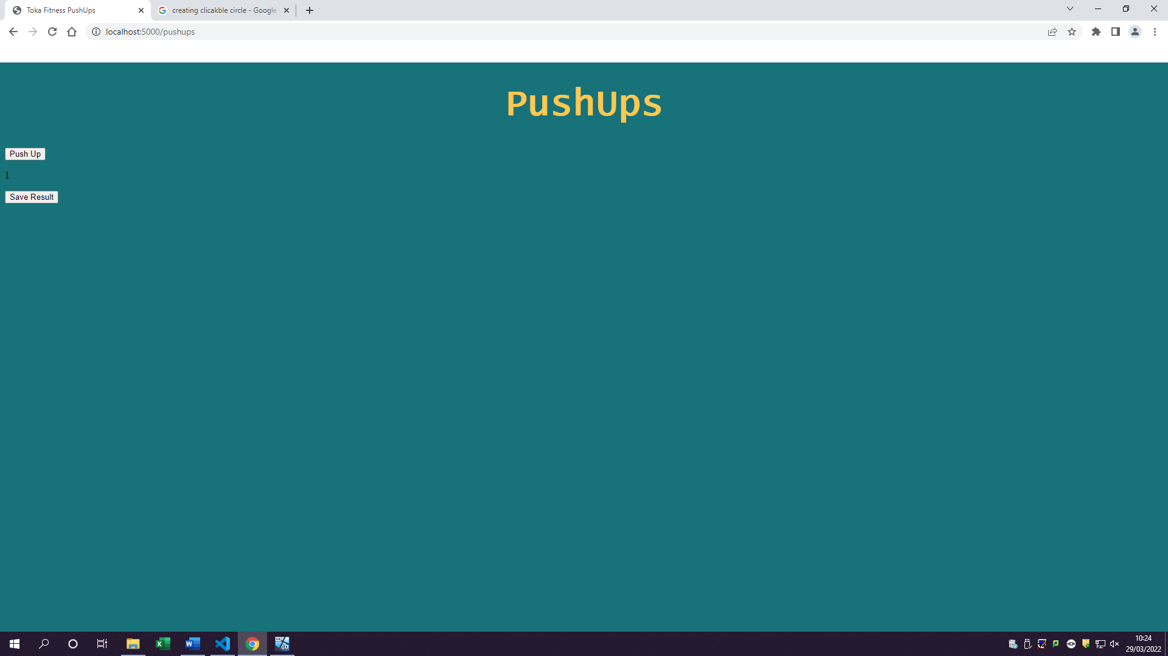

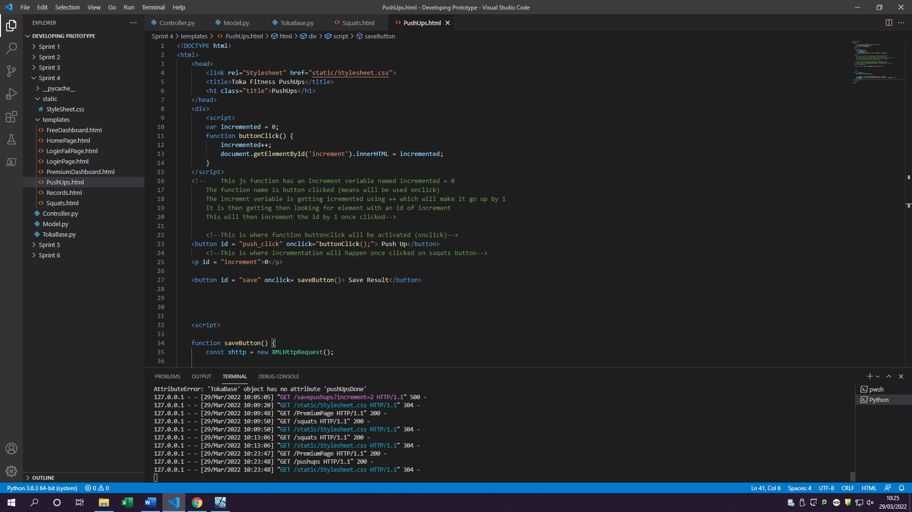Code for 2.3 & 2.4

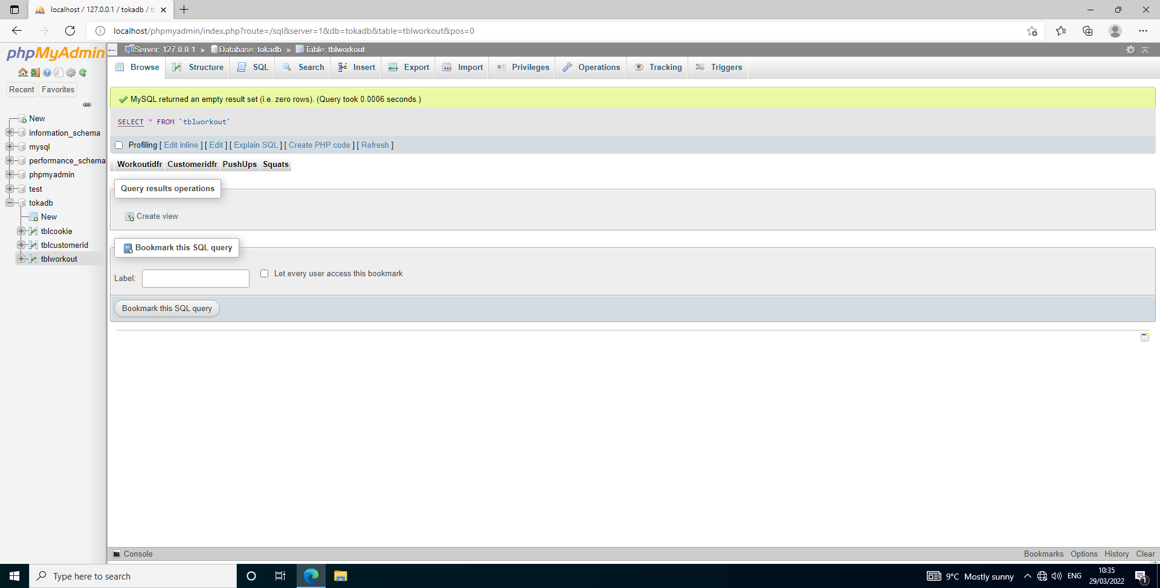2.5 Create a tblworkouts

Tblworkout has now been created with columns such as: Workoutidfr, Customeridfr, PushUps, Squats

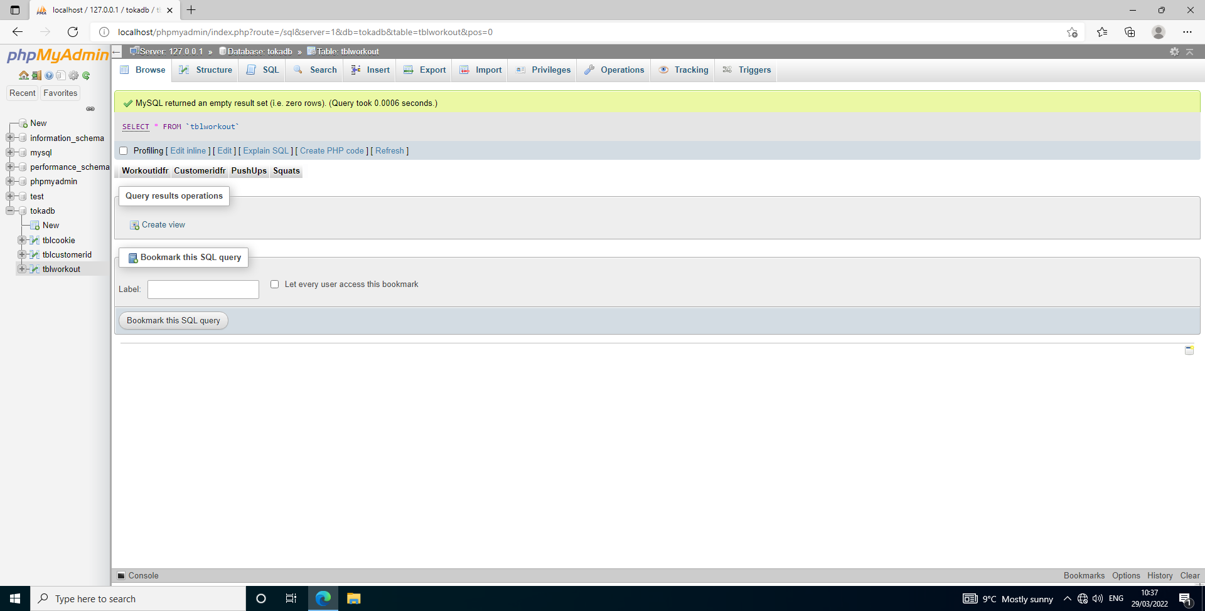

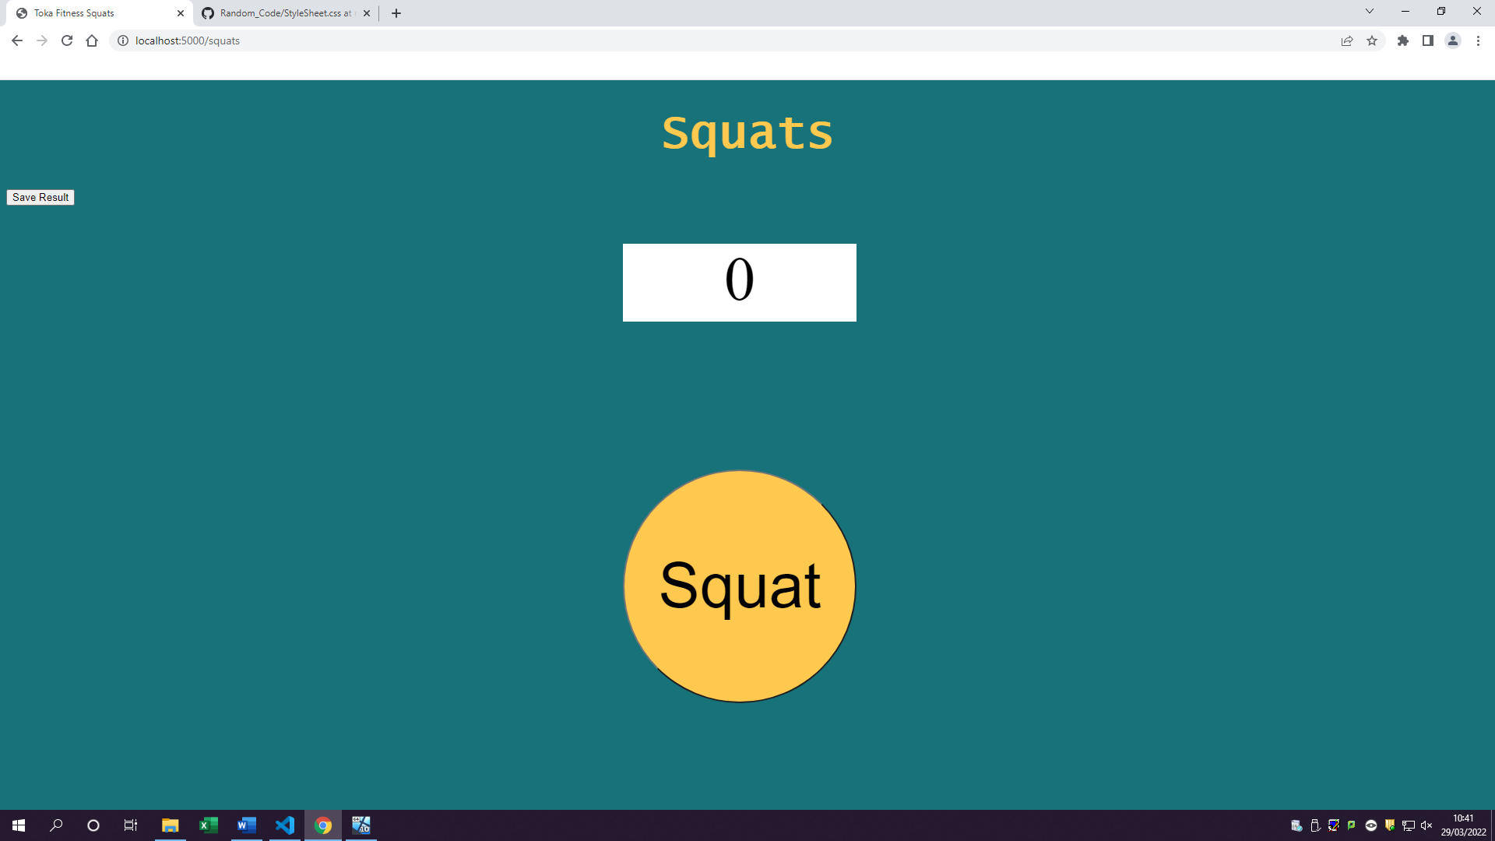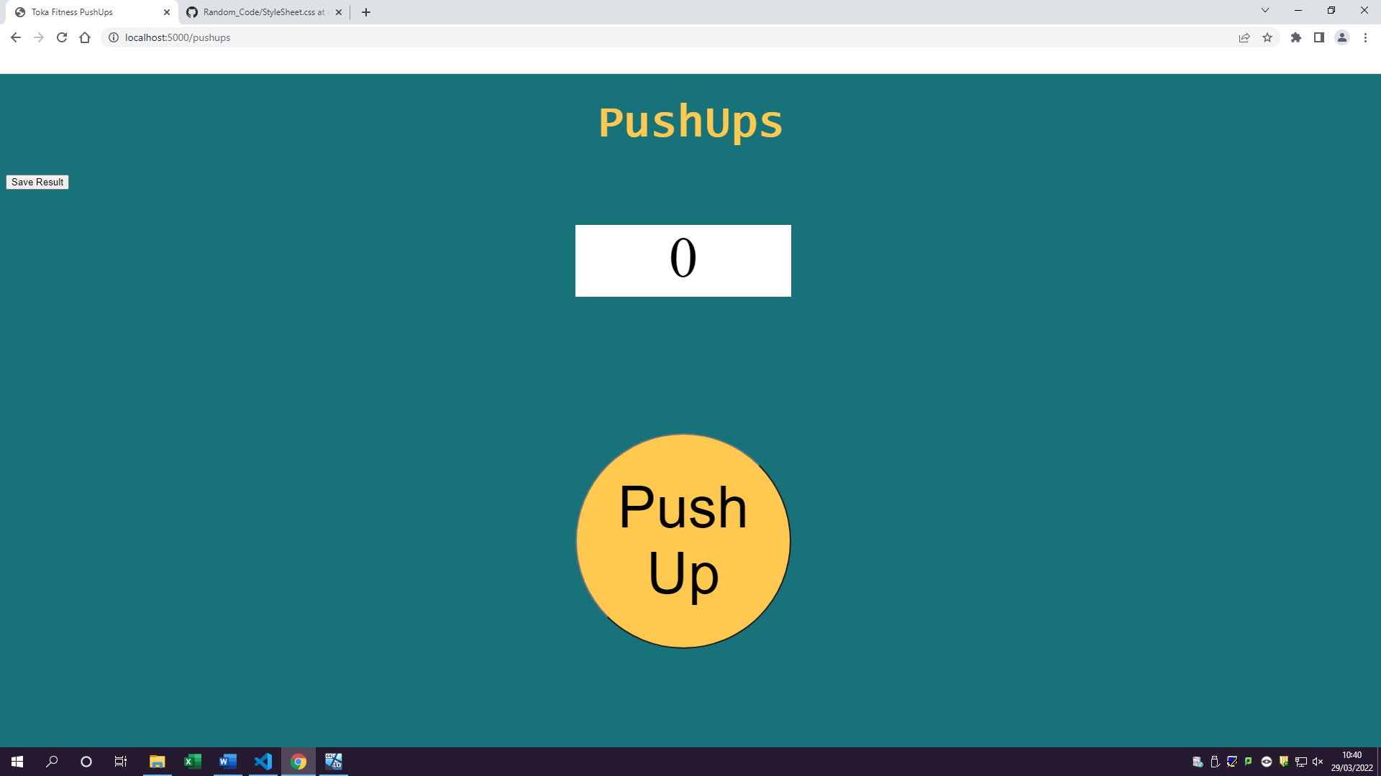3.1 Create a save button

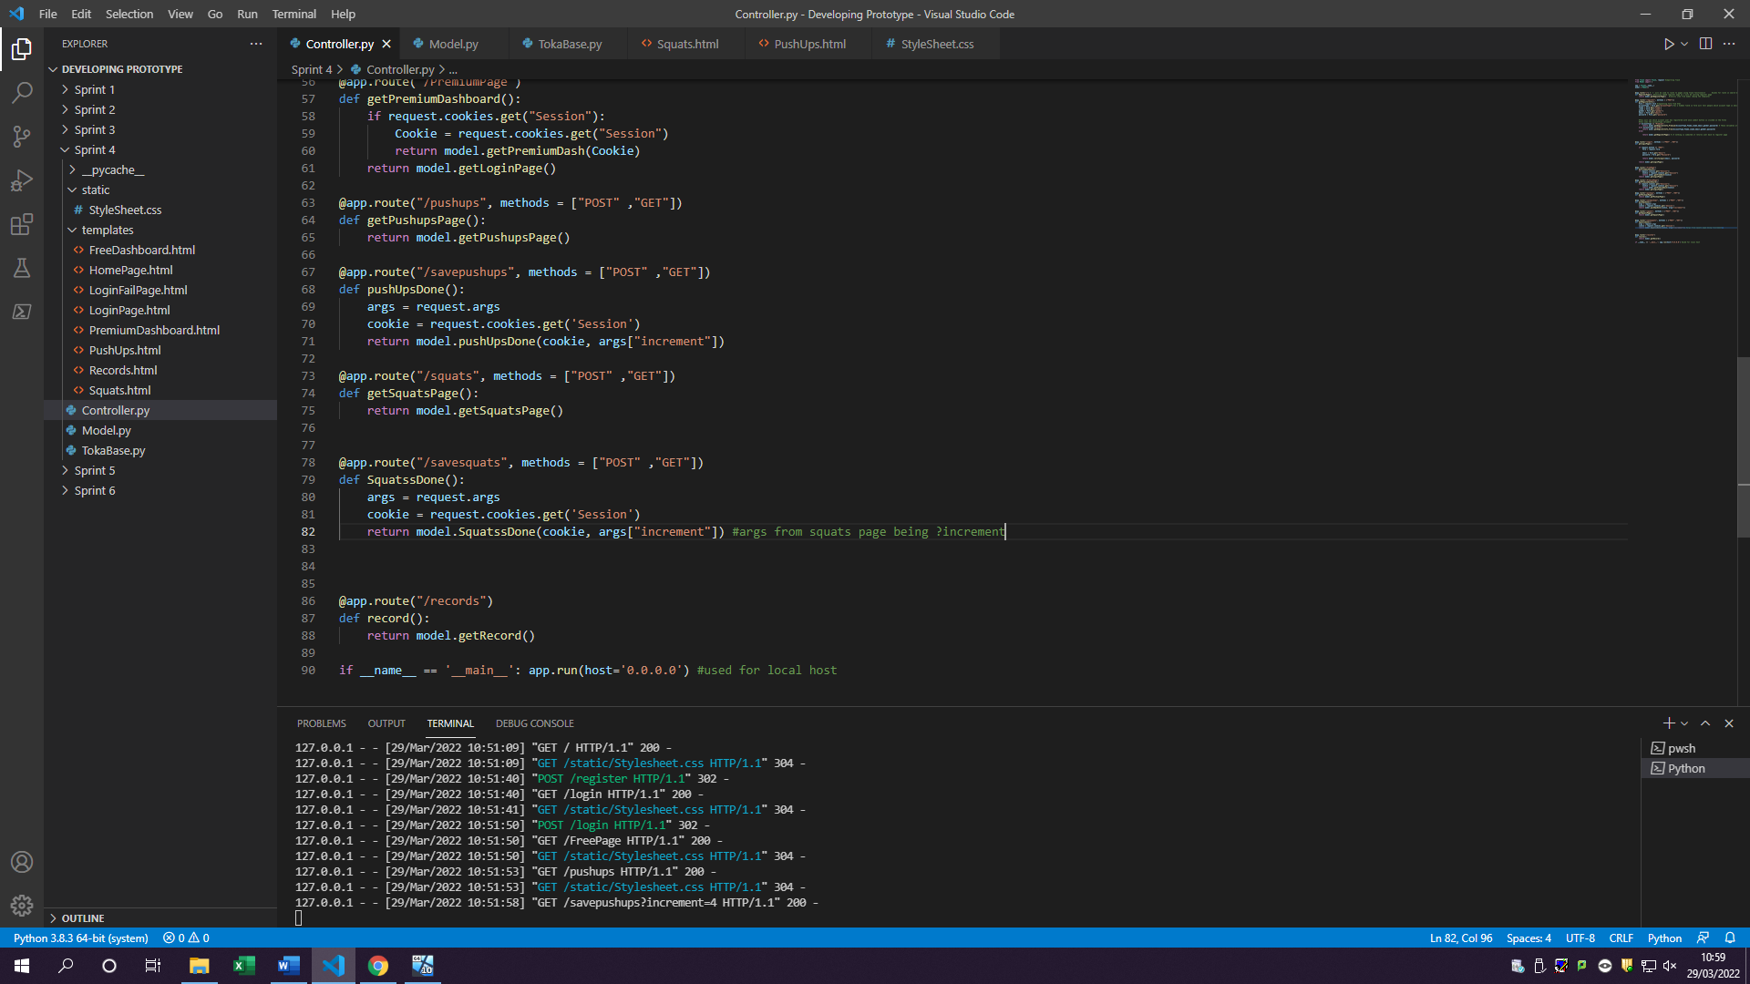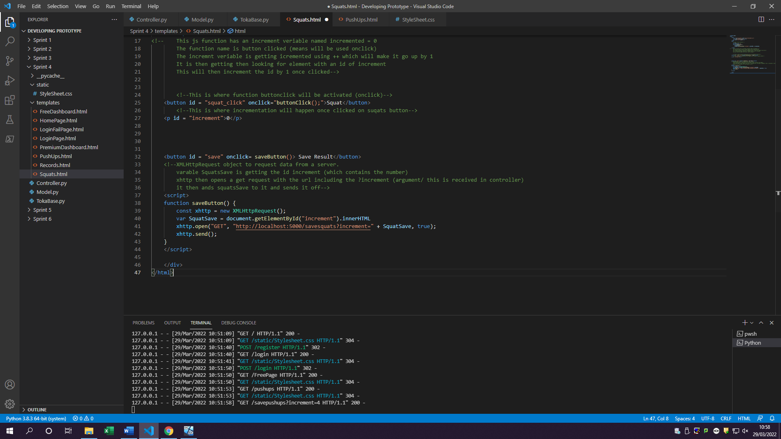3.2 Save button saves data in a variable (JS)

Increment argument is getting passed as an increment variable

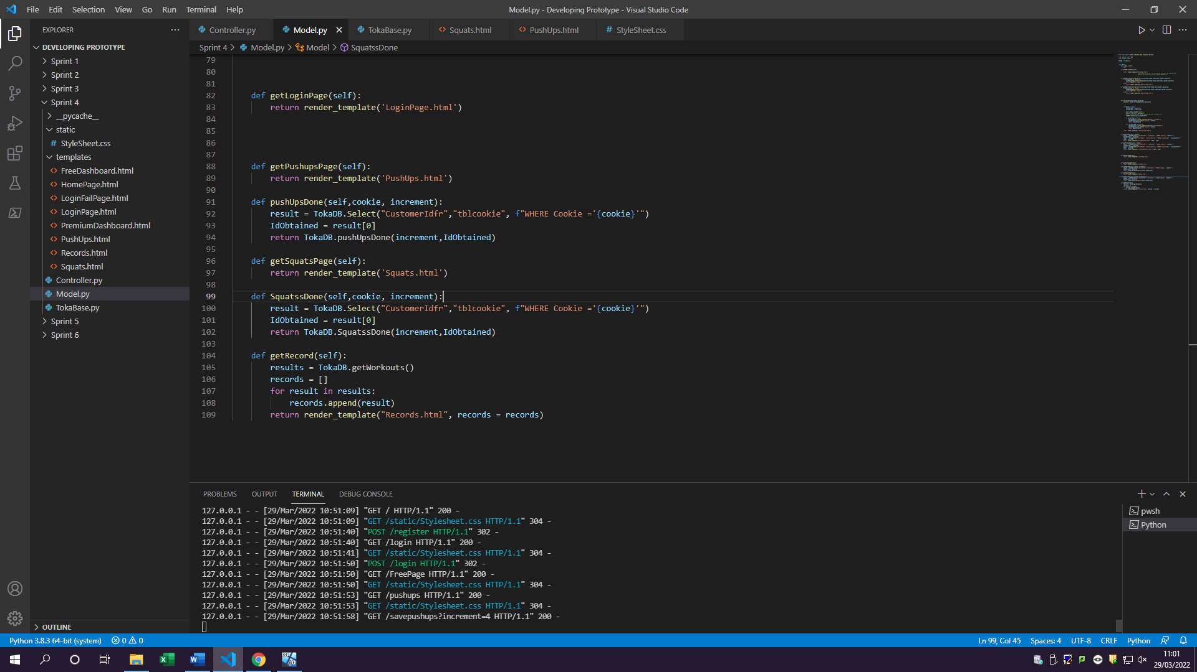

Inserting values into table workouts this column being the squats done

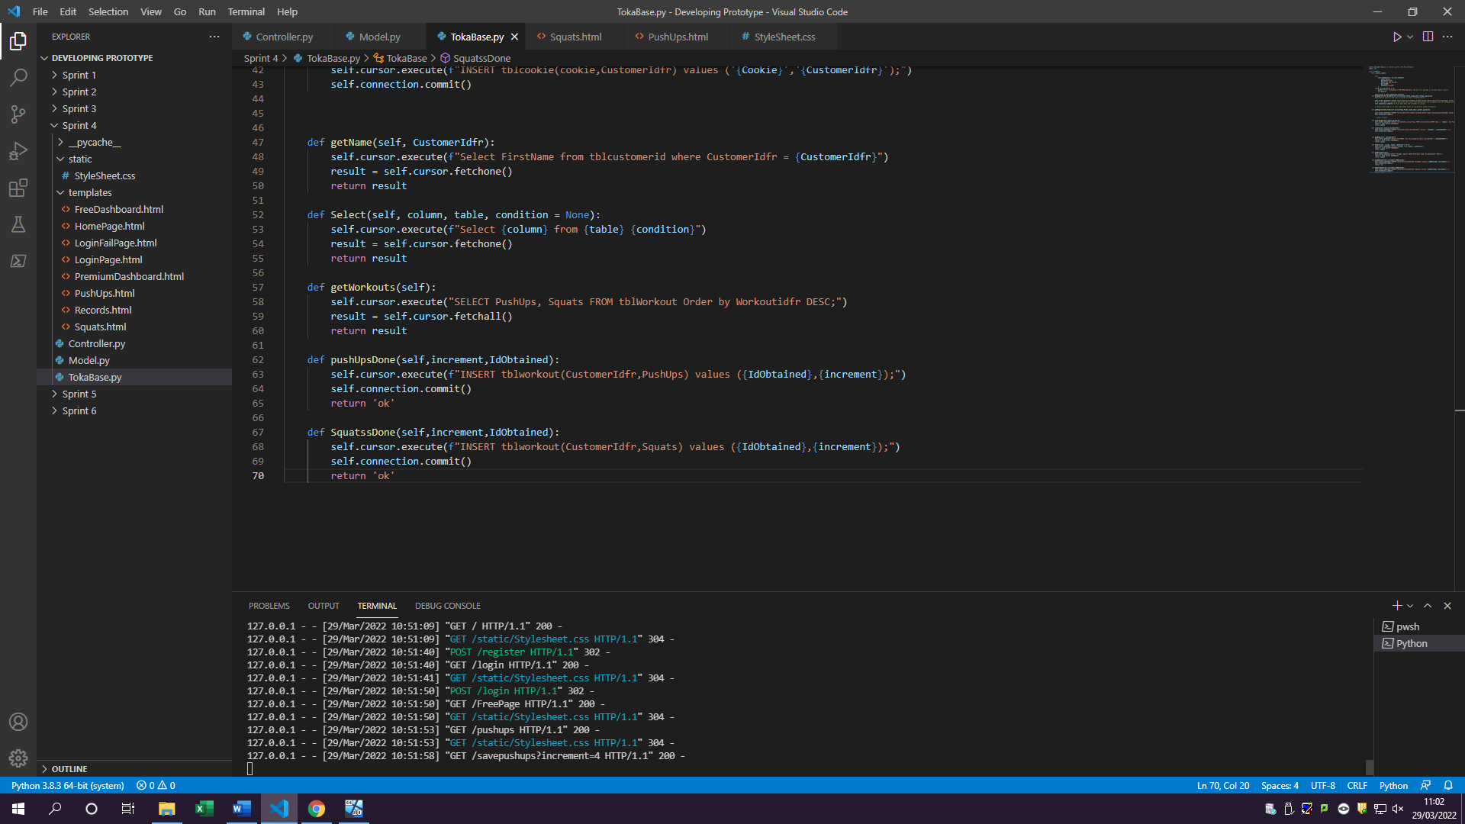

3.3 Tblworkout stores saved information from workout

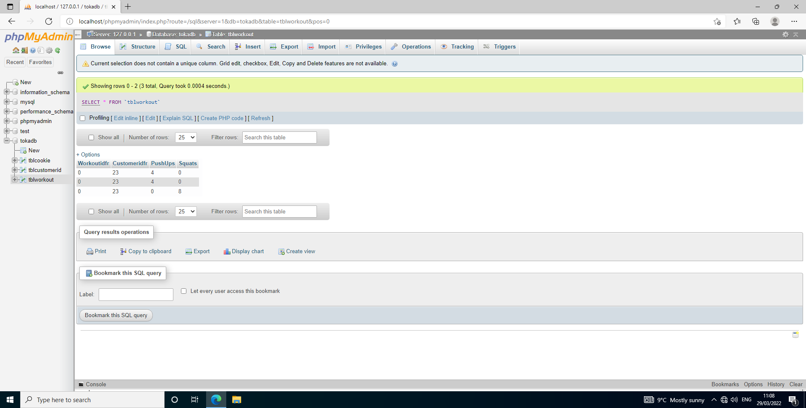

Number of reps has been saved and stored in the table under its specific table

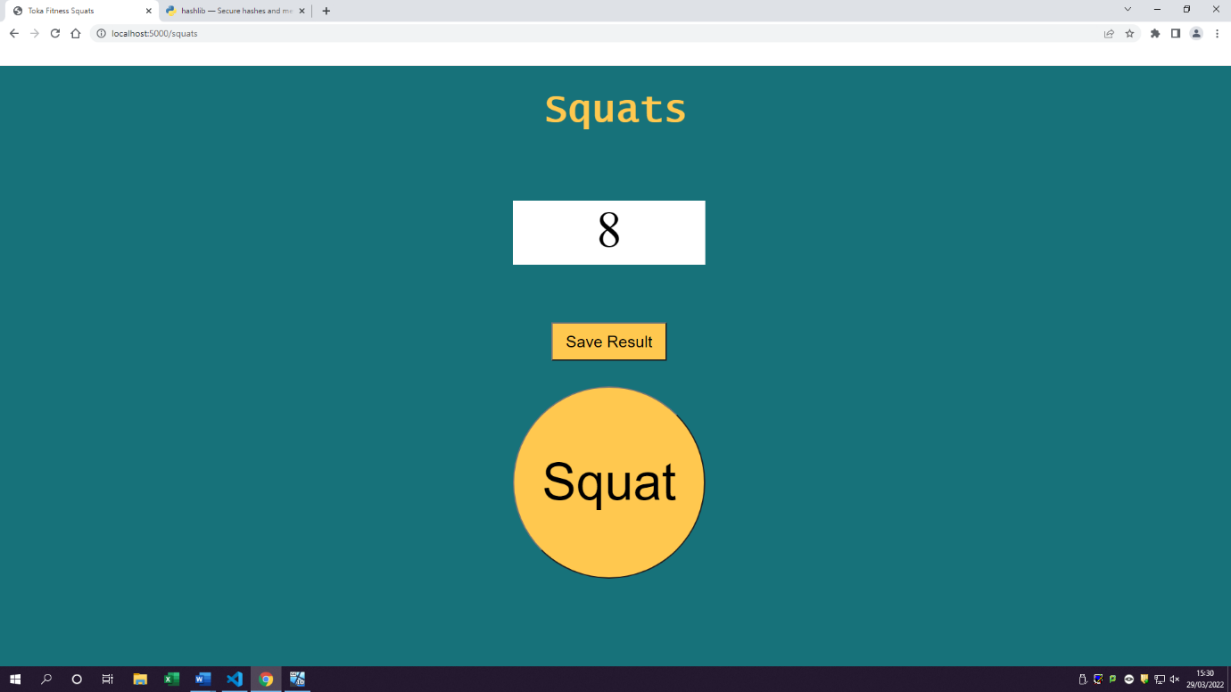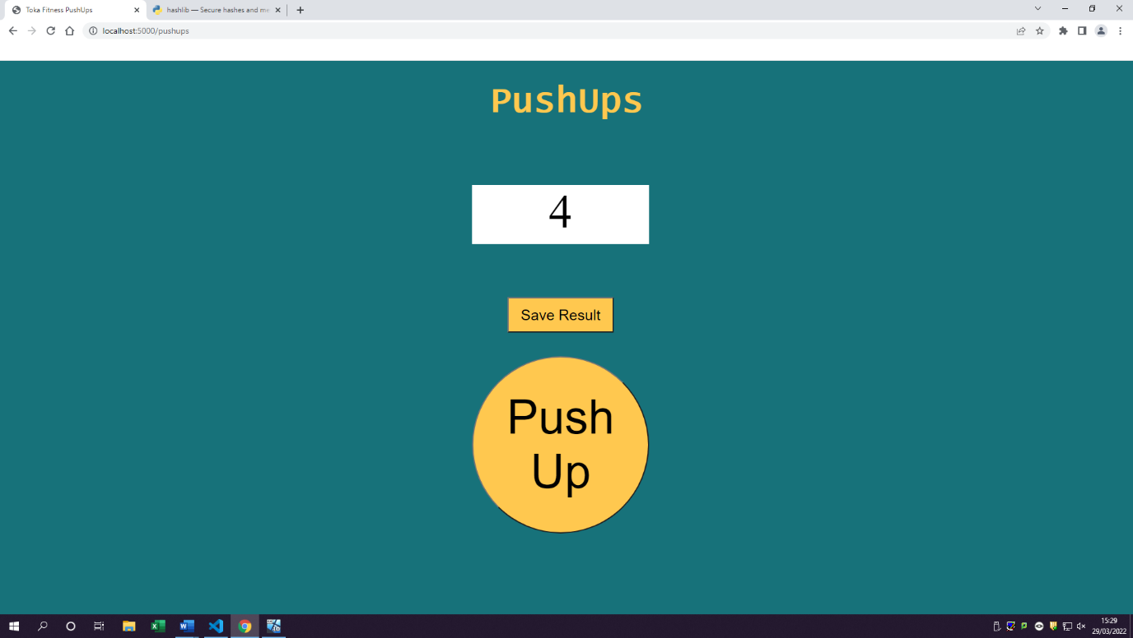

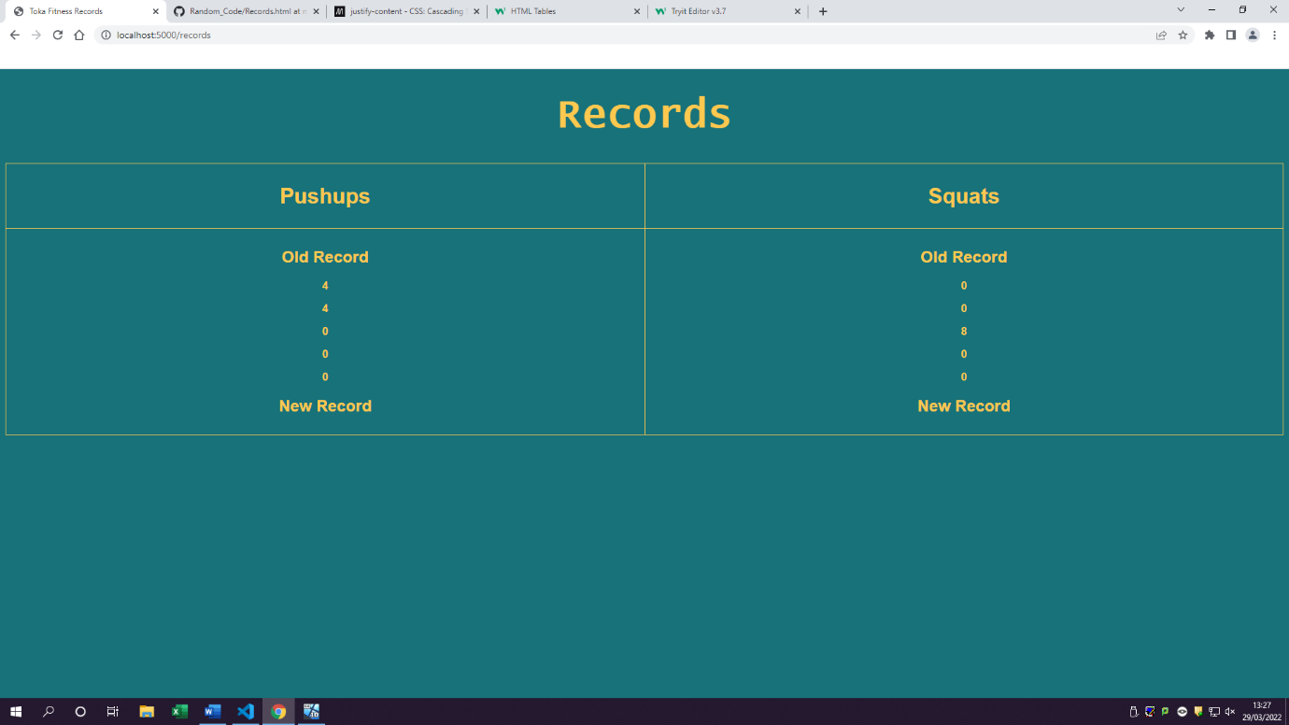4.1 Create records page with a table

4.2 The table has users’ information such as squats and pushups,

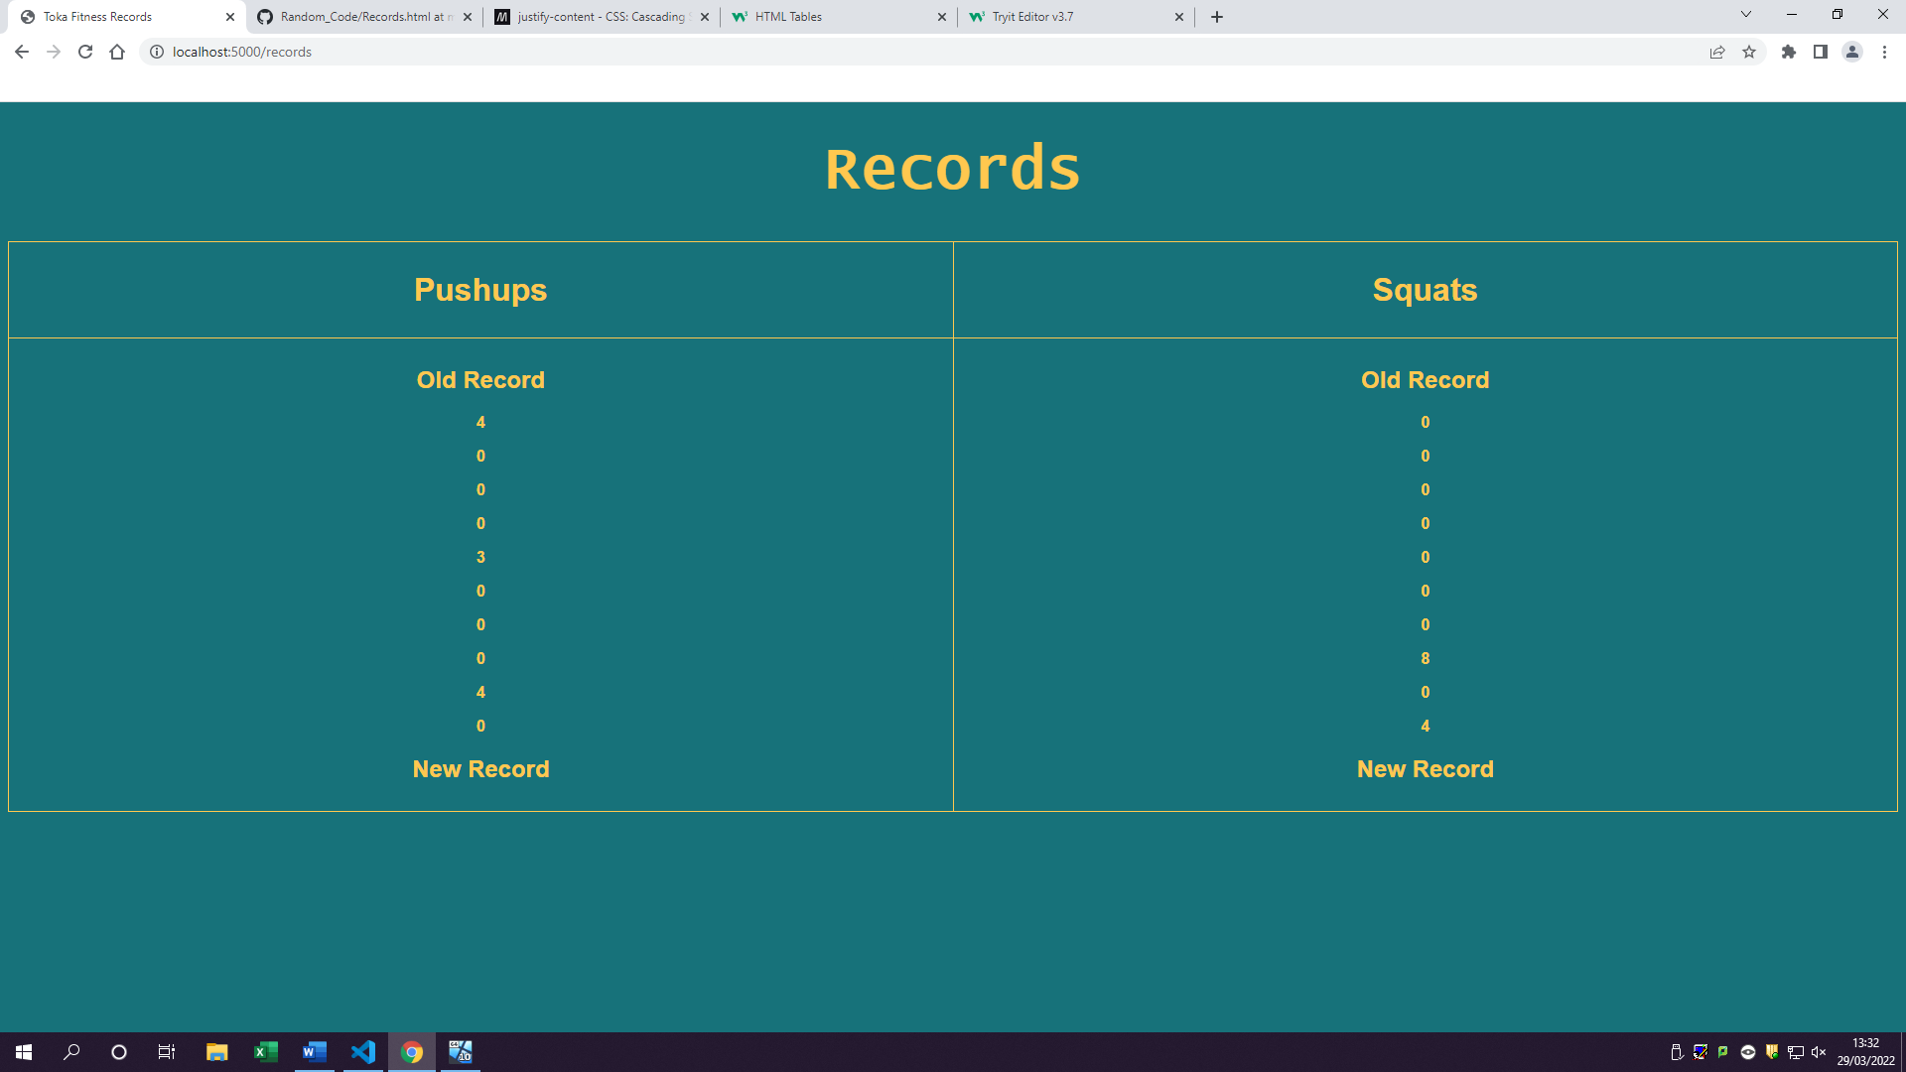

### Log table

|  |  |  |  |  |  |  |
| --- | --- | --- | --- | --- | --- | --- |
| Fr# | Task# | Testing type | Description of test | Expected outcome | Actual outcome | Notes |
| 1 | 1.1 | Unit testing | Checking to see if pages are successfully made | There should be pages made so next test can be done which user should be able to access those pages | Pages have now been built | Needs designing |
|  | 1.2 | Unit testing  Functional testing | Checking to see if user can click on a button and see the page | User should be able to click on button and view page | Pages can now be viewed by users once clicked on button | Pages have now been designed |
| 2 | 2.1 | Unit testing | Making sure buttons created are clickable | User should be able click on squats button | User can click on squats button |  |
|  | 2.2 | Integration testing | Making sure once button is clicked the counter would increase by 1 only and not anymore | Once user clicks on squats button the number 0 should increase by 1 | When user clicks on squat button counter goes up by 1 |  |
|  | 2.3 | Unit testing | Creating a button so making sure use can click and see the page | User should be able click on pushups button | User can click on push-up button |  |
|  | 2.4 | Integration testing | Making sure once button is clicked the counter would increase by 1 only and not anymore | Once user clicks on push ups button the number 0 should increase by 1 | When user clicks on push-up button counter goes up by 1 |  |
|  | 2.5 | Integration testing | Making sure tblcookie and tblworkout can communicate by getting customers ids and storing only their specific information | Making tblworkouts in MySQL with all fields necessary to store information in them | Creating tblworkouts with column such as squats and pushups | *tblworkout is created |
| 3 | 3.1 | Unit testing | Making sure save button can be pressed | User should be able to click on save | User can click on a save button |  |
|  | 3.2 | Integration testing | Once clicked on save button all the counter information gets saved | Once clicked on save button all the counter information should get saved | Once clicked on save button all the counter information gets saved |  |
|  | 3.3 | Integration testing | The tblworkout should store data such as push ups and squats once clicked on save | The tblworkout should store data such as push ups and squats once clicked on save | Tblworkout stores saved information from workouts |  |
| 4 | 4.1 | Unit testing | Making sure that there is a table for information to be stored in | Records page contains a table showing pushups and squats | Records page now shows pushups and squats as well as results from user |  |
|  | 4.2 | Integration testing | Looking to see if the correct data is showing for the correct user such as is the correct number of pushups, and squats done by user correct. | Table should be storing data from tblworkout such as number of squats and pushups from other peoples too | The table now stores all users results and can be added to it if other users save their items. |  |

### Review

Sprint 4 was easier than the other sprints as most of the things I had to do was creating pages for users to view and functionality of them which mostly included JavaScript such as getting the incrementing number when pressed on a squat button. I was also able to create tblWorkout which stores all the necessary fields such as squats and push ups. I was then able to make tblworkout and tblcustomer to communicate by getting the customer id and saving their workouts to that person.

However, I did face some challenges such as getting the table to show up and splitting the squats from push ups in a table as they all just went under each other making a massive line going down. Another difficulty I faced was getting nice to the eye colours to show up on the table as I tried keeping table in black colour, but it was just not appealing to look at and it was quite hard to read, as a result of this I changed the entire table to one colour scheme as it follows throughout my application. This however could be worked on in the future to get the best design and choice of colours which would appeal to the user more than just plain simple colours.

Another major change has occurred of deleting the show password function using JavaScript. I have done this due to issues with login and variable naming requirements. I removed this feature as I believe its not needed and when user tried to login it would sometimes mess their password up making them no long able to login in as a result this feature is no longer going to exist in my product. But could however come back in the future development stages.

Overall, I believe sprint 4 has been completed to its high standards therefore giving the client another feature which the customers will enjoy by sharing their records and showing to everybody else. Another good thing is that by completing sprint 4 we are on target to have this project finished by the client’s deadline set. If I was able to meet with the client at this point, I would be asking questions such as are the features functioning the way you have desires? does it meet your expectations? any thoughts on the colour scheme and is there any changes you would like me to make? These questions would be vital at this stage of development as it would allow me to understand what the client is thinking about the development of this product.

Lesson learn from this sprint is to get the designs and colour schemes all set out so when it comes to developing a project like this, I would know what colours go well with each over. On the other hand, Toka Fitness has not given or supplied any information about the colour scheme or colours they want to see on the website as a result of this I had to assume throughout my development process

## Sprint 5

Sprint 5 will be based around creating blogs page with personal training videos included in it. This will mostly be a html and CSS work and a bit of JavaScript to get the functionality such as read more buttons and getting the YouTube videos to work. As a result of this most of the items to test will be through use of unit test. Blogs feature will only be on Premium dashboard and not free.

### Goals/Requirements

|  |  |  |
| --- | --- | --- |
| Goal Set | FR# | Requirements |
| 1 | 1 | Having blogs page with readable content |
| 2 | 2 | Having content which has audio/video |

### Triage/Tasks

|  |  |  |  |
| --- | --- | --- | --- |
| FR# | Task # | Functional requirement | Expected outcomes |
| 1 | 1.1 | Create a blogs page | User can access the blogs |
| 1.2 | Add content to blogs | User can read content/text |
| 1.3 | Add read more button | User can click on read more to see more text |
| 1.4 | Add images to blogs | User can see images |
| 2 | 2.1 | Add video links to pages | User can see YouTube links |
| 2.2 | Make videos playable and watchable | User can watch the YouTube videos |

1.1 Create a blogs page

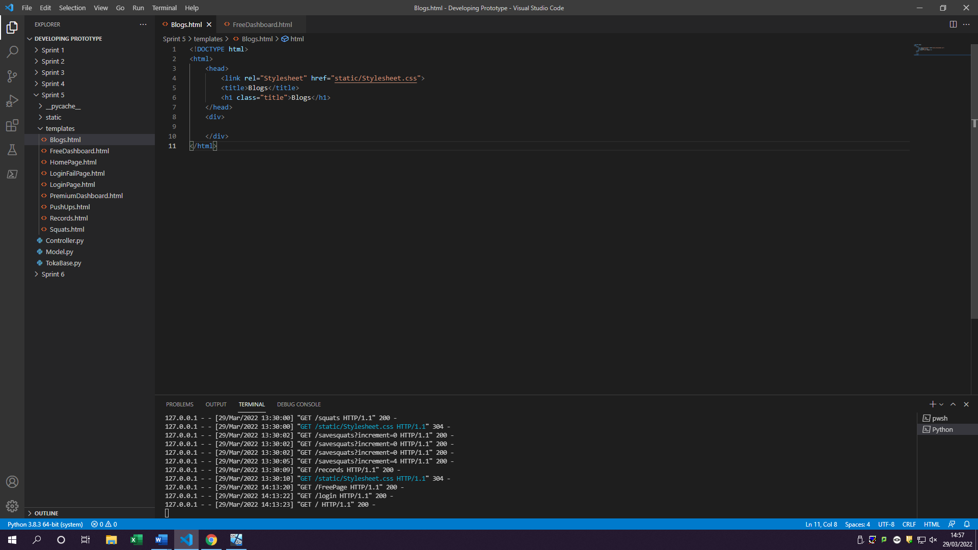

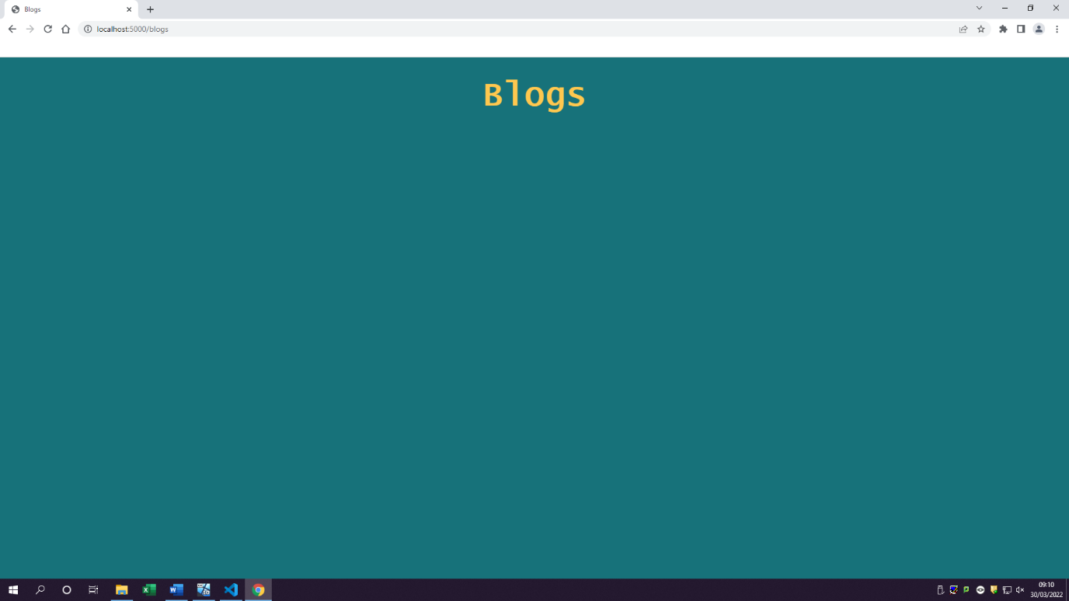

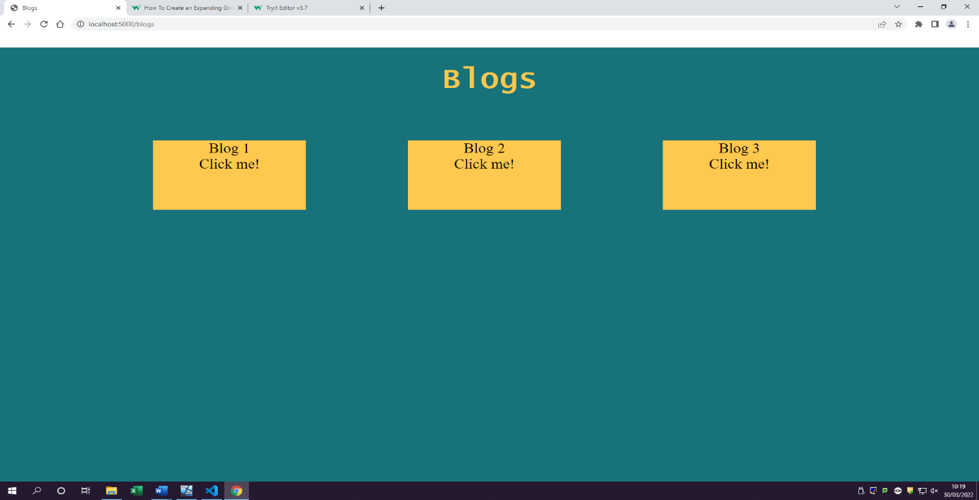1.2 Add content to blogs & 1.3 Add read more button

Once user clicks on click me box it will open up a box under it with all the content in this case being random text (facts)

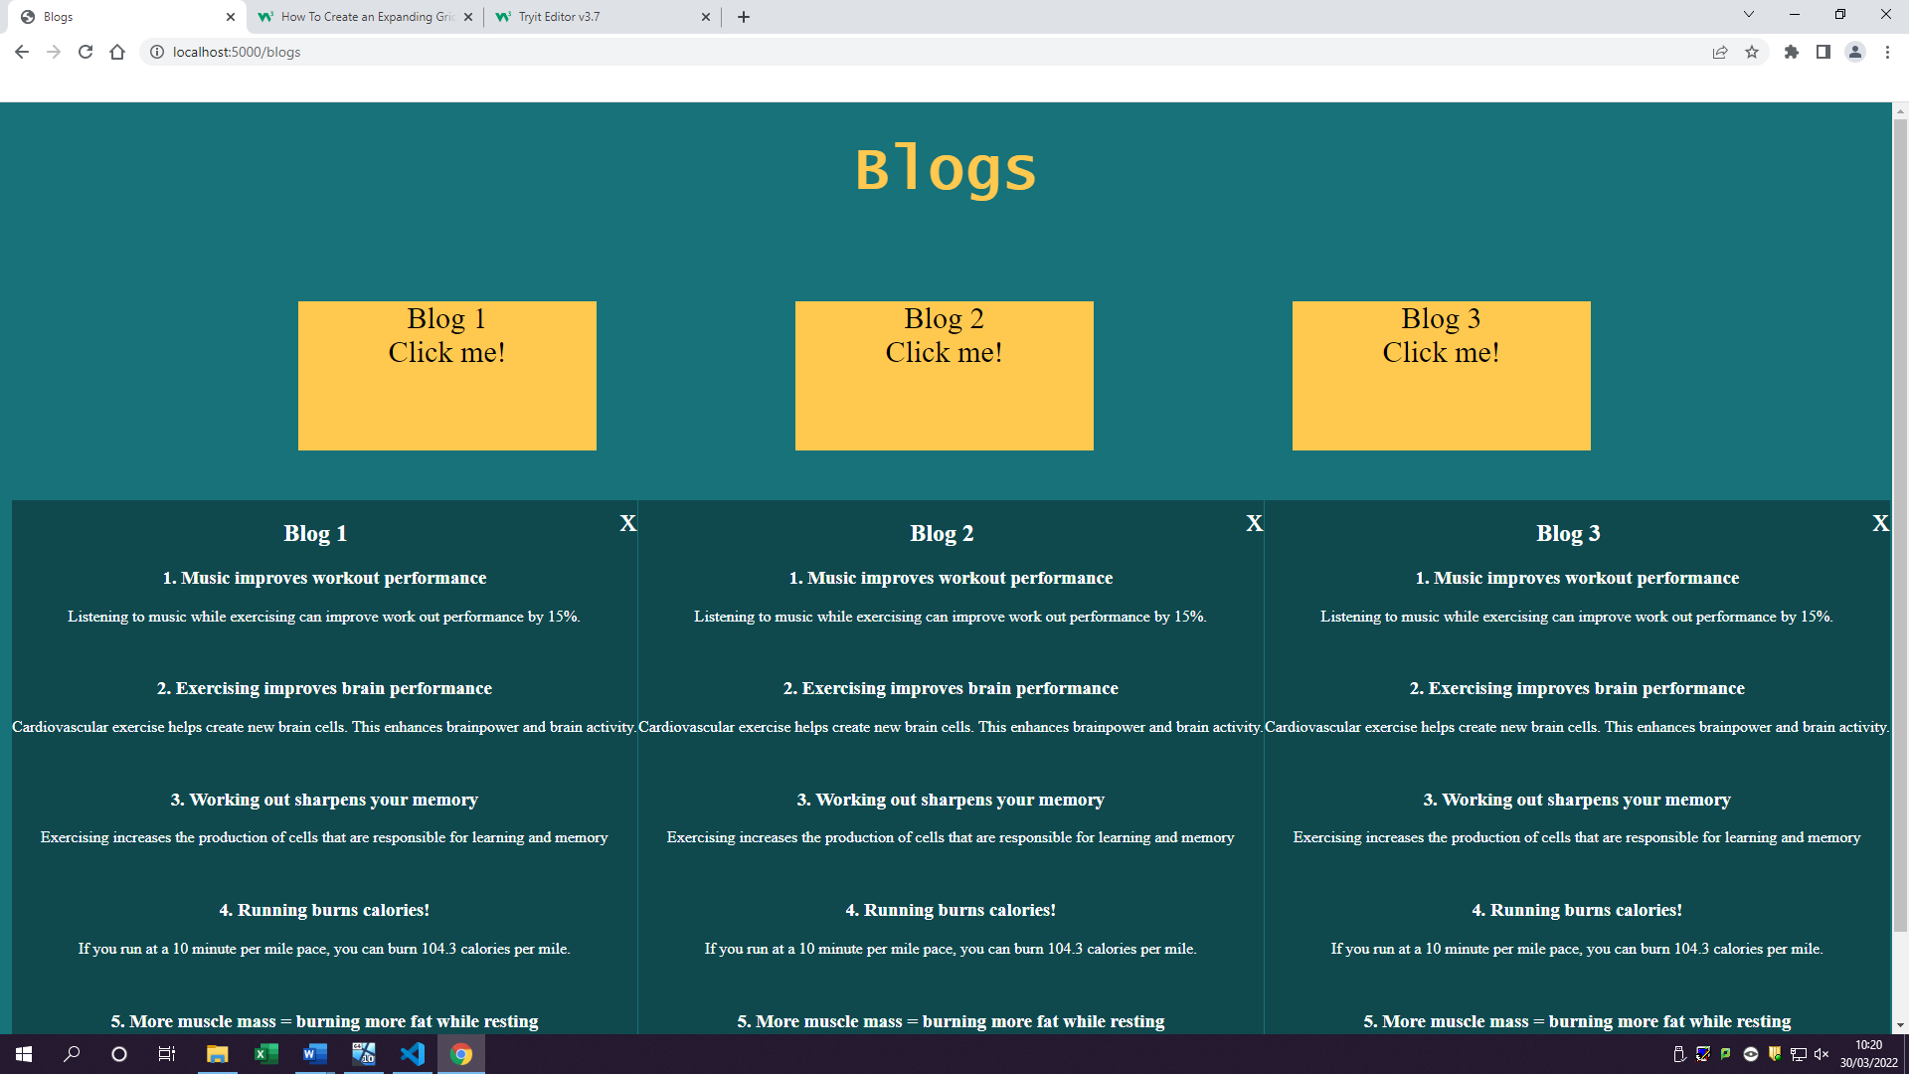

User can also press on the x button to close the blogs sub part

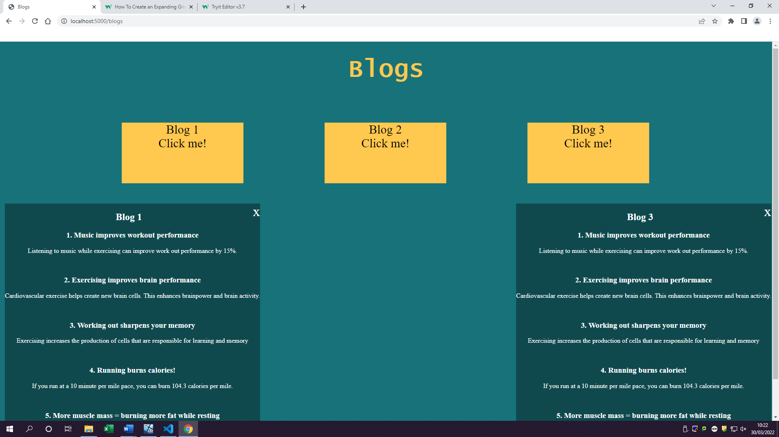

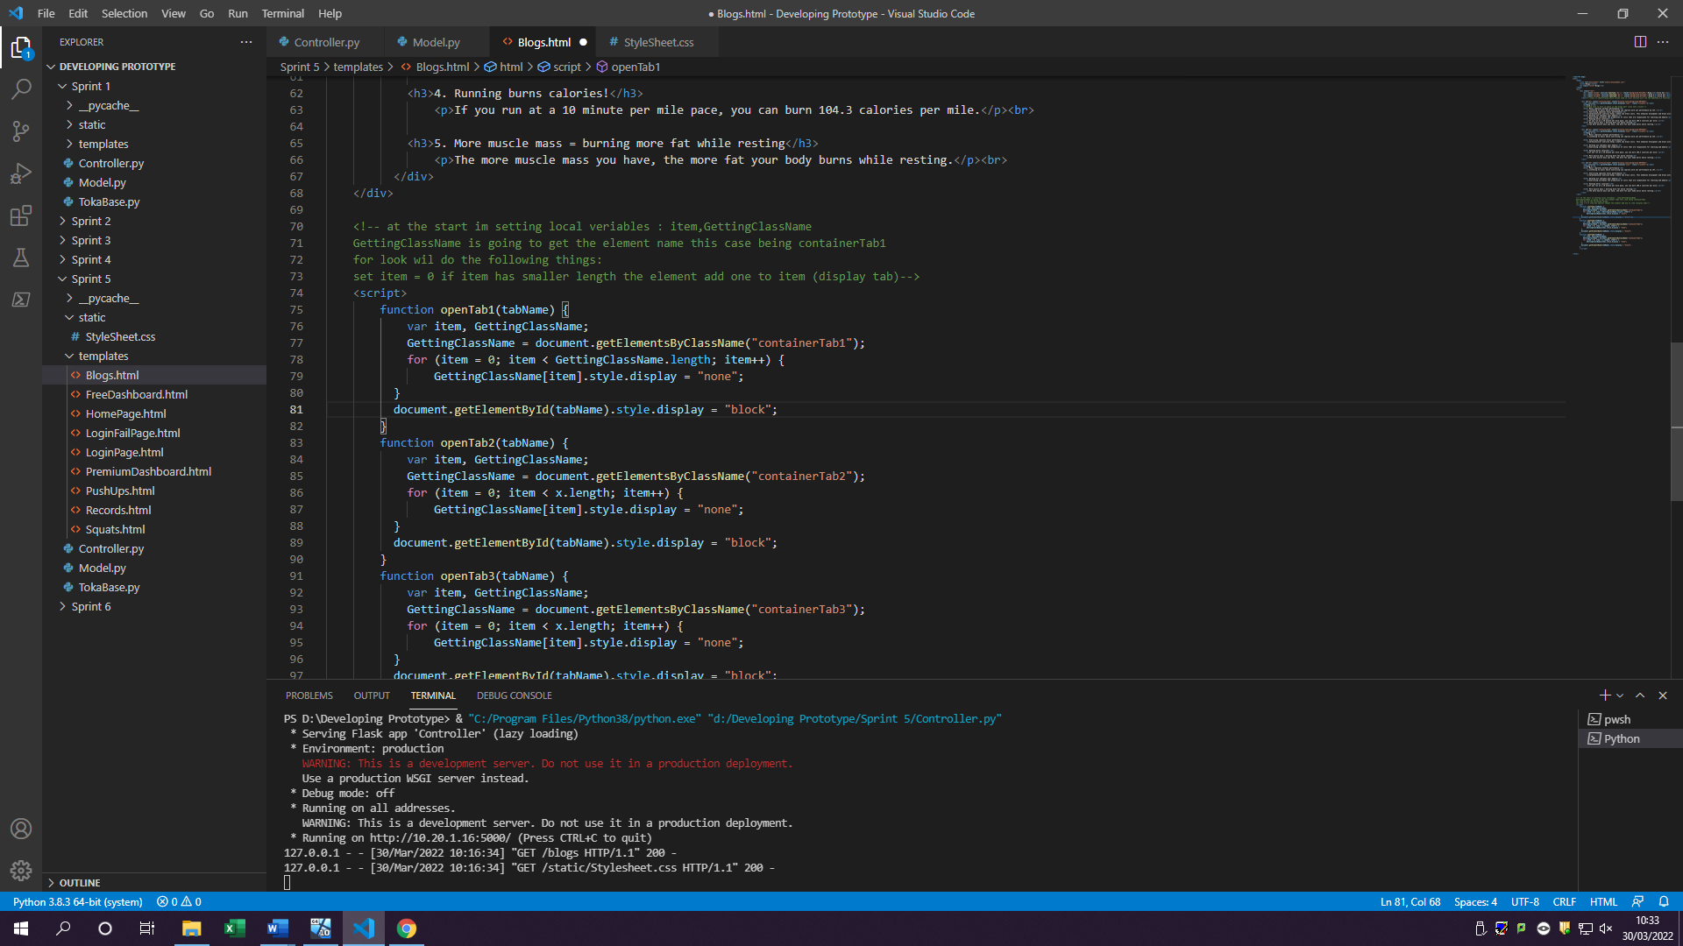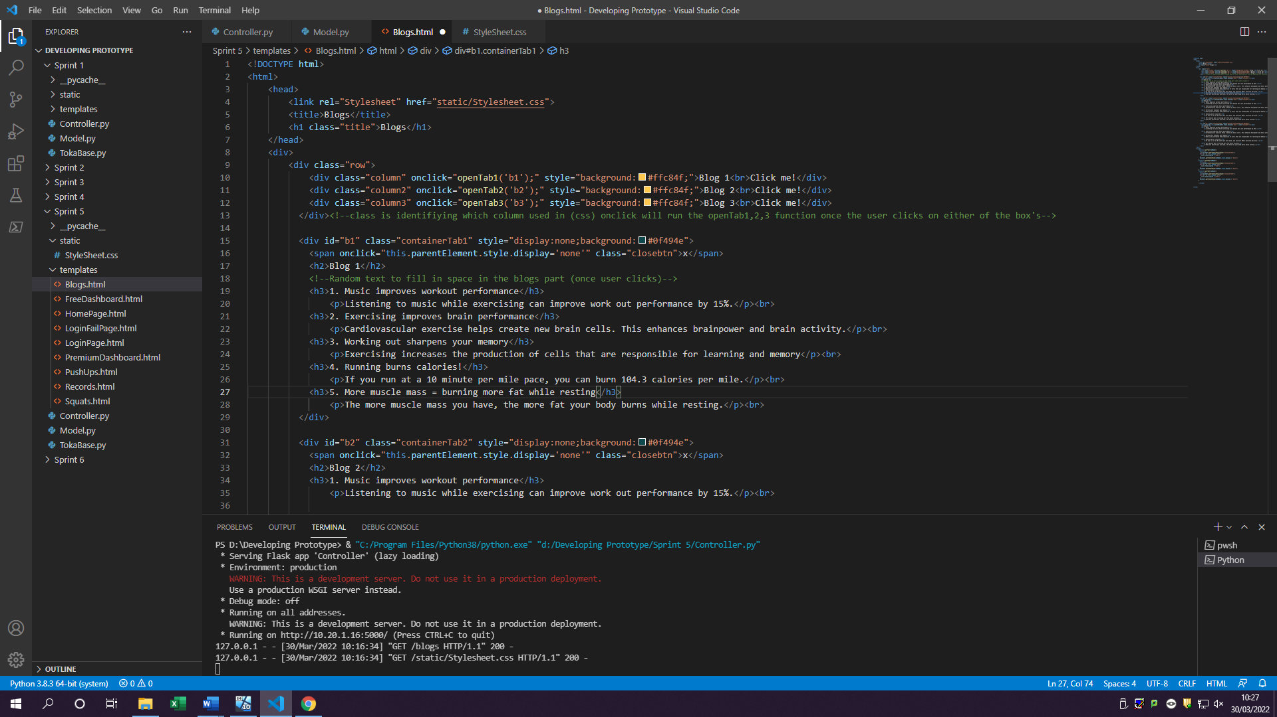

Java script code behind the function

1.4 Add images to blogs

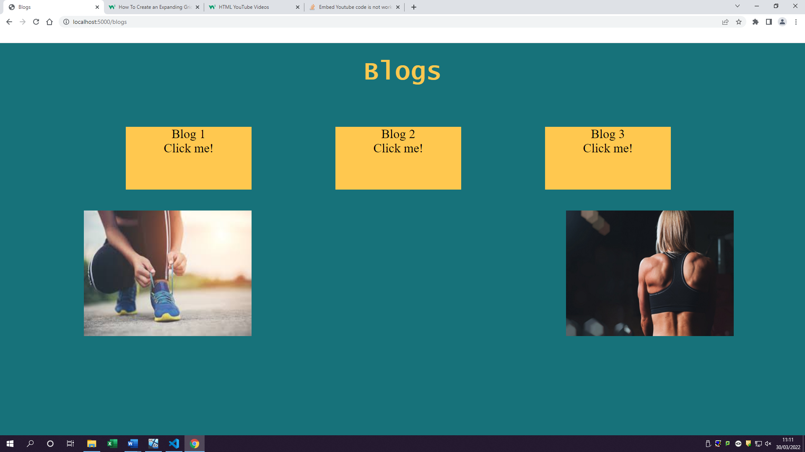

2.1 Add video links to pages

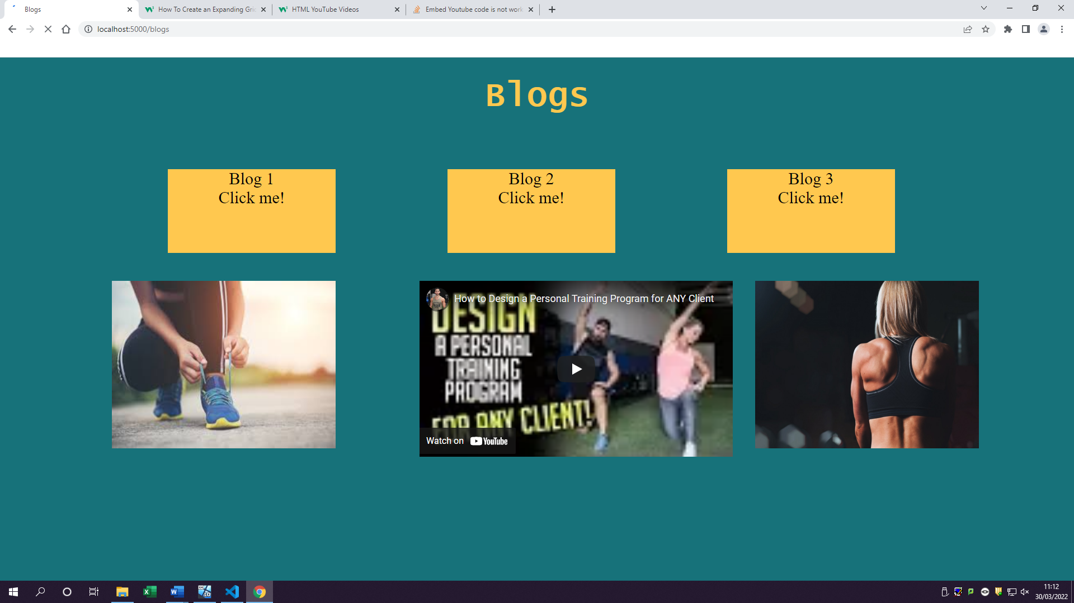

2.2 Make videos playable and watchable

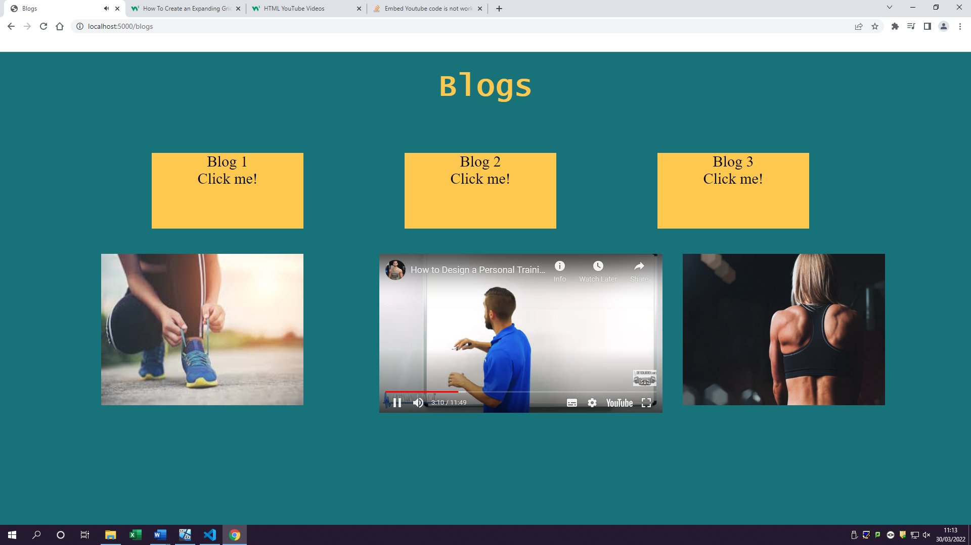

Video is now playable, and user has controls to pause it and go full screen

### Log table

|  |  |  |  |  |  |  |
| --- | --- | --- | --- | --- | --- | --- |
| Fr# | Task# | Testing type | Description of test | Expected outcome | Actual outcome | Notes |
| 1 | 1.1 | Unit test | Creating blogs page | Blogs page should be created | Blogs page has now been made | Not yet displaying to user |
|  | 1.2 | Unit test | Adding content to the blogs page | There should be some sentences or paragraphs of information | User can now see content on the blogs page (random content) | Blogs page is now displaying to the user |
|  | 1.3 | Unit test | Testing read more button to see if extra text appears | When user clicks on read more button, they can see extra text on the screen. | Instead of button its now a box once clicked opens up sub box for more information |  |
|  | 1.4 | Unit test | Checking to see if images can be seen by the user and if they have good resolution | Users should be able to see the images in good quality | Images are from google with creative commons license meaning we are allowed to use them. The images are also high quality |  |
| 2 | 2.1 | Unit test | Checking if the YouTube links selected are working | User should be able to see YouTube videos | YouTube link is just an example of how and where the video would be placed on the blogs page (but reference has been made once clicked it goes to creators channel) |  |
|  | 2.2 | Unit test | Testing to see if video’s function when clicking play such as is it running and can you hear sound | User can watch the YouTube videos | User has all controls over the video including pause and full screen |  |

### Review

Sprint 5 was the easiest sprint to complete as most of the work was just designing on how blogs page will look and things it will contains. Blogs page is a great addition but only for premium members as this is the feature which sets Premium account and Free differences.

In functional requirements I said I will make a read more button however as I was designing, I turned button into a box which can be clicked on. I done this because I believe its more appealing to the user as well as would look better than having a normal button under. I also changed the way my blogs will be seen, instead of blogs going straight under each box they are now separated meaning if the user decides to close 1 blog, they can through clicking the ‘x’ letter/button they can. As well as this gives the user an opportunity to have all blogs open at the same time without automatically closing the previous one. The text, video and images are all examples of how things may look like once Toka Fitness decides to put their content in.

All together I believe sprint 5 was successfully complete giving another addition to Toka Fitness web application and meaning that we are getting close to finishing this development project set by Toka.

Lessons learnt from this sprint are to have some CSS code as examples which would give me more time by not having to google on how to do a set thing instead focusing more on the design with the CSS I already have from other webpages and trying to reuse them for blogs.

## Sprint 6

Sprint 6 will be finishing all the small details such as the designs and cleaning up all the code as well as to make it more maintainable in the future, adding comments on how things work and function

### Goals/Requirements

|  |  |  |
| --- | --- | --- |
| Goal Set | FR# | Requirements |
| 1 | 1 | Finish the designs of pages such as (back buttons) |
| 2 | 2 | Comment the entire code on what it does |

### Triage/Tasks

|  |  |  |  |
| --- | --- | --- | --- |
| FR# | Task # | Functional requirement | Expected outcomes |
| 1 | 1.1 | Add back buttons to dashboard | User should be able to see and click on back buttons on each dashboard page |
| 1.2 | Make back buttons go to homepage | Once user clicks on back button it goes to homepage |
| 2 | 2.1 | Comment each line of code on what it does | - |

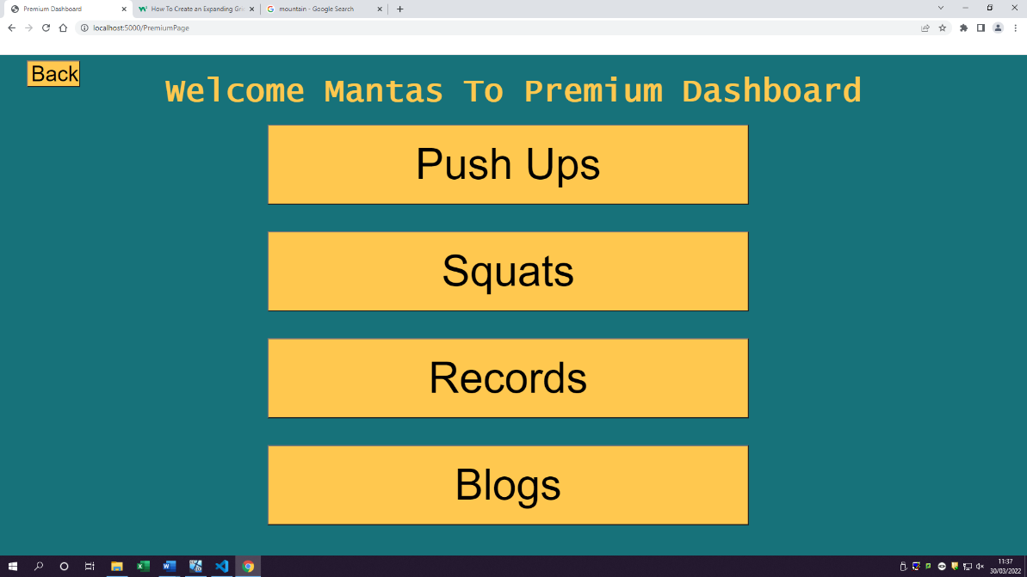1.1 Add back buttons to dashboard

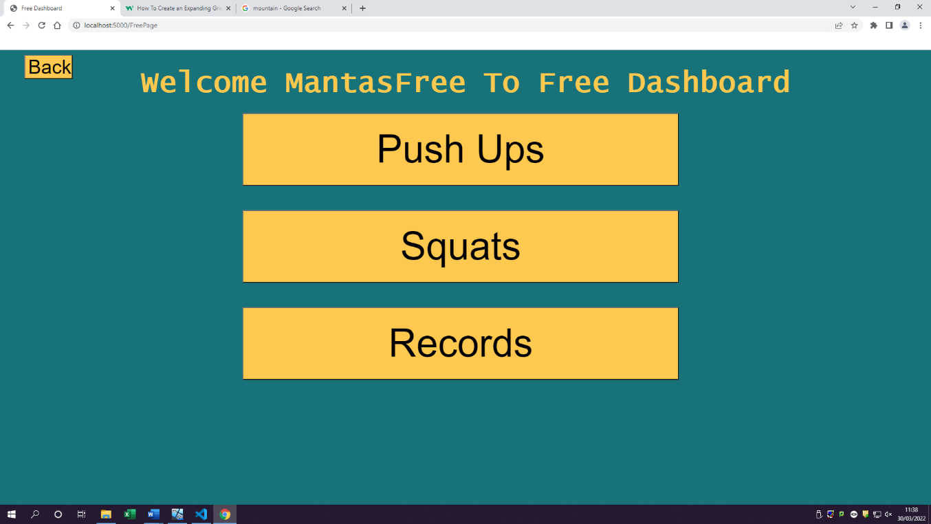

1.2 Make back buttons go to homepage

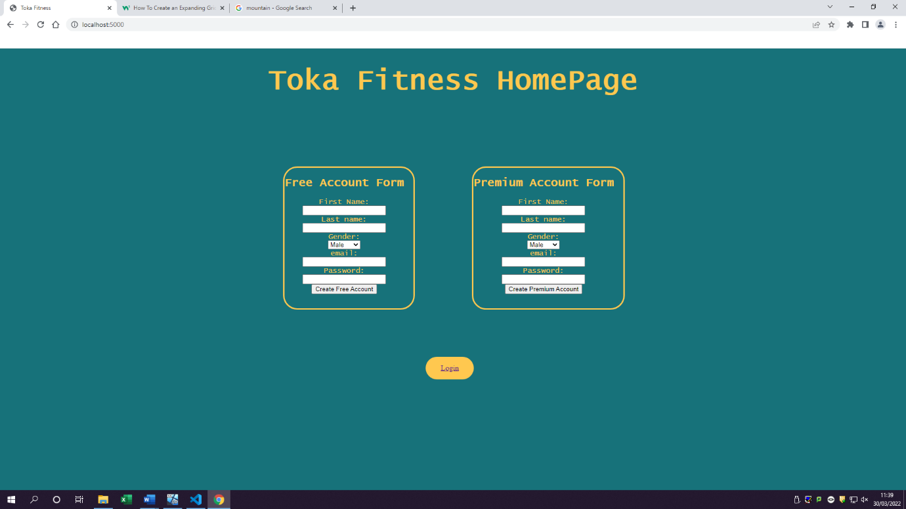

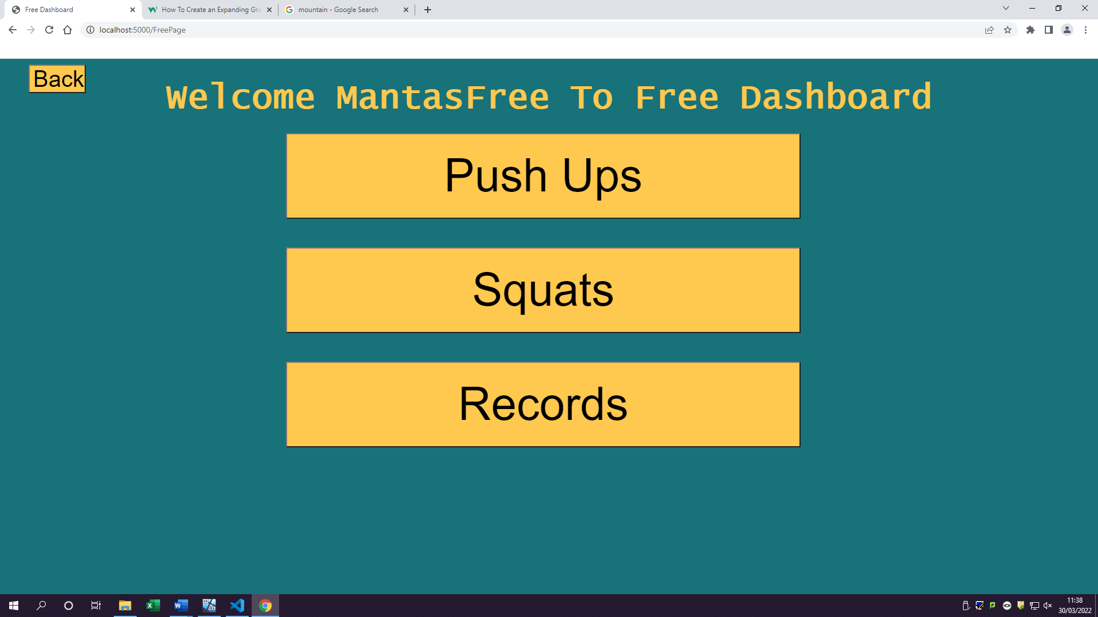

Once user has clicked on back button it sends them back to homepage

### Log table

|  |  |  |  |  |  |  |
| --- | --- | --- | --- | --- | --- | --- |
| Fr# | Task# | Testing type | Description of test | Expected outcome | Actual outcome | Notes |
| 1 | 1.1 | Unit test | Checking to see if buttons are correctly places and can be seen by user and clicked | User should be able to see and click on back buttons on each dashboard page | Users can see and are able to click on back button but get frown internal server error as no page is yet getting returned | Throws internal error |
| 1.2 | Integrated test | Checking to see if back buttons go back a page | Once user clicks on back button it goes to homepage | Users can now click on back button to go to homepage |  |
| 2 | 2.1 | - | Just making sure all lines of code are commented to say what they do | - | Most of code is commented |  |

### Review

Sprint 6 was the last sprint in this development process which means that the prototype for Toka Fitness is now in the final finished stage based of the requirements set by the client.

Sprint 6 had one user requirement which was having back buttons for dashboard pages allowing users to go from dashboard to homepage. This has been successfully complete; however, I did try making back buttons for every page but there would be a problem which would have occurred such as getting pages mixed up with premium and free dashboards. Example of this would if user is using a free account and is on Push Ups page and they click back they would have a 50/50 chance of either going to premium dashboard or free. As a result of this I have not included back buttons on functional pages. In future development of this product, I would have added back buttons which would go to the correct dashboard the user has registered from.

As this is the last sprint one of the requirements was commenting the code which I have completed throughout my development. I set that as a requirement due to the reasons such as if there is going to be another software team wanting to pursue and carry on with development, they would be able to read the comments to understand what is happening. I have also made sure to use proper variable names on what they do so even if they can’t read the code, they may understand what it should do it. Each variable is using camelCase which is multiple words used to form a variable without any spaces or underscores, and each word starts with a capital letter. Example of this would be from one of my code snippets: “getRegisterInfo” this is a great way to name variable as it does what the name says gets register information(info).

Lesson learn on this final sprint was to make sure that when developing I should comment each line as I go, this is because I decided to only comment once I have finished a function and only commenting it until it works instead of commenting as I go. If I did comment as I programmed, I would have been able spot the mistakes in the code faster and it would be easier to see what each line does instead of having to read the entire code again and see what is wrong with the code. All together I believe this was a great sprint to finish on by commenting all the lines and getting the last couple features in.

# Overview of Development

This part of documentation is all about seeing if I have met clients’ requirements, how I done it and my thoughts of how I progressed throughout this agile development cycle

## Client Requirements

Toka Fitness needs a new digital solution which would help their company out to communicate with their existing and coming customers as well as helping their employees on completing the tasks. Now Toka Fitness currently provides customers with **personal training sessions, advice about fitness training and advice about healthy living**. But they are now in need of features such as:

* **provide information and advice about fitness training and healthy living**
* **provide access to digital content to support customers with their training and healthy lifestyle**
* **encourage existing customers to use more of the services provided by Toka Fitness**

Toka Fitness has also carried out market research with existing customers to identify potential features which could be included in the digital solution. Potential features included items such as:

* **free and paid-for content**
* **accessibility features for users with sight loss**
* **‘social’ features**
* **customisable workout and eating plans**

## How Requirements been met

Toka Fitness has requested the solution to **provide information and advice about fitness** training and healthy living. I believe I have managed to achieve this task by creating a Blogs page which would have content such as images/videos and text about healthy living and fitness training advice. To make sure I have fulfilled this requirement I would have had a meeting the client themselves about the blogs page I made and if it contains everything they want and if its what they were thinking of. This meeting would also help in the future development of this blogs page as maybe Toka wants some additional features added to the page or any other design ideas they have.

Second feature which Toka Fitness has requested for their solution to have been a way to **provide access to digital content to support customers with their training and healthy lifestyle.**  With this requested I had to think outside the box such as thinking how I should make the user interact with application and support them with the training. So, I decided to create PushUps and Squats functionality which allows user to interact by clicking on the “Push Up” button which would indicate to them that they have done 1 push up, this brings in interactivity with the user/customer and makes it more fun by having the user needing to perform the push up or squat. And once they are done they can click on save result which would send the amount of pushups/squats completed to a socials record page where everyone’s results are showing in a table.

Third feature Toka Fitness has requested is a way to **encourage existing customer to use more of the services provided by Toka Fitness**. To try and complete this target I had to think about what the customer would want a Fitness website to contain and for me it was to be able to interact with objects as well as making user feel like they are important. So instead of going usual website way of having just text to read through and forms to fill out I have created dashboards for users. These dashboards display the users name which they have filled in once creating the account. By displaying the customers name in title you giving the customer a feeling that you care about them and that its made for them. Functionality such as Squats and Pushups also encourage the customers to stay and use the services provided in a competitive way with other people. This can be seen through the records page where each user is able to share their high score making other people want to try and beat the score which would keep the existing customer attracted and use more of the services such as blogs page which goes together by receiving tips on how to get in great shape to do the large amount of push ups or squats.

With these three main features Toka Fitness has requested to be complete I believe I managed to achieve this in a unique unusual way making this product stand out from any other fitness website by having more interactive parts for customer to enjoy.

Toka Fitness has also carried out some market research with existing customers to identify potential features which could be included in the digital solution. One of the features was having **free and paid-for content**. With this feature I straight away thought about having two different account types such as Premium being the one which would have to be paid and have the additional content and free which is free and wouldn’t have additional content. However, this potential feature was hard to achieve as I was unable to ask users for their bank details this is because the risks of storing users’ payment information, I have decided to no longer include any fields requiring a user to enter their private card number information to buy a premium account due to security and Toka Fitness assumably not having a valid or usable e-commerce license to sell products online. This does mean that users are able to create their account in premium form for free too however in future development and/or toka fitness having a valid e-commerce license this would be able to be added to premium forms such as asking for bank details and confirmation emails. As of right now though Premium(paid) version has additional content which is the blogs page allowing users to get their latest fitness information and watch personal training videos.

Another potential feature requested by existing customers was **accessibility features for users with sight loss.** I made sure to have this disability covered as many people are colour blind or have sight have interest in fitness which is a wide range of people. As a result of this I decided to make this web application use as little colours and mostly containing blue and yellow. I decided to use these colours as blue and yellow colour blindness is uncommon for people to have; I have also made sure to have large text as well as big buttons for people to click on in case they cannot read or see any small text/buttons. If Toka Fitness wanted me to change the colour scheme the meeting in Sprint 1 would have been where they would have said it as its where I determined the colour scheme should look like. However, in future development this can still be changed with ease through changing the body in the stylesheet and setting it to the colour Toka wants. However, I do believe the size of text and buttons is appropriate and users with sight loss would not have any trouble directing/moving across my web application.

Customer have also requested the prototype to have a **‘social’ feature**. I believe I managed to achieve this in a quite unique way which includes interactivity. This is done by users doing the workout in this case being push ups or squats and then saving results which would then be shared on records page. On records page everyone can see everybody else’s high scores giving the ‘social’ feature its functionality instead of having the basic share buttons to social media platforms such as Instagram, Facebook or twitter. Instead Toka has a tailored feature just for them and customers/users only to participate in and watch how other people are doing with their high scores.

For the final requirement made by the customers was to have a **customisable workout and eating plans.** This is the requirement which I couldn’t fully fulfil I have instead created two main workout buttons being Squats and Push Ups however this isn’t customisable in a way which customers want. In future development of this project instead of having Squats and Push ups buttons there would be a workout button which acts as a drop down allowing you to select a specific exercise but function the same as others such as having to click on a button, this would then increase the counter and having a share button which would then go on records page with all the other exercises such as squats and push ups and once again giving the ability for other users to see and try beating it. For the eating plan I haven’t included anything with It due to the reasons of this application being interactive and mostly based on workouts done by the user and exercises in general. However, in my proposal I did mention ability to have a ‘calorie counter’ but I have decided to no longer include this as I believe this application doesn’t need one. On the other hand, if Toka Fitness wishes to have this calorie counter it can be added as a feature in future sprints / development.

## Development progress review

At the start of Sprint 1 I was able to create all the tasks set out which where the most important ones as this would be everything, I would have been doing my work from things such as Controller and model files there created and even the first Homepage as well as login page. I Also managed to create TokaBase file haven’t tested in which backfired on me in Sprint2.

Sprint 2 was probably the hardest at the start since I was struggling on getting a connection with the TokaBase and MySQL server. This was because When I was creating a user account for the database, I was entering host name of: “192.168.56.101” in the MySQL statement which when if you run on python would give out an error saying: “Error connecting to MariaDB platform: Host 'CC-DT005-03-WCA' is not allowed to connect to”. To overcome this problem all I had to do was give user hostname of ‘%’ meaning any host can access my database now. This problem made me stuck for 2 hours of my development however once I manged to get past this, I was starting to get back up with the speed but due to the lack of spending time on trying to figure out what was wrong I had to set one of the tasks as ‘backlogged’ for Sprint 3. All of this would have been avoided if I tested my tokabase file in sprint 1, but all together sprint 2 was successful looking back on it as I manged to get most of the functional requirements, I set out to complete.

Sprint 3 was all about creating a cookies table and a function to login/authenticate users to determine which dashboard they are getting sent to. This also includes the task from previous Sprint 2 to be completed 2.4 for login the user in and displaying the correct dashboard for the account. This Sprint was the hardest by far as I was trying to figure out on how to verify users as well as giving them a unique cookie once they log in. I then had to create a way to display users name on the dashboard making sure its correct by the account they are on. Looking back on Sprint 3 I believe couple of these tasks could have been moved to sprint 4 or decomposed a bit more so I would have not struggled as much as I had to. However, I did manage to complete all the functional requirements set and have no backlogged tasks for sprint 4 which is great.

Sprint 4 was based around functionality of the dashboards such as getting push-ups, squats, blogs and records pages up and running with some of its functionality. As well as having to create another table for workouts to be stored in. There were a few challenges which I did face such as getting the table to show on records page and splitting the squats score away from push ups score. I also struggled with thinking of the eye-catching colour schemes which would go well together however I left it to my normal bright gold coloured table where its easier to see on blue background. This sprint I also had to delete one of my functionalities which was ShowPassword from the JavaScript because this would mess up my registering account password. As a result, to avoid this problem I decided to remove it, but this however can now be added in future development and not effect the register in any way or form. This Sprint had me thinking about what would of Toka Fitness liked to see on this page and in real scenario if I was able to be in meeting with them I would of asked questions on deciding features and colour schemes.

Sprint 5 was based around blogs page with personal training videos included in it. This will mostly be a html and CSS work and a bit of JavaScript to get the functionality such as read more buttons and getting the YouTube videos to work. Through development stage in Sprint 5 I decided to not include the Read More button but instead a box with click me sign which is more appealing in my opinion for the user. Sprint 5 was quick and easy sprint to start to finish on as I knew I was getting closer to finishing this development project and having easier tasks at the end is better than having hard ones.

Sprint 6 being one of the final sprints for this development of prototype only had a task of adding back button and making sure the code is maintainable for future development. Developing the back button was quick and easy for purpose of being able to go back to home screen from dashboard page. For the code maintainable task, it was all based of commenting the code and making sure all the variables are named as in the way they act/do. This was important to complete because if Toka Fitness do wish to continue and let somebody else to continue to develop this prototype and publish it the code should be maintainable by a third party and having ability to add features if necessary

## Future development

There are many of things I want to add to this product in future such as getting the users calorie calculator they wanted, as well as having more than two workouts which users can pick from instead having something like a drop down and users having a wide range of choices to pick from and perform.

To make sure all this future development is possible this code had to be well commented and variables named correctly which I have done. This therefore means any third-party software developers Toka may hire would be able to understand what’s going on in the code just by reading the code and comments to see what each line of code does. I have also split the code in different functions therefore if they do wish to update and test a specific function, they are able to without affecting any of the other code.

## Thoughts about the project

I believe this project was saucerful looking back on the sprints and reviews. This is because I see that I have developed skills which I haven’t yet used by incorporating use of MySQL database and having a way to communicate from python to a server which would store user data. It would have been very beneficial of being able to have a meeting with Toka at the end of every sprint as well as at the start as they would be able to see if the ideas and functionality is what they want and expect to have. This would also make Toka Fitness staff feel more involved if meetings are set in place giving them ability to participate and help in the project. They would also be able to tell me anything they would have wanted to be changed or a feature to act in a certain way. However, I believe this development of a protype has been very successful testing all my skills as well as giving me ability to look up on internet and do some research on new ways of coding and completing this project.

# Citations

|  |  |
| --- | --- |
| Link | Number |
| https://docs.microsoft.com/en-us/aspnet/core/mvc/overview?view=aspnetcore-6.0 | (1) |
| https://www.w3schools.com/css/ | (2) |
| https://docs.python.org/3/library/hashlib.html | (3) |